# Visoka škola strukovnih studija za informacione I telekomunikacione tehnologije

GAMEHUT

<https://adamnik101.github.io/gamehut/>

Smer : Internet tehnologije

Modul: WEB programiranje

Predmet: WEB programiranje 2

Student: Adam Nikolić 101/19

# Sadržaj

Visoka škola strukovnih studija za informacione I telekomunikacione tehnologije 1

https://adamnik101.github.io/gamehut/ 1

1 Sadržaj 2

2 Uvod 3

2.1 Korisćene tehnologije 4

2.2 Opis funkcionalnosti 4

3 Template 6

3.1 index.html 6

3.2 contact.html 10

3.3 cart.html 11

3.4 author.html 11

4 Slike sekcija na stranicama i opisi funkcionalnosti 12

4.1 navigacija 12

4.2 Slajder 13

4.3 New releases 14

4.4 Hot sales 15

4.5 Exclusive offer 15

4.6 Best sellers 16

4.7 Discover 16

4.8 Upcoming games 17

4.9 Newsletter 17

4.10 Footer 18

4.11 Prodavnica 19

4.12 Kontakt forma 21

4.13 Stranica sa informacija odredjene igrice 22

4.14 Korpa 23

5 Organizacija 24

5.1 sitemap.xml 24

5.2 Organizaciona šema 25

6 Kodovi 25

6.1 index.html 25

6.2 shop.html 31

6.3 contact.html 37

6.4 single.html 41

6.5 author.html 45

6.6 main_styles.css 49

6.7 responsive.css 78

6.8 custom.js 85

7 JSON 110

7.1 allGames.json 110

7.2 categories.json 159

7.3 comingSoon.json 160

7.4 modes.json 162

7.5 navigation.json 162

7.6 otherFilters.json 162

# Uvod

## Korisćene tehnologije

Za izradu sajta korišćene su sledeće tehnologije:

* HTML 5
* CSS 3
* Bootstrap
* Javascript
* jQuery
* AJAX
* PHP Storm / Visual Studio Code
* Gimp
* Owl-carousel slider

## Opis funkcionalnosti

Sajt poseduje sledeće funkcionalnosti:

* Sajt je prilagođen za sve vrste uređaja
* Dinamičko učitavanje navigacije u header-u, meniju za manje rezolucije i u futeru
* Dinamičko učitavanje slajdera na početnoj stranici i njegovog sadržaja
* Dinamičko učitavanje proizvoda na početnoj strani i u prodavnici
* Dinamičko učitavanje podataka određenog proizvoda na zasebnoj stranici (single.html) pomoću slanja ’id’ određenog proizvoda u Local Storage i dohvatanje tog proizvoda na osnovu ’id’-a
* Dodavanje proizvoda u korpu i brisanje, pomoću Local Storage-a, ukoliko je proizvod već dodat, povećaće se samo količina tog proizvoda
* Dinamičko učitavanje unetih proizvoda u korpu na stranici ’cart.html’
* Pamćenje svakog unetog email-a za newsletter i proveravanje za sve unete email-ove da li su već uneti pomoću kolačića
* Dinamičko učitavanje filtera po određenim kategorijama u prodavnici iz JSON fajlova
* Sortiranje proizvoda po ceni i nazivu, opadajuće i rastuće
* Pretraživanje proizvoda po unetom stringu
* Filtriranje u rangu izabrane cene
* Filtriranje proizvoda uz primenu više filtera odjednom, kao i po jednom u zavisnosti šta korisnik izabere
* Menjanje broja prikazanih proizvoda po stranici u prodavnici
* Dinamičko učitavanje paginacije
* Dinamičko učitavanje proizvoda koji će uskoro biti u ponudi pri dnu nekih stranica
* Proveravanje unetih podataka pomoću regularnih izraza (newsletter i kontakt forma) i ispisivanje grešaka na osnovu unetih podataka ukoliko ne prođu regularni izraz ili ako podaci nisu uneti
* Pamćenje pomoću kolačića kada je korisnik poslednji put poslao poruku preko kontakt forme, tako da sledeću poruku može da pošalje sat vremena od trenutka slanja poruke (sprečava spam)
* Dinamičko ispisivanje određene poruke na osnovu toga sta korisnik uradi(doda proizvod u korpu, posalje poruku preko kontakt forme, unese email za newsletter i određene poruke ako korisnik pokuša ponovo da uradi isto to)
* Ispisivanje poruke korisniku kad prvi put uđe na sajt koja ga obaveštava da sajt koristi kolačiće

# Template

Korišćen je preuzet template sa <https://themewagon.com/themes/free-bootstrap-ecommerce-website-template/> uz modifikacije prilagođene mojim potrebama

## index.html

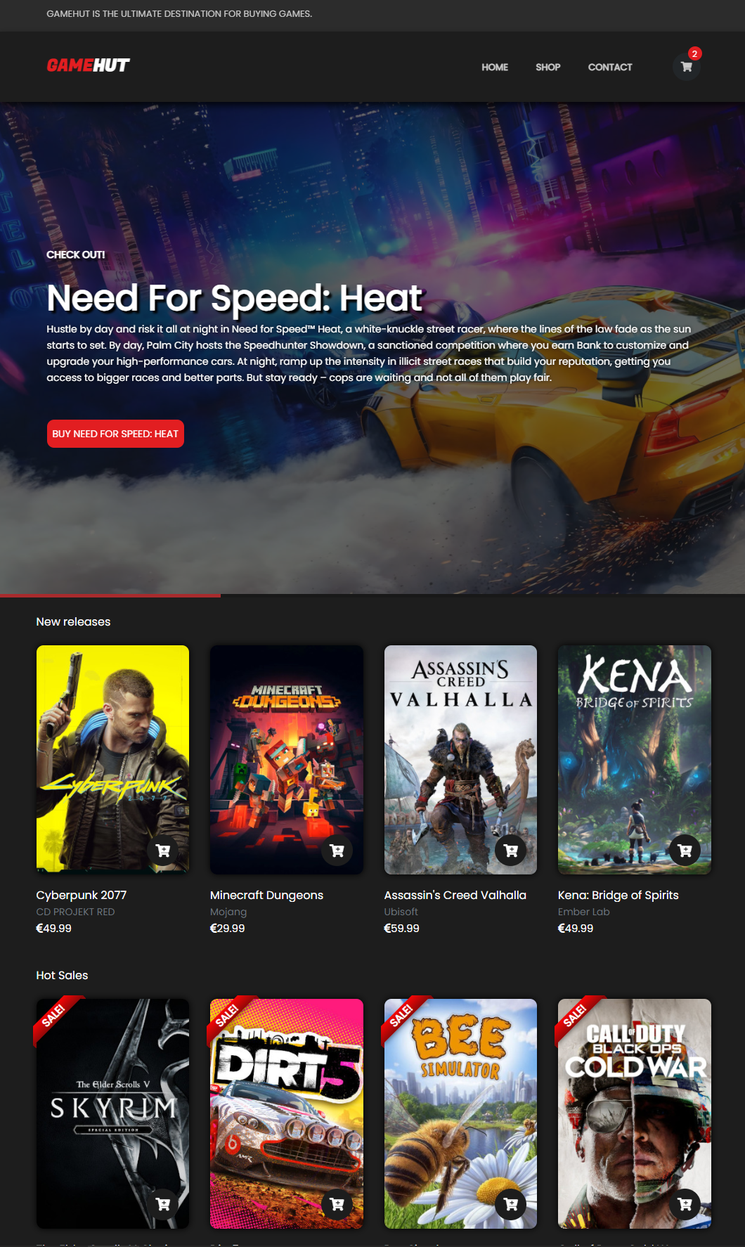

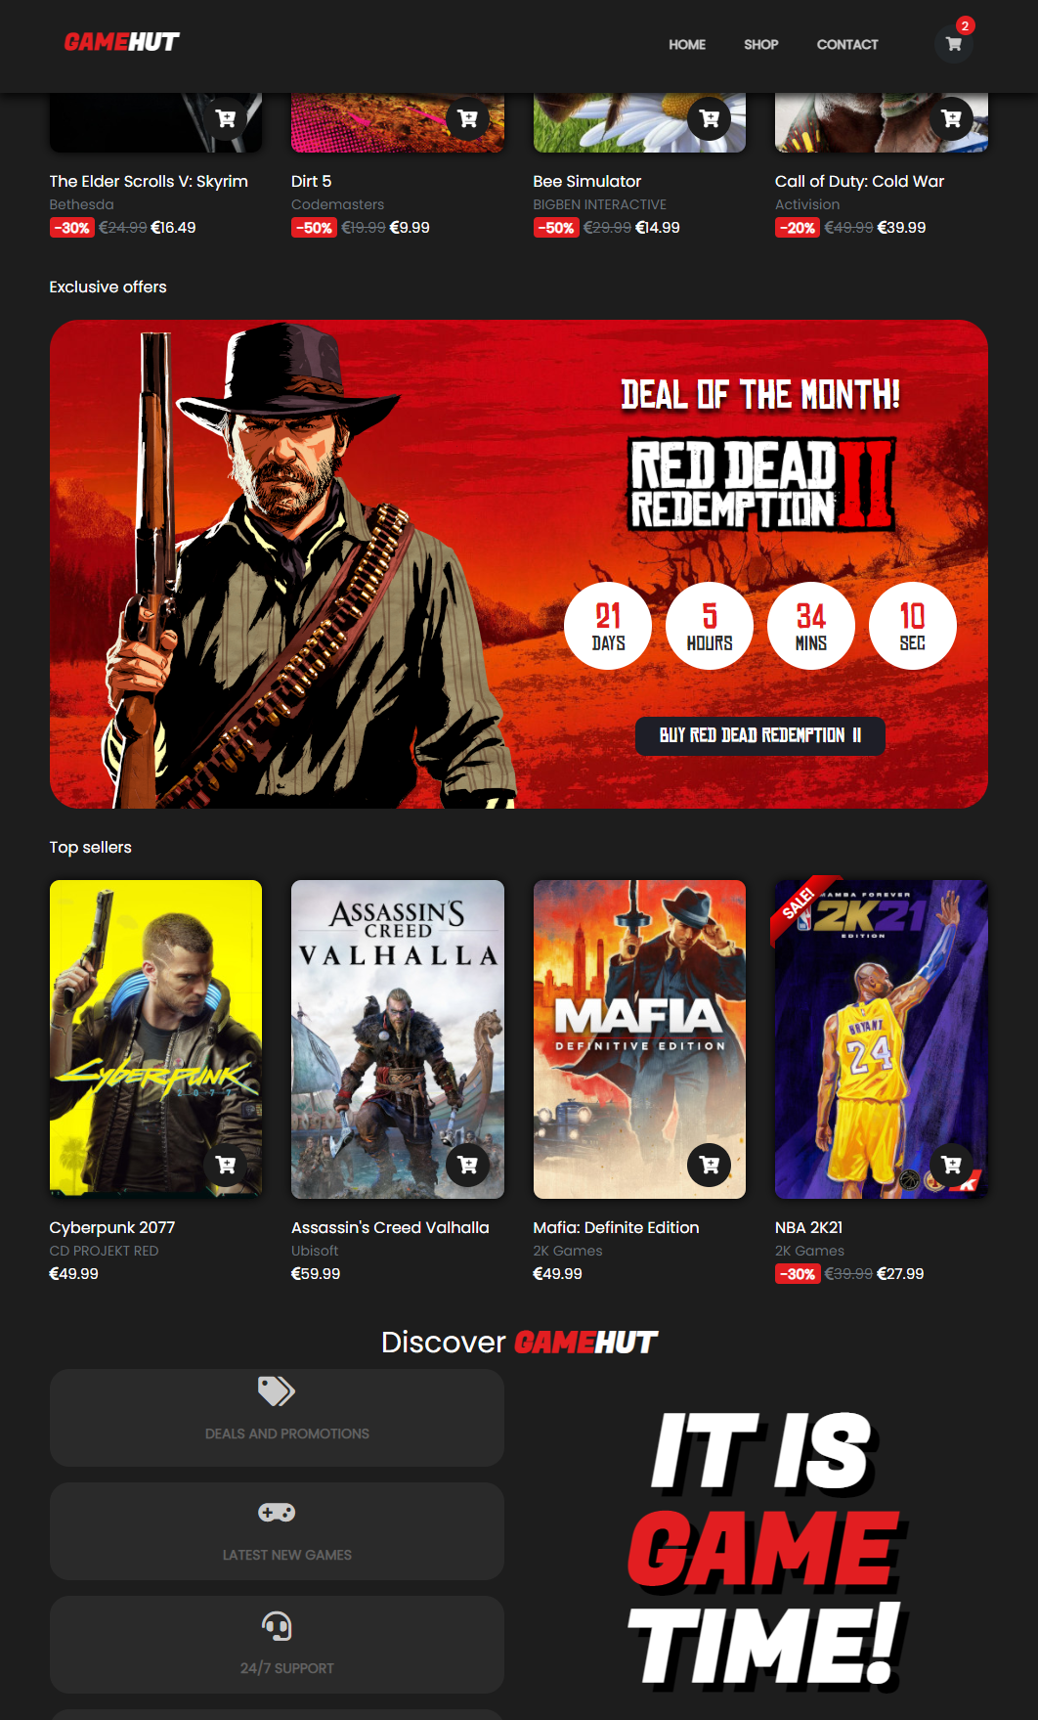

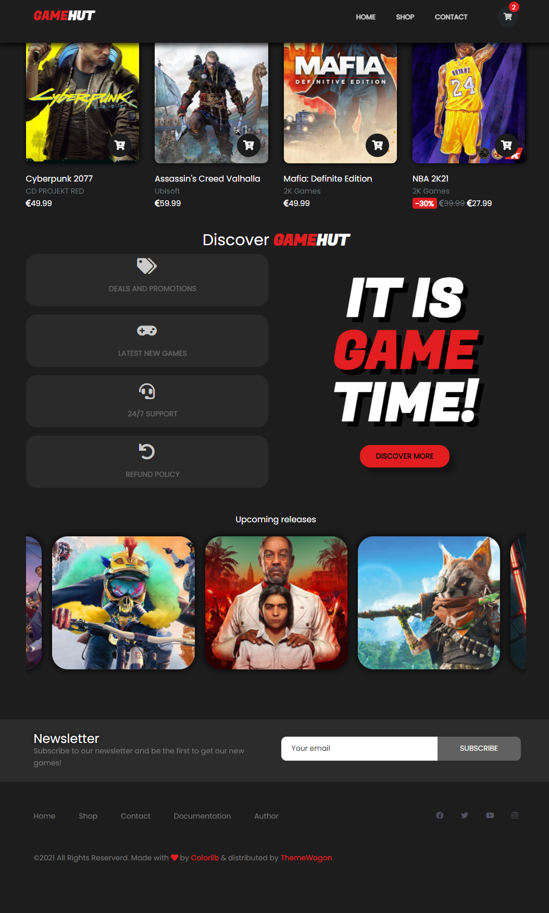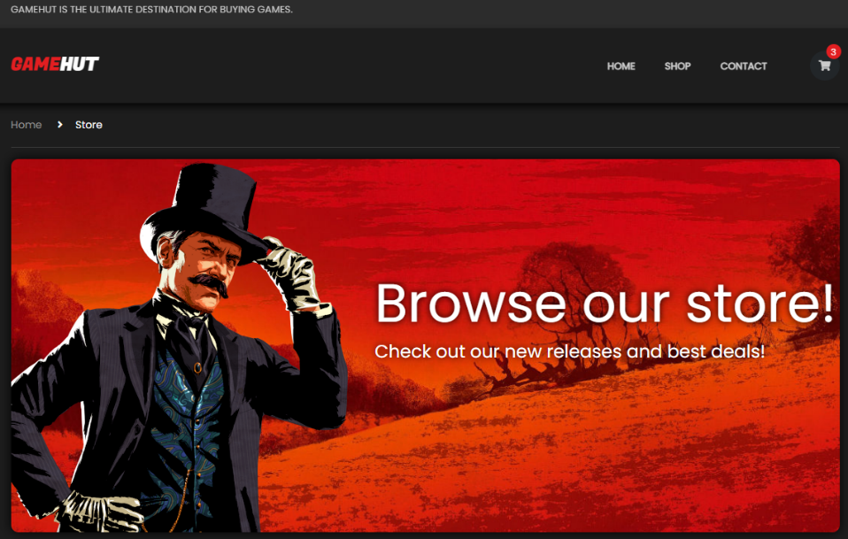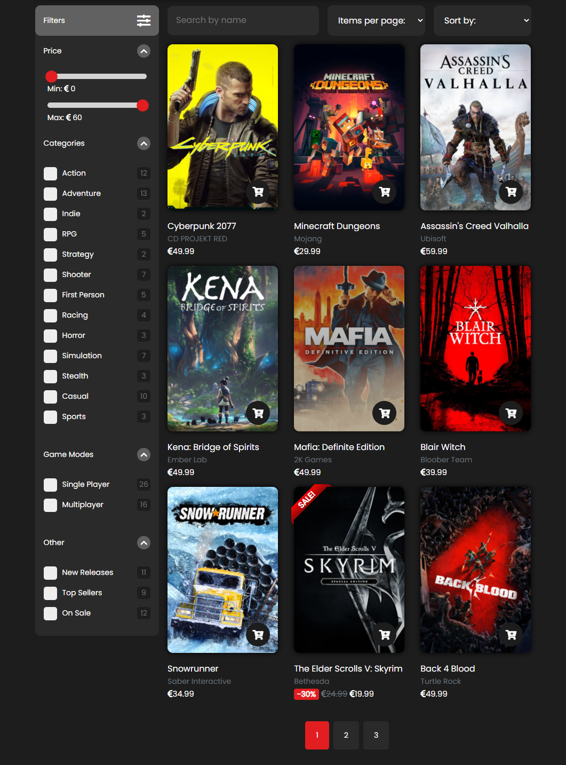shop.html

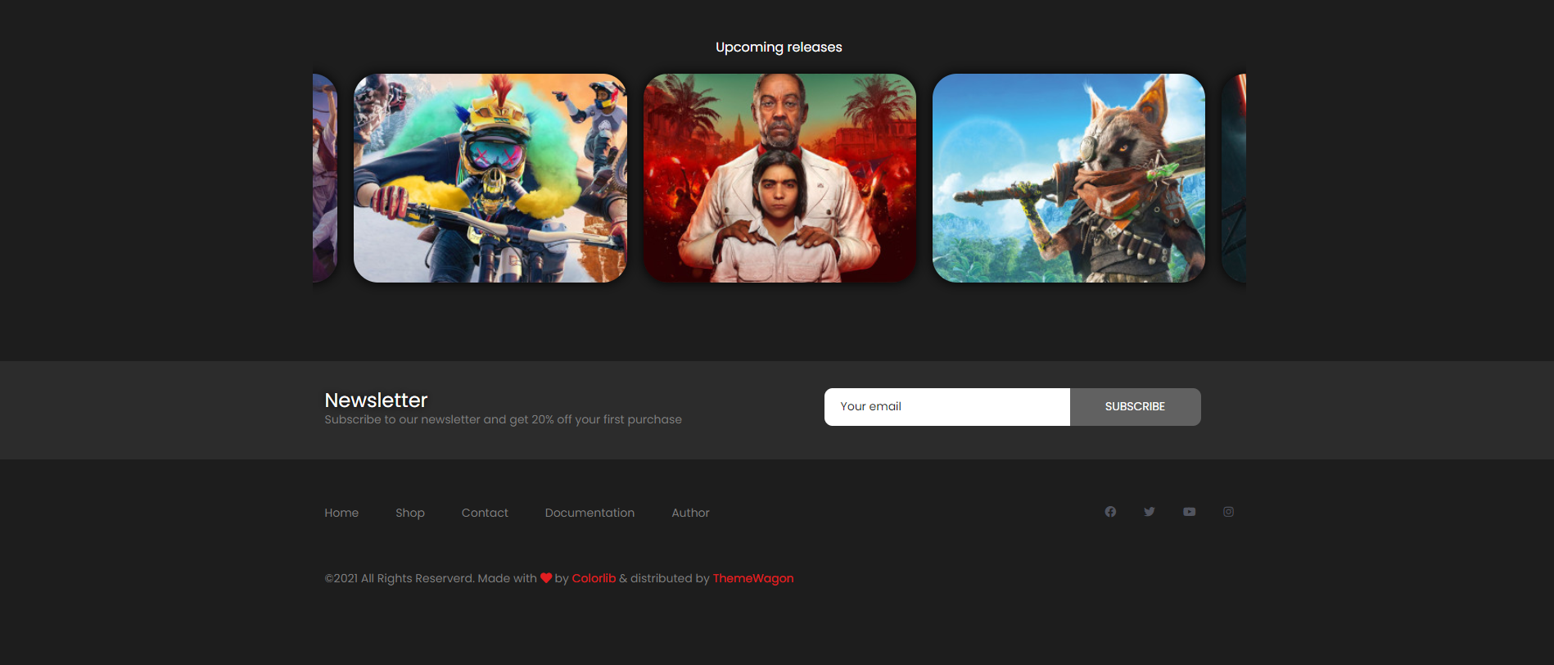

## contact.html

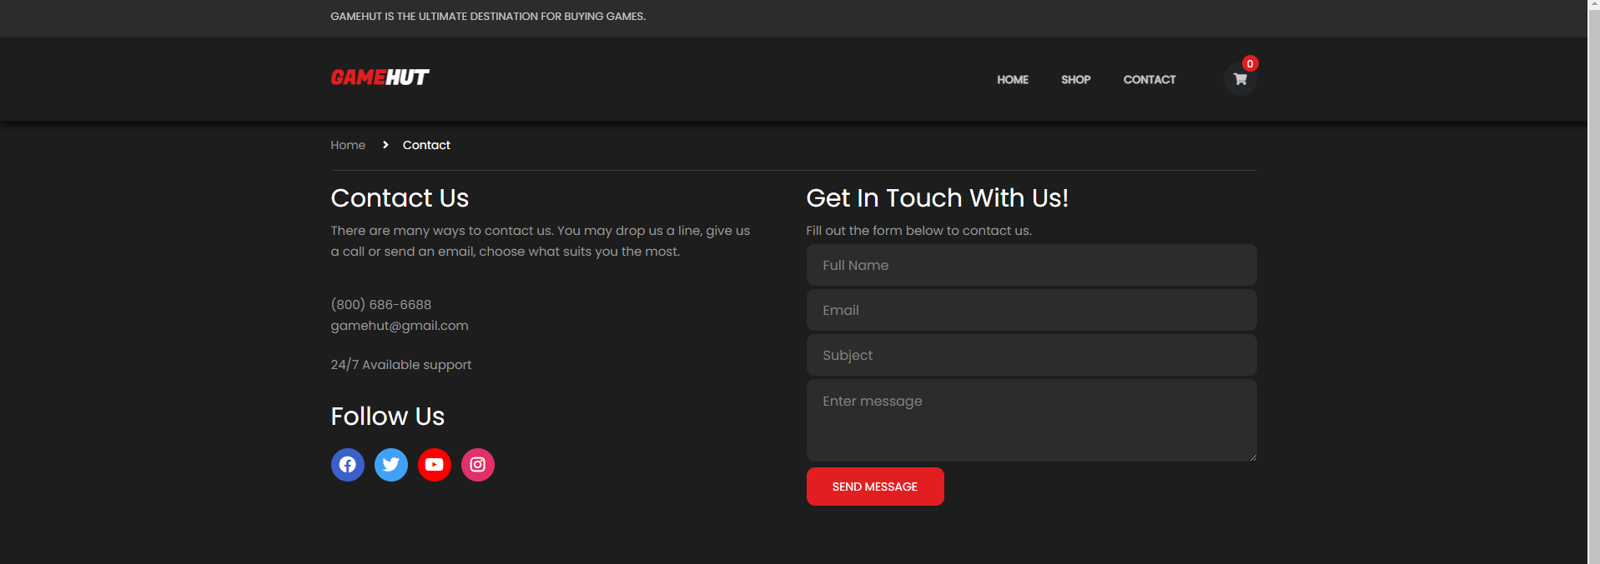



## cart.html

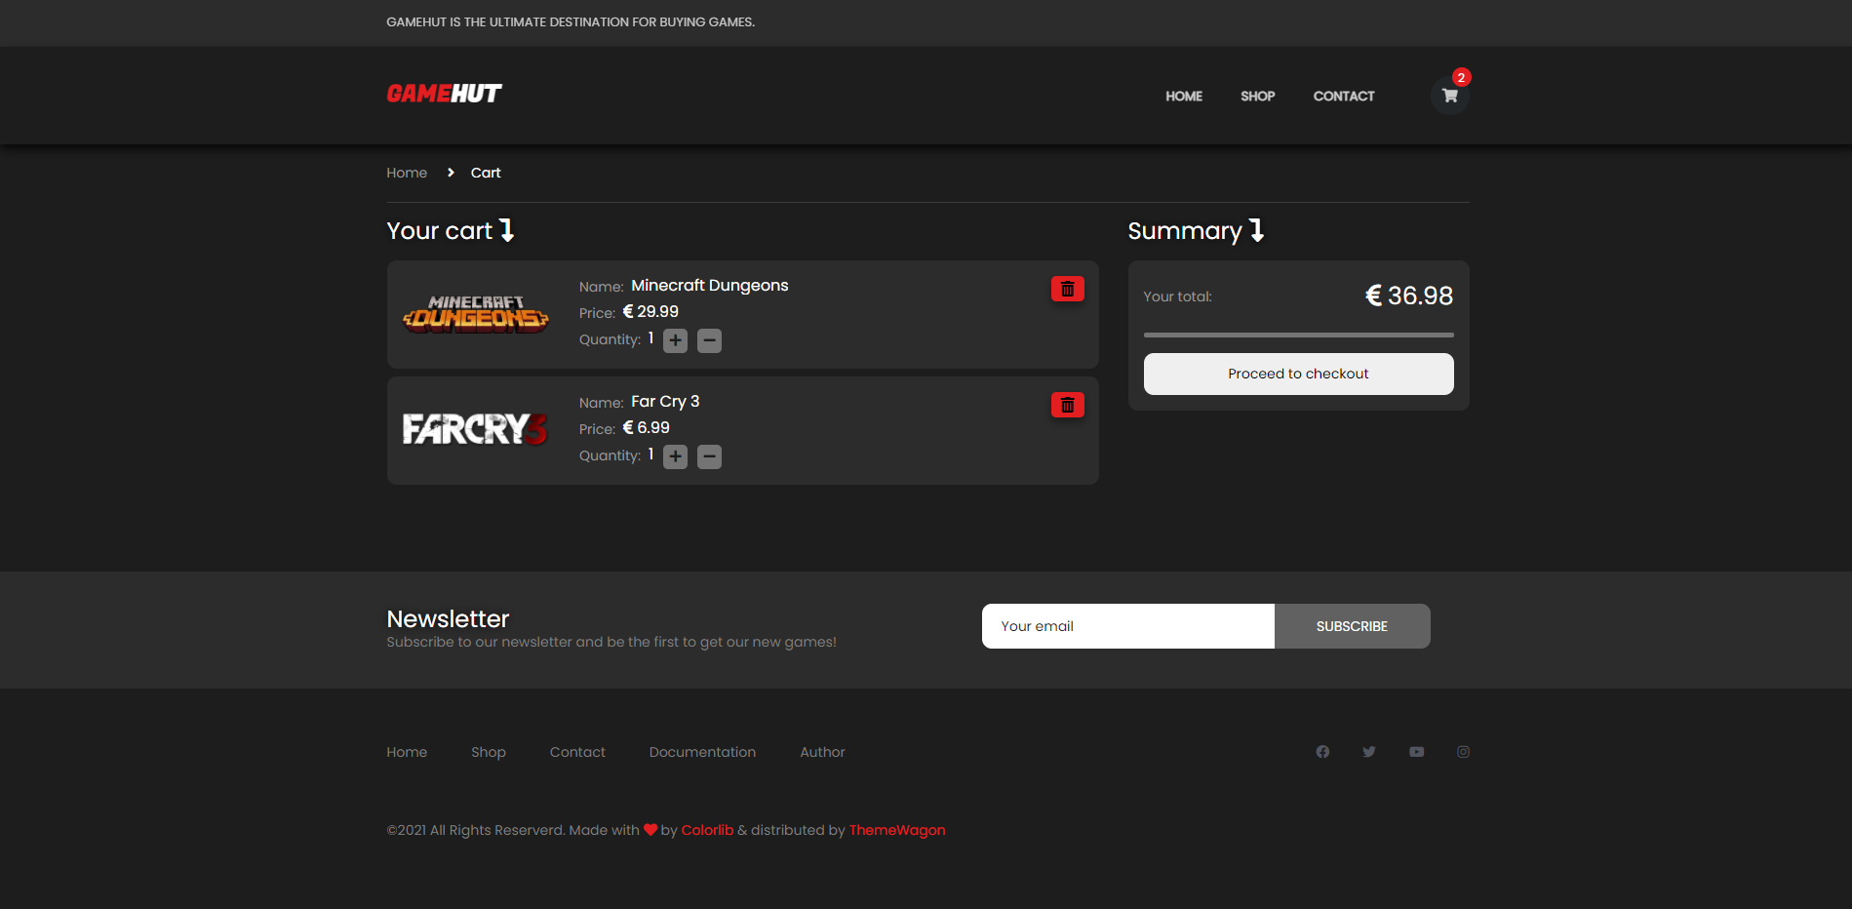

## author.html

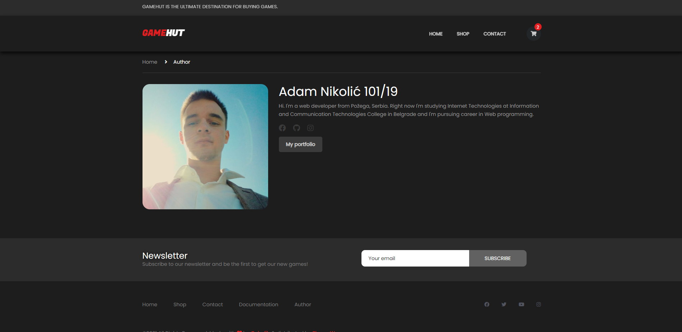

# Slike sekcija na stranicama i opisi funkcionalnosti

## navigacija

Glavna navigacija na velikim rezolucijama

* Navigacija se dinamički ispisuje dohvatanjem podataka iz JSON fajla (navigation.json)
* Ispisuje se na svakoj stranici sajta
* Fiksno je pozicionirana na vrhu stranice
* Tekst iznad navigacije se uklanja ukoliko korisnik skroluje na dole
* Takođe se ispisuje u footer-u i na manjim rezolucijama u sidenav-u
* Na manjim rezolucijama se pojavljuje ’hamburger’ i klikom na njega, korisniku se prikazuje sidenav sa navigacijom
* 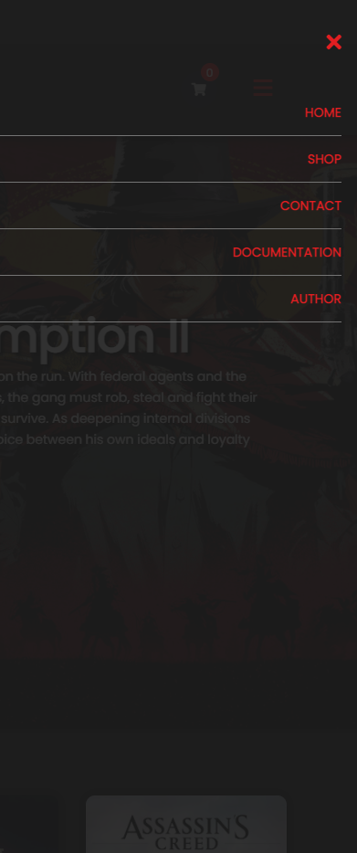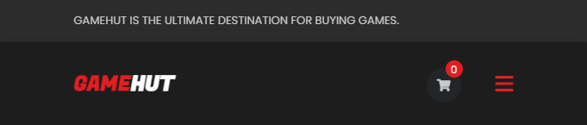Sidenav i footer sadrže dva dodatna linka ka dokumentaciji i autoru sajta

Ispis navigacije na manjim rezolucijama

Navigacija u footer-u

Hamburger na manjim rezolucijama

## Slajder

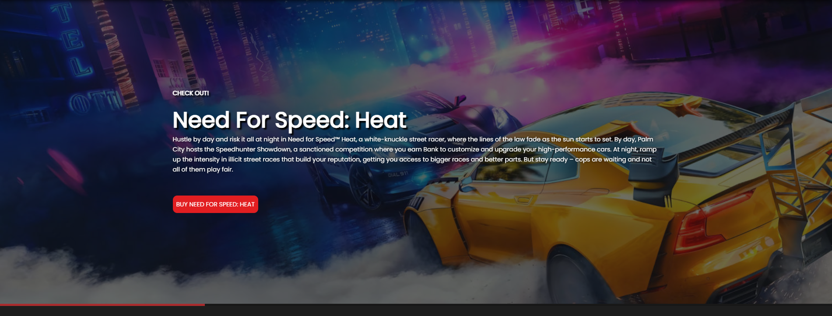

Slajder na početnoj stranici

* Slajder je inicijalizovan pomoću owl-carousel-a
* Korisniku je onemogućeno da skroluje levo-desno
* Slajder se dinamički učitava, prikazani podaci se dohvataju iz JSON fajla
* Slajder se na svakih 10 sekundi menja
* Odmah ispod slajdera se nalazi progress bar koji ukazuje korisniku koliko je preostalo vremena dok se slajder ne promeni
* Klikom na crveno dugme ’BUY ${naziv igrice}’, korisnik se usmerava na stranicu te igrice, pomoću Local Storage-a gde se prosleđuje ’id’ te igrice

## New releases

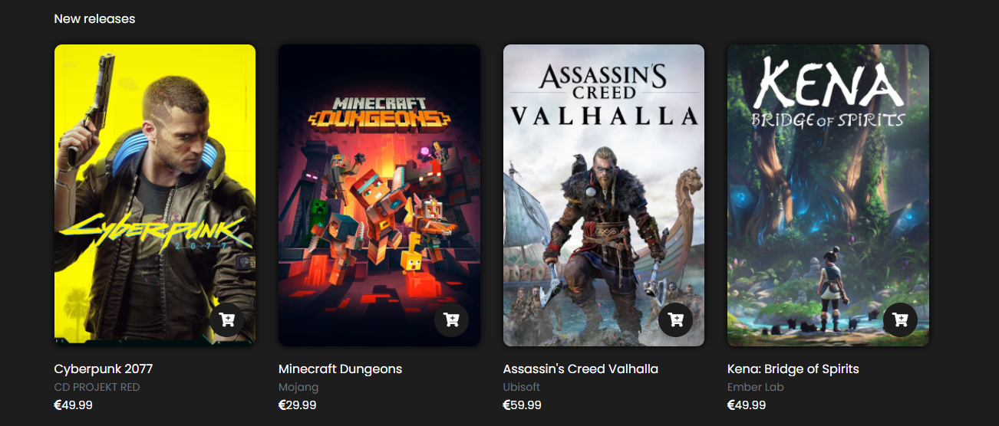

Prikaz igrica koje su skoro izasle

* Inicijalni prikaz sekcije ’New releases’ koja sadrži dinamičko ispisane igrice pomoću AJAX-a iz JSON fajla na osnovu toga da li su nove igrice

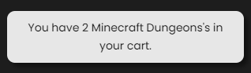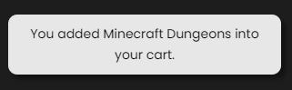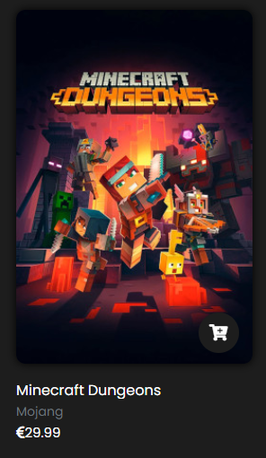Korisnik klikom na igricu se preusmerava na stranicu koja sadrži sve podatke o toj igrici(single.html). Prelaskom mišem preko ikonice sa korpom, prikazuje se tooltip sa porukom ’Add to cart’. Klikom na dugme sa ikonicom korpe, korisnik unosi u korpu tu igricu, unose se pomoću Local Storage-a. Ukoliko pre toga nije dodata u korpu, ispisuje mu se poruka je dodata u korpu, a ukoliko već postoji u korpi, ispisaće mu se poruka sa količinom te iste igrice u korpi, količina se povećava svakim klikom na dugme.

Poruka nakon drugog unosa u korpu

Poruka nakon prvog unosa u korpu

Prikaz jedne igrice

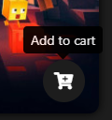

Prelazak mišem

## Hot sales

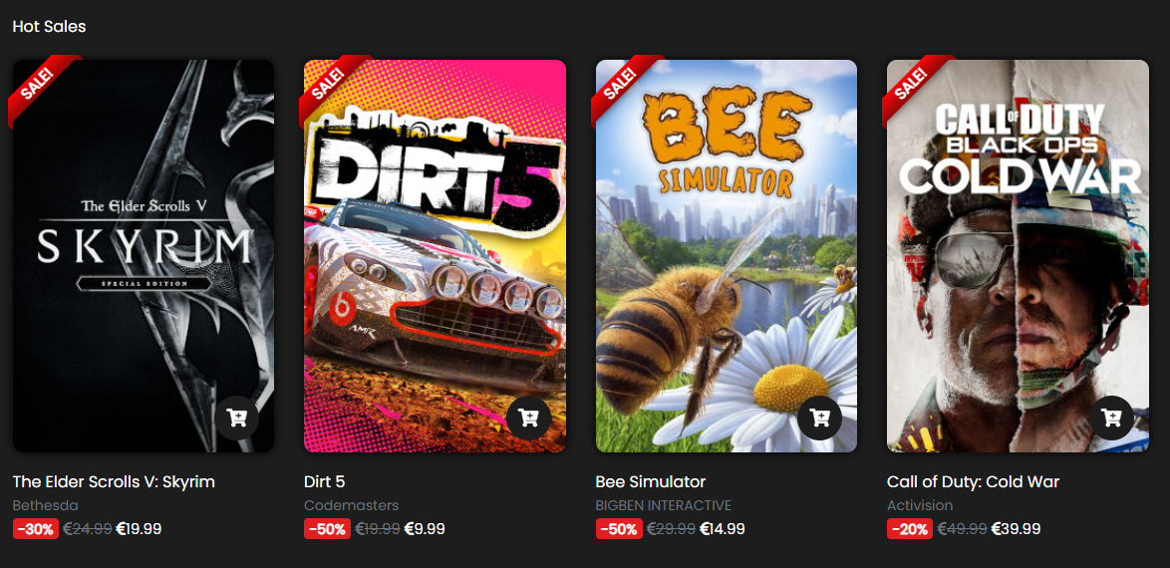

Prikaz 4 igrice koje su na popustu

* Inicijalni prikaz sekcije ’Hot Sales’ koja sadrži dinamičko ispisane igrice pomoću AJAX-a iz JSON fajla na osnovu toga da li su na popustu
* Ove igrice sadrže ribbon sa oznakom da su na popustu, koliki je popust i prethodnu cenu igrice

## Exclusive offer

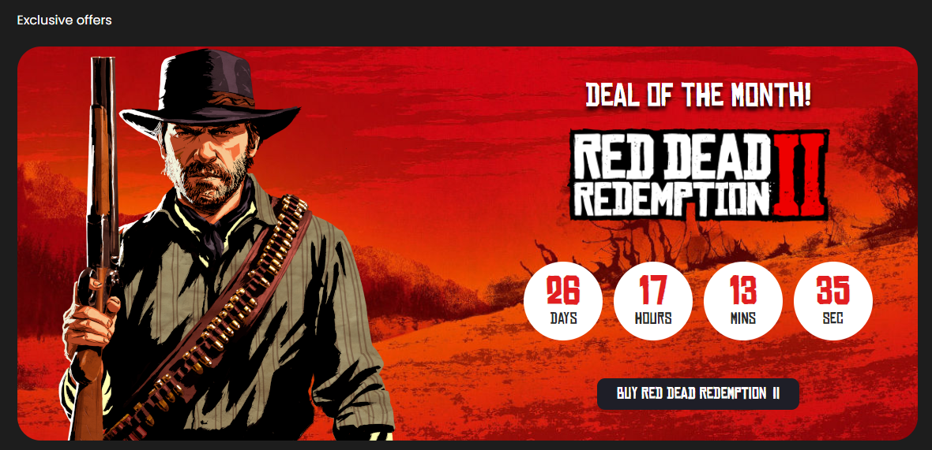

Sekcija sa prikazom istaknute igrice

* Ova sekcija sadrži tajmer do zadatog datuma, do kraja tekućeg meseca i ispisom logo-a istaknute igrice,nakon završetka tajmera se ispisuje poruka da će uskoro biti prikazana druga igrica, klikom na dugme ’BUY RED DEAD REDEMPTION II’ korisnik se usmerava na stranicu te igrice, nakon sto istekne ponuda, prikazace se poruka ’New offer coming soon’

## Best sellers

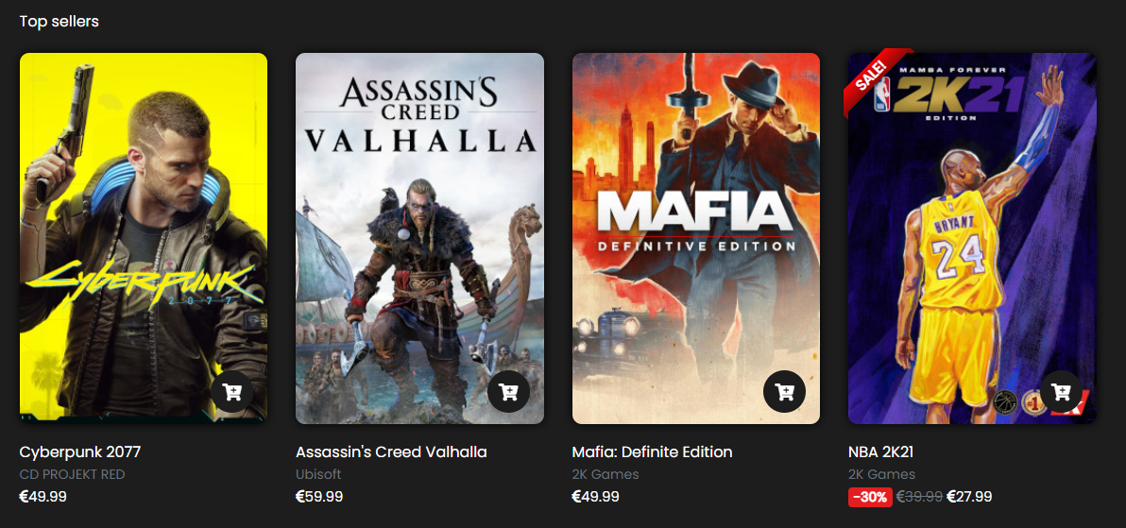

Prikaz 4 igrice koje su najprodavanije

* Inicijalni prikaz sekcije ’Best sellers’ koja sadrži dinamičko ispisane igrice pomoću AJAX-a iz JSON fajla na osnovu toga da li su najprodavanije

## Discover

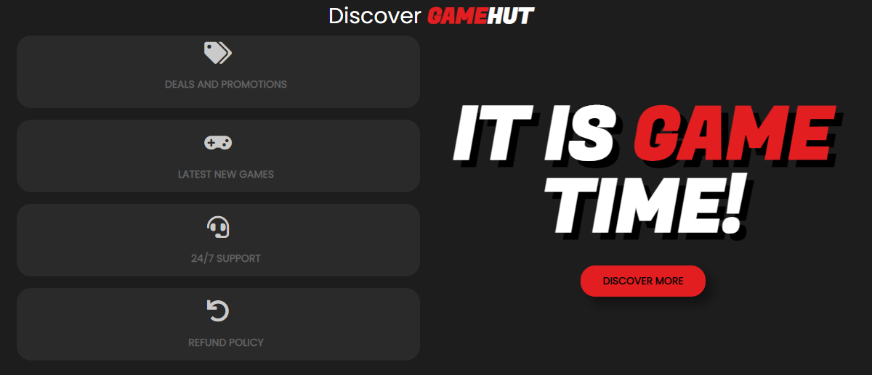

Sekcija o nekim informacijama

## Upcoming games

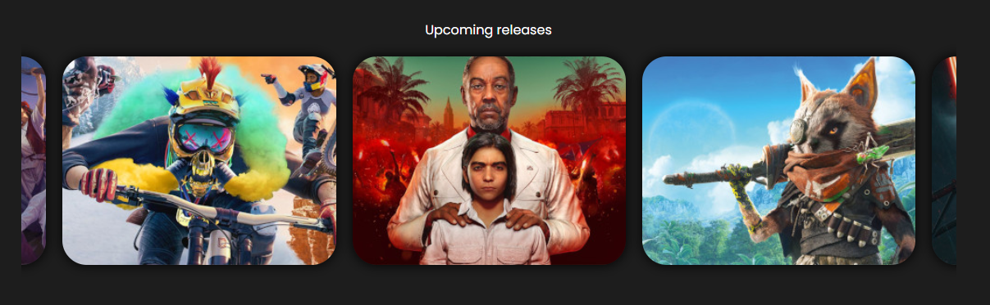

Sekcija sa igricama koje uskoro izlaze

* Igrice se dinamički ispisuju pomoću AJAX-a iz JSON fajla (comingSoon.json)
* Slajder se takodje dinamički prikazuje(owl-carousel)
* Prelaskom mišem preko bloka sa igricom, prikazuje se logo te igrice i datum kada izlazi
* Ova sekcija se nalazi na početnoj stranici i u prodavnici (index.html & shop.html)

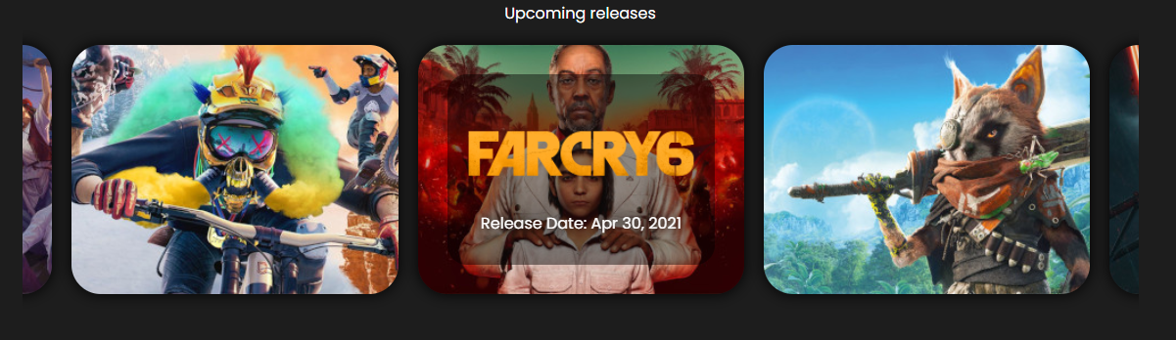

Prikaz prelaskom miša preko bloka sa igricom

## Newsletter



Newsletter forma

* Newsletter forma se sastoji od jednog tekstualnog polja namenjen za email i jednog dugmeta za slanje
* Provera vrednosti za uneto polje se proverava regularnim izrazom za email
* Ispisaće se greska ukoliko korisnik ne popuni ispravno email
* Ukoliko ispravno popuni polje, prikazaće mu se poruka da se uspešno prijavio za newsletter
* Ukoliko ponovo unese isti email, proverava se da li već postoji taj email u kolačićima, ako postoji onda mu se prikazuje poruka da je već prijavljen
* 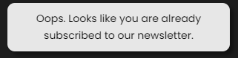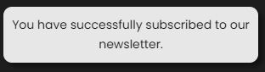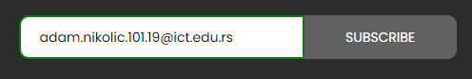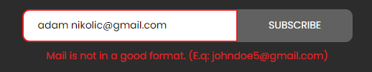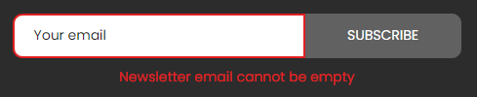Svaki uneti email se čuva posebno u kolačić za sebe i u trajanju je od 6 meseci

Ukoliko provera vrati da email već postoji u kolačićima

Ukoliko provera vrati da nema taj email u kolačićima

Ukoliko unese ispravno email

Ukoliko ne unese ispravno email

Ukoliko pokuša da pošalje, a da pre toga ništa nije uneto u polje

## Footer

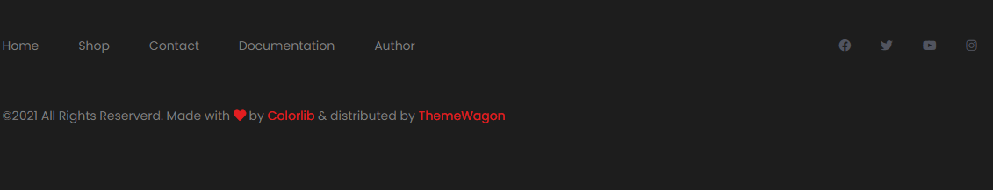

Footer

* Footer koji dinamički učitava linkove za navigaciju pomoću AJAX-a iz JSON fajla
* Footer se nalazi na svakoj stranici

## Prodavnica



Korisniku je omoguceno da pretrazuje igrice po unetom stringu, da menja broj prikazanih igrica po stranici, paginacija se ispisuje dinamicki na osnovu koliko ima igrica izabranih za odredjene filtere. Omoguceno je sortiranje po ceni opadajuce i rastuce, tako isto i po naslovu rastuce i opadajuce

U prodavnici sa leve strane se nalaze filteri:

-Za pretrazivanje po opsegu cene, inicijalno je postavljeno u rangu od 0 do najskuplje igrice

-Za pretrazivanje po kategorijama igrica

-Za pretrazivanje po vrstama igrica(single player ili multiplayer

-I jos jedna sekcija za pretrazivanje igrica koje su najnovije, najprodavanije i koje su na popustu

- Sa desne strane naziva svih dostupnih kategorija se nalazi broj igrica koje zadovoljavaju taj uslov

Sve kategorije se ispisuju dinamicki iz json fajla pomocu ajaxa

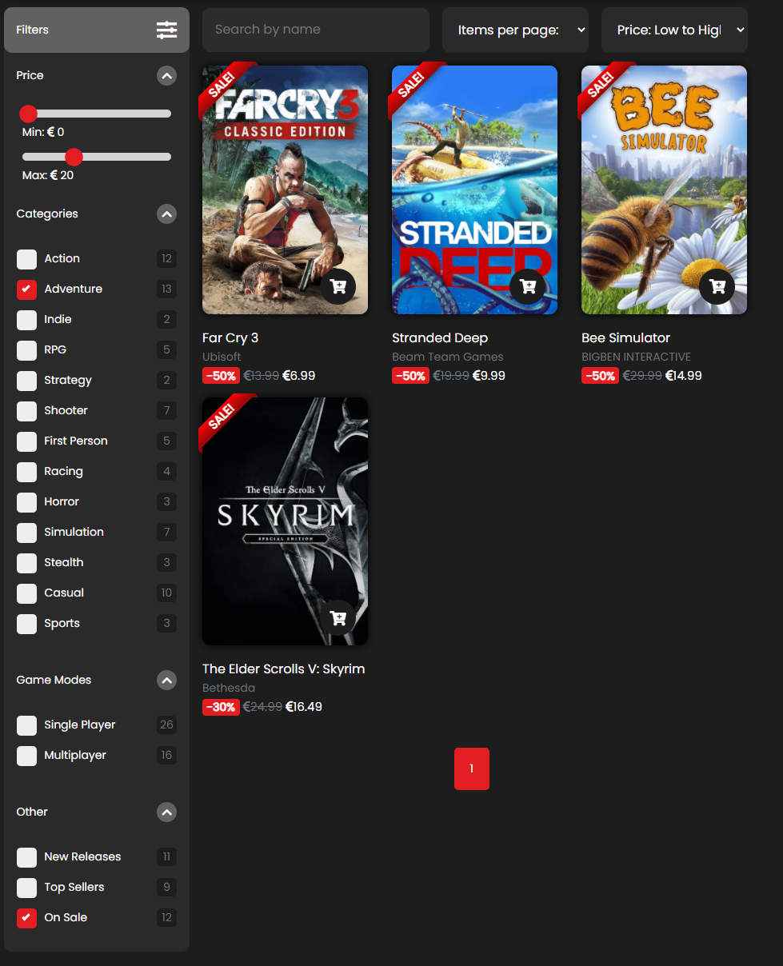

Prikaz igrica koje ispunjavaju izabrane filtere koje su sortirane po ceni rastuce

## Kontakt forma

Ispisivanje gresaka ukoliko podaci nisu ispravno uneti

Korisniku je omoguceno da posalje jednu poruku na svakih sat vremena, ukoliko pokusa da posalje dok taj vremenski period nije prosao, ispisace mu se modal sa dinamickom porukom da mora da saceka odredjeno vreme da bi ponovo mogao da posalje poruku. Realizovano je pomocu kolacica

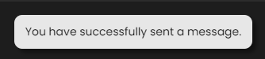

Ukoliko unese ispravno podatke

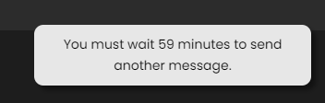

Poruka koja se ispisuje ukoliko korisnik ponovo pokusa da posalje poruku

## Stranica sa informacija odredjene igrice

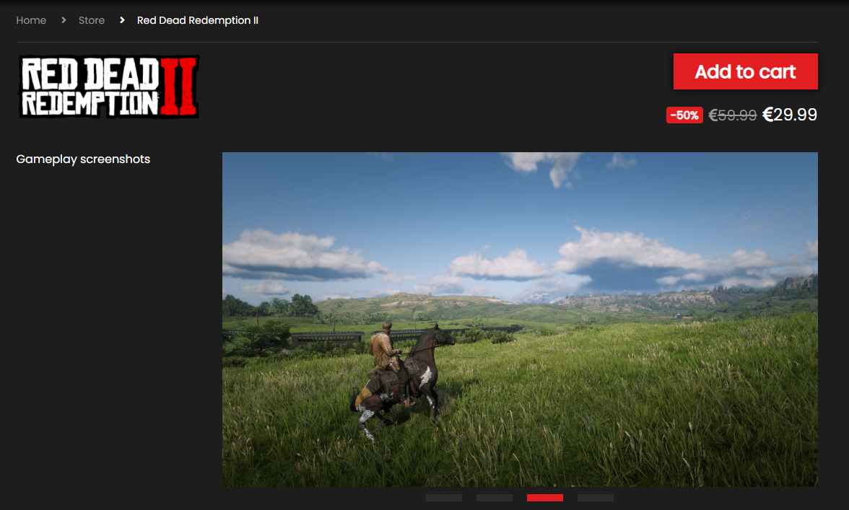

Svi podaci u zavisnosti na koju je korisnik kliknuo se ispisuju dinamicki. Podaci se preuzimaju na osnovu prosledjenog id-a igrice pomocu Local Storage-a.

Stranica sadrzi i dinamicki slajder koji prikazuje slike vezane za tu igricu

Klikom na dugme ’Add to cart’, korisniku se ispisuje dinamicki modal sa porukom da je uneo proizvod u korpu. Svaki naredni klik na to dugme se broji i tako prikazuje dinamicku poruku pomocu modala koliki je kvantitet te igrice u korpi

Cena se ispisuje dinamicki

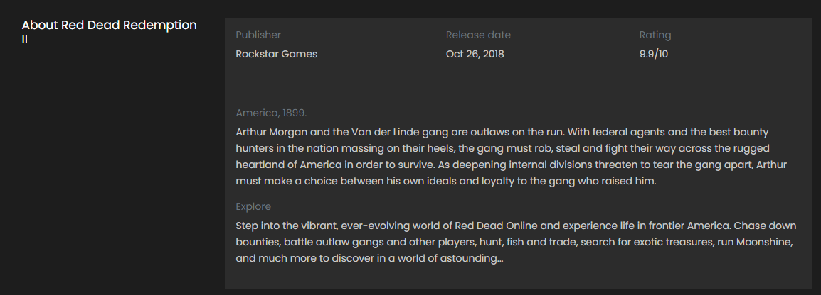

Takodje ispod se dinamicki ispisuje vise informacija o igrici, koja sadrze naziv kompanije koja je proizvela, datum kad je izasla i ocenu korisnika i opis igrice

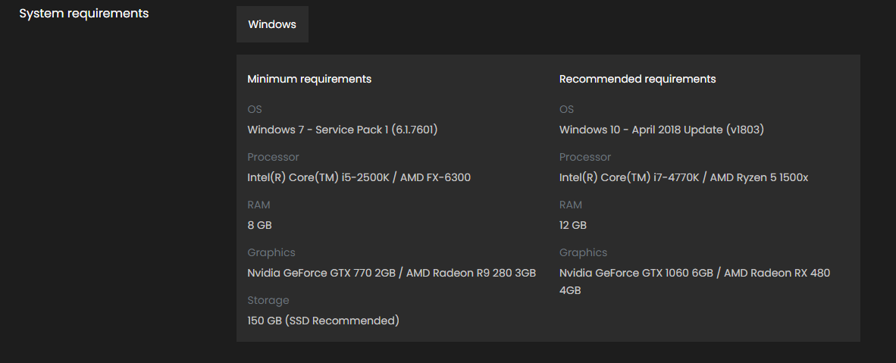

Ispod se dinamicki ispisuju minimalni i predlozeni sistemski zahtevi te igrice, svaka igrica ima razlicite zahteve ili neke navedene nema

## Korpa

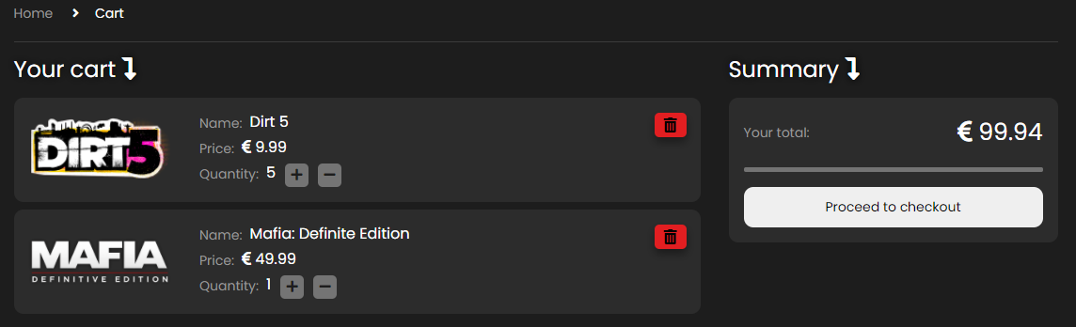

U korpi se dinamicki ispisuju sve igrice koje je korisnik dodao prethodno. Omoguceno je da klikom na ’+’ ili ’-’ menja kvantitet te igrice,

Cena se dinamicki ispisuje u zavisnosti koliko ima igrica u korpi

Klikom na logo ili na naslov, korisnik se salje ka stranici sa informacijama te igrice.

Klikom na crveno dugme sa ikonicom, korisnik brise igricu iz korpe

Ukoliko izbrise sve igrice iz korpe, prikazace se tekst da u korpi nema nijedan proizvod

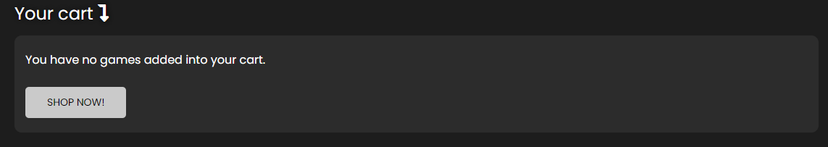

Sadrzaj prazne korpe

# Organizacija

## sitemap.xml

<?xml version="1.0" encoding="UTF-8"?>  
<urlset xmlns="http://www.sitemaps.org/schemas/sitemap/0.9">  
 <url>  
 <loc>https://adamnik101.github.io/gamehut/index.html</loc>  
 <lastmod>2021-03-05</lastmod>  
 <changefreq>daily</changefreq>  
 <priority>1</priority>  
 </url>  
 <url>  
 <loc>https://adamnik101.github.io/gamehut/shop.html</loc>  
 <lastmod>2021-03-05</lastmod>  
 <changefreq>daily</changefreq>  
 <priority>0.9</priority>  
 </url>  
 <url>  
 <loc>https://adamnik101.github.io/gamehut/contact.html</loc>  
 <lastmod>2021-03-05</lastmod>  
 <changefreq>monthly</changefreq>  
 <priority>0.6</priority>  
 </url>  
 <url>  
 <loc>https://adamnik101.github.io/gamehut/author.html</loc>  
 <lastmod>2021-03-05</lastmod>  
 <changefreq>monthly</changefreq>  
 <priority>0.4</priority>  
 </url>  
</urlset>

## robots.txt

User-agent: *  
Disallow: /js/data

## Organizaciona šema

# Kodovi

## index.html

<!DOCTYPE html>  
<html lang="en">  
<head>  
 <title>Game Hut - PC Games</title>  
 <meta charset="utf-8">  
 <meta http-equiv="X-UA-Compatible" content="IE=edge">  
 <meta name="description" content="Colo Shop Template">  
 <meta name="viewport" content="width=device-width, initial-scale=1">  
 <link rel="shortcut icon" href="images/favicon.png" type="image/x-icon">  
 <link rel="stylesheet" href="https://use.fontawesome.com/releases/v5.15.1/css/all.css" integrity="sha384-vp86vTRFVJgpjF9jiIGPEEqYqlDwgyBgEF109VFjmqGmIY/Y4HV4d3Gp2irVfcrp" crossorigin="anonymous">  
 <link rel="stylesheet" href="https://cdn.jsdelivr.net/npm/bootstrap@4.6.0/dist/css/bootstrap.min.css" integrity="sha384-B0vP5xmATw1+K9KRQjQERJvTumQW0nPEzvF6L/Z6nronJ3oUOFUFpCjEUQouq2+l" crossorigin="anonymous">  
 <link rel="stylesheet" type="text/css" href="owlcarousel/owl.carousel.min.css"/>  
 <link rel="stylesheet" type="text/css" href="styles/main_styles.css">  
 <link rel="stylesheet" type="text/css" href="styles/responsive.css">  
</head>  
  
<body>  
 <div class="loader-flex-fix">  
 <div class="loader-wrapper">  
 <div class="loader"></div>  
 </div>  
 </div>  
  
<div class="super_container">  
  
 <!-- Header -->  
  
 <header class="header trans_300">  
  
 <!-- Top Navigation -->  
  
 <div class="top_nav">  
 <div class="container">  
 <div class="row">  
 <div class="col-md-6">  
 <div class="top_nav_left">Gamehut is the ultimate destination for buying games.</div>  
 </div>  
 <div class="col-md-6 text-right">  
   
 </div>  
 </div>  
 </div>  
 </div>  
  
 <!-- Main Navigation -->  
  
 <div class="main_nav_container">  
 <div class="container">  
 <div class="row">  
 <div class="col-lg-12 text-right">  
 <div class="logo_container">  
 <a href="index.html">game<span>hut</span></a>  
 </div>  
 <nav class="navbar">  
 <ul class="navbar_menu">  
  
 </ul>  
 <ul class="navbar_user">  
   
 <li class="checkout">  
 <a href="cart.html">  
 <i class="fa fa-shopping-cart" aria-hidden="true"></i>  
 <span id="checkout_items" class="checkout_items"></span>  
 </a>  
 </li>  
 </ul>  
 <div class="hamburger_container">  
 <i class="fa fa-bars" aria-hidden="true"></i>  
 </div>  
 </nav>  
 </div>  
 </div>  
 </div>  
 </div>  
  
 </header>  
  
 <div class="fs_menu_overlay"></div>  
 <div class="hamburger_menu">  
 <div class="hamburger_close"><i class="fa fa-times" aria-hidden="true"></i></div>  
 <div class="hamburger_menu_content text-right">  
 <ul class="menu_top_nav">  
  
 </ul>  
 </div>  
 </div>  
  
 <!-- Slider -->  
  
 <div class="main_slider">  
 <div id="transparent"></div>  
 <div id="slider">  
  
 </div>  
  
 <div class="progress">  
 <div id="progressBar"></div>  
 </div>  
 </div>  
  
  
 <div class="banner">  
 <div class="container">  
 <div class="row d-flex justify-content-between flex-column" id="new">  
 <div class="col-12 pl-0 pb-3"><h5>New releases</h5></div>  
 <div class="col-12 p-0">  
 <div id="newReleases">  
  
 </div>  
 </div>  
   
 </div>  
 </div>  
 </div>  
 <div class="banner">  
 <div class="container">  
 <div class="row d-flex justify-content-between flex-column">  
 <div class="col-12 pl-0 pb-3">  
 <h5>Hot Sales</h5>  
 </div>  
 <div class="col-12 p-0">  
 <div id="hotSales"></div>  
 </div>  
   
 </div>  
 </div>  
 </div>  
 <div class="new_arrivals mt-4 pl-3 pr-3">  
 <div class="container">  
 <div class="row">  
 <div class="col-12 pl-0 pb-3">  
 <h5>Exclusive offers </h5>  
 </div>  
 </div>  
 <div class="row align-items-center" id="box">  
 <div class="deal_ofthe_week">  
 <div class="row">  
 <div class="col-lg-6">  
 <div class="deal_ofthe_week_img">  
 <img src="images/deal_week_guy.png" class="img-fluid" alt="guy1880">  
 </div>  
 </div>  
 <div class="col-lg-6 text-right deal_ofthe_week_col">  
 <div class="deal_ofthe_week_content d-flex flex-column align-items-center justify-content-center">  
 <div class="section_title d-flex flex-column align-items-center">  
 <h2 class="mb-3">Deal of the month!</h2>  
 <img src="images/rdr2_logo.png" alt="logo">  
 </div>  
 <ul class="timer mt-5">  
 <li class="d-inline-flex flex-column justify-content-center align-items-center">  
 <div id="day" class="timer_num"></div>  
 <div class="timer_unit">Days</div>  
 </li>  
 <li class="d-inline-flex flex-column justify-content-center align-items-center">  
 <div id="hour" class="timer_num"></div>  
 <div class="timer_unit">Hours</div>  
 </li>  
 <li class="d-inline-flex flex-column justify-content-center align-items-center">  
 <div id="minute" class="timer_num"></div>  
 <div class="timer_unit">Mins</div>  
 </li>  
 <li class="d-inline-flex flex-column justify-content-center align-items-center">  
 <div id="second" class="timer_num"></div>  
 <div class="timer_unit">Sec</div>  
 </li>  
 </ul>  
 <a href="shop.html" class="mt-5"><div class="red_button deal_ofthe_week_button d-flex justify-content-center align-items-center flex-row">Buy Red Dead Redemption <span class="pl-2">II</span> </div></a>  
 </div>  
 </div>  
 </div>  
 </div>  
 </div>  
 </div>  
 </div>  
 <div class="banner">  
 <div class="container">  
 <div class="row d-flex justify-content-between flex-column">  
 <div class="col-12 pl-0 pb-3">  
 <h5>Top sellers</h5>  
 </div>  
 <div class="col-12 p-0">  
 <div id="topSellers"></div>  
 </div>  
   
 </div>  
 </div>  
 </div>  
 <div class="benefit">  
 <div class="container p-3 p-sm-0">  
 <div class="row">  
 <div class="col">  
 <h1 class="text-center colorH1Span">Discover <span class="text-uppercase font-weight-bold">game</span><span class="text-uppercase font-weight-bold">Hut</span></h1>  
 </div>  
 </div>  
 <div class="row row-cols-2">  
 <div class="col-12 col-md-6">  
 <div class="row row-cols-1">  
 <div class="col benefit_col mb-3">  
 <div class="benefit-clip"></div>  
 <div class="benefit_item d-flex flex-column align-items-center justify-content-center">  
 <div class="benefit_icon pb-3"><i class="fas fa-tags"></i></div>  
 <div class="benefit_content">  
 <h6>Deals and promotions</h6>  
 <p></p>  
 </div>  
 </div>  
 </div>  
 <div class="col benefit_col mb-3">  
 <div class="benefit-clip"></div>  
 <div class="benefit_item d-flex flex-column align-items-center justify-content-center">  
 <div class="benefit_icon pb-3"><i class="fas fa-gamepad"></i></div>  
 <div class="benefit_content">  
 <h6>Latest new games</h6>  
 </div>  
 </div>  
 </div>  
 <div class="col benefit_col mb-3">  
 <div class="benefit-clip"></div>  
 <div class="benefit_item d-flex flex-column align-items-center justify-content-center">  
 <div class="benefit_icon pb-3"><i class="fas fa-headset"></i></div>  
 <div class="benefit_content">  
 <h6>24/7 support</h6>  
 </div>  
 </div>  
 </div>  
 <div class="col benefit_col">  
 <div class="benefit-clip"></div>  
 <div class="benefit_item d-flex flex-column align-items-center justify-content-center">  
 <div class="benefit_icon pb-3"><i class="fas fa-undo"></i></div>  
 <div class="benefit_content">  
 <h6>Refund policy</h6>  
 </div>  
 </div>  
 </div>  
 </div>  
 </div>  
 <div class="col-12 col-md-6 discover d-flex justify-content-center align-items-center flex-column-reverse">  
 <button type="button" id="btnDiscover">DISCOVER MORE</button>  
 <h1 class="game mt-5 mt-md-0">IT IS <span>GAME</span><span></span> TIME!</h1>  
 </div>  
   
 </div>  
 </div>  
 </div>  
  
 <!-- Upcoming -->  
  
 <div class="upcoming">  
 <div class="container">  
 <div class="row">  
 <div class="col text-center">  
 <div class="section_title">  
 <h5>Upcoming releases</h5>  
 </div>  
 </div>  
 </div>  
 <div class="row coming-soon">  
 </div>  
 </div>  
 </div>  
  
 <!-- Newsletter -->  
  
 <div class="newsletter">  
 <div class="container">  
 <div class="row">  
 <div class="col-lg-6">  
 <div class="newsletter_text d-flex flex-column justify-content-center align-items-lg-start align-items-md-center text-center text-lg-left">  
 <h4>Newsletter</h4>  
 <p>Subscribe to our newsletter and be the first to get our new games!</p>  
 </div>  
 </div>  
 <div class="col-lg-6 d-flex justify-content-center align-items-center">  
 <form method="POST" id="newsletter_form" class="d-flex justify-content-center align-items-center flex-column">  
 <div class="newsletter_form d-flex flex-md-row flex-column flex-xs-column align-items-center justify-content-lg-end justify-content-center">  
 <input id="newsletter_email" type="email" placeholder="Your email">  
 <input id="newsletter_submit" type="submit" class="newsletter_submit_btn trans_300" value="Subscribe">  
 </div>  
 <span class="err newsletterErr text-center pb-2 pb-lg-0 pt-lg-2 pt-0"></span>  
 </form>  
 </div>  
 </div>  
 </div>  
 </div>  
  
 <!-- Footer -->  
  
 <footer class="footer">  
 <div class="container">  
 <div class="row">  
 <div class="col-lg-7">  
 <div class="footer_nav_container d-flex flex-sm-row flex-column align-items-center justify-content-lg-start justify-content-center text-center">  
 <ul class="footer_nav">  
  
 </ul>  
 </div>  
 </div>  
 <div class="col-lg-5">  
 <div class="footer_social d-flex flex-row align-items-center justify-content-lg-end justify-content-center">  
 <ul>  
 <li><a href="https://www.facebook.com"><i class="fab fa-facebook"></i></a></li>  
 <li><a href="https://www.twitter.com"><i class="fab fa-twitter"></i></a></li>  
 <li><a href="https://www.youtube.com"><i class="fab fa-youtube"></i></a></li>  
 <li><a href="https://www.instagram.com"><i class="fab fa-instagram"></i></a></li>  
 </ul>  
 </div>  
 </div>  
 </div>  
 <div class="row">  
 <div class="col-lg-12">  
 <div class="footer_nav_container">  
 <div class="cr">&copy;2021 All Rights Reserverd. Made with <i class="fas fa-heart"></i> by <a href="#">Colorlib</a> &amp; distributed by <a href="https://themewagon.com">ThemeWagon</a></div>  
 </div>  
 </div>  
 </div>  
 </div>  
 </footer>  
 <div id="cookie-wrapper">  
 <div id="cookie-notice" class="p-2 d-flex justify-content-around align-items-center flex-column flex-lg-row">  
 <p class="text-center m-0 mb-3 mb-lg-0">We use cookies to provide you with a better experience. By continuing to use our site you accept our <a href="#!">cookie policy.</a></p>  
 <button type="button" id="cookie-accept">I understand</button>  
 </div>  
 </div>  
</div>  
  
<script src="https://code.jquery.com/jquery-3.5.1.min.js" integrity="sha256-9/aliU8dGd2tb6OSsuzixeV4y/faTqgFtohetphbbj0=" crossorigin="anonymous"></script>  
<script src="https://cdn.jsdelivr.net/npm/bootstrap@4.6.0/dist/js/bootstrap.bundle.min.js" integrity="sha384-Piv4xVNRyMGpqkS2by6br4gNJ7DXjqk09RmUpJ8jgGtD7zP9yug3goQfGII0yAns" crossorigin="anonymous"></script>  
<script type="text/javascript" src="owlcarousel/owl.carousel.min.js"></script>  
<script src="js/custom.js"></script>  
</body>  
  
</html>

## shop.html

<!DOCTYPE html>  
<html lang="en">  
<head>  
<title>Game Hut - Store</title>  
<meta charset="utf-8">  
<meta http-equiv="X-UA-Compatible" content="IE=edge">  
<meta name="description" content="Colo Shop Template">  
<meta name="viewport" content="width=device-width, initial-scale=1">  
<link rel="shortcut icon" href="images/favicon.png" type="image/x-icon">  
<link rel="stylesheet" href="https://cdn.jsdelivr.net/npm/bootstrap@4.6.0/dist/css/bootstrap.min.css" integrity="sha384-B0vP5xmATw1+K9KRQjQERJvTumQW0nPEzvF6L/Z6nronJ3oUOFUFpCjEUQouq2+l" crossorigin="anonymous">  
<link rel="stylesheet" href="https://use.fontawesome.com/releases/v5.15.1/css/all.css" integrity="sha384-vp86vTRFVJgpjF9jiIGPEEqYqlDwgyBgEF109VFjmqGmIY/Y4HV4d3Gp2irVfcrp" crossorigin="anonymous">  
<link rel="stylesheet" type="text/css" href="owlcarousel/owl.carousel.min.css"/>  
<link rel="stylesheet" type="text/css" href="styles/main_styles.css">  
<link rel="stylesheet" type="text/css" href="styles/responsive.css">  
</head>  
  
<body>  
<div class="loader-flex-fix">  
 <div class="loader-wrapper">  
 <div class="loader"></div>  
 </div>  
</div>  
<div class="super_container">  
  
 <!-- Header -->  
  
 <header class="header trans_300">  
  
 <!-- Top Navigation -->  
  
 <div class="top_nav">  
 <div class="container">  
 <div class="row">  
 <div class="col-md-6">  
 <div class="top_nav_left">Gamehut is the ultimate destination for buying games.</div>  
 </div>  
 <div class="col-md-6 text-right">  
 <div class="top_nav_right">  
 <ul class="top_nav_menu">  
  
   
 </ul>  
 </div>  
 </div>  
 </div>  
 </div>  
 </div>  
  
 <!-- Main Navigation -->  
  
 <div class="main_nav_container">  
 <div class="container">  
 <div class="row">  
 <div class="col-lg-12 text-right">  
 <div class="logo_container">  
 <a href="#">game<span>hut</span></a>  
 </div>  
 <nav class="navbar">  
 <ul class="navbar_menu">  
  
 </ul>  
 <ul class="navbar_user">  
 <li class="checkout">  
 <a href="cart.html">  
 <i class="fa fa-shopping-cart" aria-hidden="true"></i>  
 <span id="checkout_items" class="checkout_items"></span>  
 </a>  
 </li>  
 </ul>  
 <div class="hamburger_container">  
 <i class="fa fa-bars" aria-hidden="true"></i>  
 </div>  
 </nav>  
 </div>  
 </div>  
 </div>  
 </div>  
  
 </header>  
  
 <div class="fs_menu_overlay"></div>  
  
 <!-- Hamburger Menu -->  
  
 <div class="hamburger_menu">  
 <div class="hamburger_close"><i class="fa fa-times" aria-hidden="true"></i></div>  
 <div class="hamburger_menu_content text-right">  
 <ul class="menu_top_nav">  
  
 </ul>  
 </div>  
 </div>  
  
 <div class="container breadcrumbs_container">  
 <div class="row">  
 <div class="col">  
 <!-- Breadcrumbs -->  
 <div class="breadcrumbs d-flex flex-row align-items-center">  
 <ul>  
 <li><a href="index.html">Home</a></li>  
 <li class="active"><a href="shop.html"><i class="fa fa-angle-right" aria-hidden="true"></i>Store</a></li>  
 </ul>  
 </div>  
  
 </div>  
 </div>  
 </div>  
 <div class="container">  
 <div class="row m-0">  
 <div class="col-12" id="store-banner">  
 <img src="images/store_banner.png" class="img-fluid" alt="guy_with_hat_tipping">  
 <div>  
 <h1>Browse our store!</h1>  
 <h4>Check out our new releases and best deals!</h4>  
 </div>  
 </div>  
 </div>  
 </div>  
 <div class="container">  
 <div class="row m-0">  
 <div class="col-12 col-lg-3 p-0 mt-0 mt-lg-3" id="filter-wrapper">  
 <div id="filter">  
 <span id="filterBg" class="d-flex justify-content-between align-items-center p-3">  
 <span>Filters</span>  
 <i class="fas fa-sliders-h"></i>  
 </span>   
 <div id="price-container" class="d-block">  
 <span class="d-flex justify-content-between align-items-center p-3 hoverFilter" id="priceToggle">  
 <span>Price</span>  
 <span class="circ d-flex justify-content-center align-items-center"><i class="fas fa-chevron-up"></i></span>  
 </span>  
 <div class="pt-2" id="priceRange">  
 <div class="slidecontainer mx-auto">  
 <form action="" method="GET">  
 <input type="range" min="0" max="60" value="0" class="slider" id="priceFrom">  
 <label for="priceFrom" id="labelMin">Min: <i class="fas fa-euro-sign"></i> <output id="from">0</output></label>  
 <input type="range" min="0" max="60" value="60" class="slider" id="priceTo">  
 <label for="priceTo" id="labelMax">Max: <i class="fas fa-euro-sign"></i> <output id="to">60</output></label>  
 </form>  
 </div>  
 </div>  
   
 </div>  
 <div id="categories-container" class="d-block">  
 <span id="filterCat" class="d-flex justify-content-between align-items-center p-3 hoverFilter">  
 <span>Categories</span>  
 <span class="circ d-flex justify-content-center align-items-center"><i class="fas fa-chevron-up"></i></span>  
 </span>  
 <ul class="whiteChb" id="categoryChb">  
   
 </ul>  
 </div>  
 <div id="more-filters-container" class="d-block">  
 <span id="more-filters" class="d-flex justify-content-between align-items-center p-3 hoverFilter">  
 <span>Game Modes</span>  
 <span class="circ d-flex justify-content-center align-items-center"><i class="fas fa-chevron-up"></i></span>  
 </span>  
 <ul id="mode" class="whiteChb">  
   
 </ul>  
 </div>  
 <div id="other-filter-container" class="d-block">  
 <span id="filter-other" class="d-flex justify-content-between align-items-center p-3 hoverFilter">  
 <span>Other</span>  
 <span class="circ d-flex justify-content-center align-items-center"><i class="fas fa-chevron-up"></i></span>  
 </span>  
 <ul class="whiteChb" id="otherFilter">  
   
 </ul>  
 </div>  
 </div>  
   
 </div>  
 <div class="col-12 pr-0 pl-0 pl-lg-3 col-lg-9">  
 <div id="sortBy" class="row m-0 d-flex justify-content-lg-between justify-content-between align-items-center pt-md-3 pb-3">  
 <div class="col-12 col-lg-5 p-0 mb-3 mt-3 mb-lg-0 mt-lg-0 col">  
 <input type="text" name="search" id="search" placeholder="Search by name" class="p-3">  
 </div>  
 <div class="col-12 col-md p-0 mb-3 mb-md-0 px-lg-3 px-0">  
 <select id="numberOfProducts" name="numberOfProducts" class="p-3 w-100 form-control">  
 <option value="9">Items per page: 9</option>  
 <option value="6">Items per page: 6</option>  
 <option value="12">Items per page: 12</option>  
 </select>  
 </div>  
 <div class="col-12 col-md p-0 mb-3 mb-md-0 px-md-3 px-lg-0 ">  
 <div id="sortBtn-wrapper">  
 <select name="sorting" id="sort" class="p-3 w-100 form-control">  
 <option value="0">Sort by:</option>  
 <option value="nameASC">Name: A-Z</option>  
 <option value="nameDESC">Name: Z-A</option>  
 <option value="priceDESC">Price: High to Low</option>  
 <option value="priceASC">Price: Low to High</option>  
 </select>  
 </div>  
 </div>  
 <div id="filter-small" class="col d-lg-none d-block p-0"></div>  
  
  
  
 </div>  
 <div id="products"></div>  
 <div class="col-12 d-flex justify-content-center align-items-center p-4" id="pag">  
   
 </div>  
 </div>  
   
  
 </div>  
   
 </div>  
 <div class="upcoming">  
 <div class="container">  
 <div class="row">  
 <div class="col text-center">  
 <div class="section_title">  
 <h5>Upcoming releases</h5>  
 </div>  
 </div>  
 </div>  
 <div class="row coming-soon">  
 </div>  
 </div>  
 </div>  
 <!-- Newsletter -->  
  
 <div class="newsletter">  
 <div class="container">  
 <div class="row">  
 <div class="col-lg-6">  
 <div class="newsletter_text d-flex flex-column justify-content-center align-items-lg-start align-items-md-center text-center text-lg-left">  
 <h4>Newsletter</h4>  
 <p>Subscribe to our newsletter and get 20% off your first purchase</p>  
 </div>  
 </div>  
 <div class="col-lg-6 d-flex justify-content-center align-items-center">  
 <form id="newsletter_form" class="d-flex justify-content-center align-items-center flex-column">  
 <div class="newsletter_form d-flex flex-md-row flex-column flex-xs-column align-items-center justify-content-lg-end justify-content-center">  
 <input id="newsletter_email" type="email" placeholder="Your email">  
 <input id="newsletter_submit" type="submit" class="newsletter_submit_btn trans_300" value="Subscribe">  
 </div>  
 <span class="err newsletterErr text-center pb-2 pb-lg-0 pt-lg-2 pt-0"></span>  
 </form>  
 </div>  
 </div>  
 </div>  
 </div>  
  
 <!-- Footer -->  
  
 <footer class="footer">  
 <div class="container">  
 <div class="row">  
 <div class="col-lg-7">  
 <div class="footer_nav_container d-flex flex-sm-row flex-column align-items-center justify-content-lg-start justify-content-center text-center text-lg-left">  
 <ul class="footer_nav">  
  
 </ul>  
 </div>  
 </div>  
 <div class="col-lg-5">  
 <div class="footer_social d-flex flex-row align-items-center justify-content-lg-end justify-content-center">  
 <ul>  
 <li><a href="https://www.facebook.com"><i class="fab fa-facebook"></i></a></li>  
 <li><a href="https://www.twitter.com"><i class="fab fa-twitter"></i></a></li>  
 <li><a href="https://www.youtube.com"><i class="fab fa-youtube"></i></a></li>  
 <li><a href="https://www.instagram.com"><i class="fab fa-instagram"></i></a></li>  
 </ul>  
 </div>  
 </div>  
 </div>  
 <div class="row">  
 <div class="col-lg-12">  
 <div class="footer_nav_container">  
 <div class="cr">&copy;2021 All Rights Reserverd. Made with <i class="fas fa-heart"></i> by <a href="#">Colorlib</a> &amp; distributed by <a href="https://themewagon.com">ThemeWagon</a></div>  
 </div>  
 </div>  
 </div>  
 </div>  
 </footer>  
 <div id="cookie-wrapper">  
 <div id="cookie-notice" class="p-2 d-flex justify-content-around align-items-center flex-column flex-lg-row">  
 <p class="text-center m-0 mb-3 mb-lg-0">We use cookies to provide you with a better experience. By continuing to use our site you accept our <a href="#!">cookie policy.</a></p>  
 <button type="button" id="cookie-accept">I understand</button>  
 </div>  
 </div>  
</div>  
  
  
  
  
  
<script src="https://code.jquery.com/jquery-3.5.1.min.js" integrity="sha256-9/aliU8dGd2tb6OSsuzixeV4y/faTqgFtohetphbbj0=" crossorigin="anonymous"></script>  
<script src="https://cdn.jsdelivr.net/npm/bootstrap@4.6.0/dist/js/bootstrap.bundle.min.js" integrity="sha384-Piv4xVNRyMGpqkS2by6br4gNJ7DXjqk09RmUpJ8jgGtD7zP9yug3goQfGII0yAns" crossorigin="anonymous"></script>  
<script type="text/javascript" src="owlcarousel/owl.carousel.min.js"></script>  
<script src="js/custom.js"></script>  
</body>  
  
</html>

## contact.html

<!DOCTYPE html>  
<html lang="en">  
<head>  
<title>Game Hut - Contact Us</title>  
<meta charset="utf-8">  
<meta http-equiv="X-UA-Compatible" content="IE=edge">  
<meta name="description" content="Colo Shop Template">  
<meta name="viewport" content="width=device-width, initial-scale=1">  
<link rel="shortcut icon" href="images/favicon.png" type="image/x-icon">  
<link rel="stylesheet" href="https://cdn.jsdelivr.net/npm/bootstrap@4.6.0/dist/css/bootstrap.min.css" integrity="sha384-B0vP5xmATw1+K9KRQjQERJvTumQW0nPEzvF6L/Z6nronJ3oUOFUFpCjEUQouq2+l" crossorigin="anonymous">  
<link rel="stylesheet" href="https://use.fontawesome.com/releases/v5.15.1/css/all.css" integrity="sha384-vp86vTRFVJgpjF9jiIGPEEqYqlDwgyBgEF109VFjmqGmIY/Y4HV4d3Gp2irVfcrp" crossorigin="anonymous">  
<link rel="stylesheet" type="text/css" href="styles/main_styles.css">  
<link rel="stylesheet" type="text/css" href="styles/responsive.css">  
</head>  
  
<body>  
<div class="loader-flex-fix">  
 <div class="loader-wrapper">  
 <div class="loader"></div>  
 </div>  
</div>  
<div class="super_container">  
  
 <!-- Header -->  
  
 <header class="header trans_300">  
  
 <!-- Top Navigation -->  
  
 <div class="top_nav">  
 <div class="container">  
 <div class="row">  
 <div class="col">  
 <div class="top_nav_left">Gamehut is the ultimate destination for buying games.</div>  
 </div>  
 </div>  
 </div>  
 </div>  
  
 <!-- Main Navigation -->  
  
 <div class="main_nav_container">  
 <div class="container">  
 <div class="row">  
 <div class="col-lg-12 text-right">  
 <div class="logo_container">  
 <a href="#">game<span>hut</span></a>  
 </div>  
 <nav class="navbar">  
 <ul class="navbar_menu">  
  
 </ul>  
 <ul class="navbar_user">  
 <li class="checkout">  
 <a href="cart.html">  
 <i class="fa fa-shopping-cart" aria-hidden="true"></i>  
 <span id="checkout_items" class="checkout_items"></span>  
 </a>  
 </li>  
 </ul>  
 <div class="hamburger_container">  
 <i class="fa fa-bars" aria-hidden="true"></i>  
 </div>  
 </nav>  
 </div>  
 </div>  
 </div>  
 </div>  
  
 </header>  
  
 <div class="fs_menu_overlay"></div>  
  
 <!-- Hamburger Menu -->  
  
 <div class="hamburger_menu">  
 <div class="hamburger_close"><i class="fa fa-times" aria-hidden="true"></i></div>  
 <div class="hamburger_menu_content text-right">  
 <ul class="menu_top_nav">  
  
 </ul>  
 </div>  
 </div>  
  
 <div class="container contact_container">  
 <div class="row">  
 <div class="col">  
  
 <!-- Breadcrumbs -->  
 <div class="breadcrumbs d-flex flex-row align-items-center">  
 <ul>  
 <li><a href="index.html">Home</a></li>  
 <li class="active"><a href="contact.html"><i class="fa fa-angle-right" aria-hidden="true"></i>Contact</a></li>  
 </ul>  
 </div>  
  
 </div>  
 </div>  
 <!-- Contact Us -->  
 <div class="row">  
 <div class="col-lg-6 contact_col">  
 <div class="contact_contents">  
 <h1>Contact Us</h1>  
 <p>There are many ways to contact us. You may drop us a line, give us a call or send an email, choose what suits you the most.</p>  
 <div>  
 <p>(800) 686-6688</p>  
 <p>gamehut@gmail.com</p>  
 </div>  
 <div>  
 <p>24/7 Available support</p>  
 </div>  
 </div>  
  
 <!-- Follow Us -->  
  
 <div class="follow_us_contents">  
 <h1>Follow Us</h1>  
 <ul class="social d-flex flex-row">  
 <li><a href="https://www.facebook.com" style="background-color: #3a61c9"><i class="fab fa-facebook"></i></a></li>  
 <li><a href="https://www.twitter.com" style="background-color: #41a1f6"><i class="fab fa-twitter"></i></a></li>  
 <li><a href="https://www.youtube.com" style="background-color: #ff0000"><i class="fab fa-youtube"></i></a></li>  
 <li><a href="https://www.instagram.com" style="background-color: #E1306C"><i class="fab fa-instagram"></i></a></li>  
 </ul>  
 </div>  
  
 </div>  
  
 <div class="col-lg-6 get_in_touch_col">  
 <div class="get_in_touch_contents">  
 <h1>Get In Touch With Us!</h1>  
 <p>Fill out the form below to contact us.</p>  
 <form method="POST" id="contact">  
 <input id="input_name" class="form_input input_name input_ph my-1" type="text" name="name" placeholder="Full Name">  
 <span class="err name"></span>  
 <input id="input_email" class="form_input input_email input_ph my-1" type="email" name="email" placeholder="Email">  
 <span class="err mail"></span>  
 <input id="input_subject" class="form_input input_subject input_ph my-1" type="text" name="name" placeholder="Subject">  
 <span class="err subject"></span>  
 <textarea id="input_message" class="input_ph input_message" name="message" placeholder="Enter message" rows="3"></textarea>  
 <span class="err message"></span>  
 <div>  
 <input id="review_submit" type="submit" class="red_button message_submit_btn trans_300" value="send message">  
 </div>  
 </form>  
 </div>  
 </div>  
  
 </div>  
 </div>  
  
 <!-- Newsletter -->  
  
 <div class="newsletter">  
 <div class="container">  
 <div class="row">  
 <div class="col-lg-6">  
 <div class="newsletter_text d-flex flex-column justify-content-center align-items-lg-start align-items-md-center text-center text-lg-left">  
 <h4>Newsletter</h4>  
 <p>Subscribe to our newsletter and be the first to get our new games!</p>  
 </div>  
 </div>  
 <div class="col-lg-6 d-flex justify-content-center align-items-center">  
 <form id="newsletter_form" class="d-flex justify-content-center align-items-center flex-column">  
 <div class="newsletter_form d-flex flex-md-row flex-column flex-xs-column align-items-center justify-content-lg-end justify-content-center">  
 <input id="newsletter_email" type="email" placeholder="Your email">  
 <input id="newsletter_submit" type="submit" class="newsletter_submit_btn trans_300" value="Subscribe">  
 </div>  
 <span class="err newsletterErr text-center pb-2 pb-lg-0 pt-lg-2 pt-0"></span>  
 </form>  
 </div>  
 </div>  
 </div>  
 </div>  
  
 <!-- Footer -->  
  
 <footer class="footer">  
 <div class="container">  
 <div class="row">  
 <div class="col-lg-7">  
 <div class="footer_nav_container d-flex flex-sm-row flex-column align-items-center justify-content-lg-start justify-content-center text-center text-lg-left">  
 <ul class="footer_nav">  
  
 </ul>  
 </div>  
 </div>  
 <div class="col-lg-5">  
 <div class="footer_social d-flex flex-row align-items-center justify-content-lg-end justify-content-center">  
 <ul>  
 <li><a href="https://www.facebook.com"><i class="fab fa-facebook"></i></a></li>  
 <li><a href="https://www.twitter.com"><i class="fab fa-twitter"></i></a></li>  
 <li><a href="https://www.youtube.com"><i class="fab fa-youtube"></i></a></li>  
 <li><a href="https://www.instagram.com"><i class="fab fa-instagram"></i></a></li>  
 </ul>  
 </div>  
 </div>  
 </div>  
 <div class="row">  
 <div class="col-lg-12">  
 <div class="footer_nav_container">  
 <div class="cr">&copy;2021 All Rights Reserverd. Made with <i class="fas fa-heart"></i> by <a href="#">Colorlib</a> &amp; distributed by <a href="https://themewagon.com">ThemeWagon</a></div>  
 </div>  
 </div>  
 </div>  
 </div>  
 </footer>  
 <div id="cookie-wrapper">  
 <div id="cookie-notice" class="p-2 d-flex justify-content-around align-items-center flex-column flex-lg-row">  
 <p class="text-center m-0 mb-3 mb-lg-0">We use cookies to provide you with a better experience. By continuing to use our site you accept our <a href="#!">cookie policy.</a></p>  
 <button type="button" id="cookie-accept">I understand</button>  
 </div>  
 </div>  
</div>  
  
<script src="https://code.jquery.com/jquery-3.5.1.min.js" integrity="sha256-9/aliU8dGd2tb6OSsuzixeV4y/faTqgFtohetphbbj0=" crossorigin="anonymous"></script>  
<script src="https://cdn.jsdelivr.net/npm/bootstrap@4.6.0/dist/js/bootstrap.bundle.min.js" integrity="sha384-Piv4xVNRyMGpqkS2by6br4gNJ7DXjqk09RmUpJ8jgGtD7zP9yug3goQfGII0yAns" crossorigin="anonymous"></script>  
<script src="js/custom.js"></script>  
</body>  
  
</html>

## single.html

<!DOCTYPE html>  
<html lang="en">  
<head>  
<title></title> <!-- Dinamicki se ispisuje -->  
<meta charset="utf-8">  
<meta http-equiv="X-UA-Compatible" content="IE=edge">  
<meta name="description" content="Colo Shop Template">  
<meta name="viewport" content="width=device-width, initial-scale=1">  
<link rel="shortcut icon" href="images/favicon.png" type="image/x-icon">  
<link rel="stylesheet" href="https://use.fontawesome.com/releases/v5.15.1/css/all.css" integrity="sha384-vp86vTRFVJgpjF9jiIGPEEqYqlDwgyBgEF109VFjmqGmIY/Y4HV4d3Gp2irVfcrp" crossorigin="anonymous">  
<link rel="stylesheet" href="https://cdn.jsdelivr.net/npm/bootstrap@4.6.0/dist/css/bootstrap.min.css" integrity="sha384-B0vP5xmATw1+K9KRQjQERJvTumQW0nPEzvF6L/Z6nronJ3oUOFUFpCjEUQouq2+l" crossorigin="anonymous">  
<link rel="stylesheet" type="text/css" href="styles/main_styles.css">  
<link rel="stylesheet" type="text/css" href="styles/responsive.css">  
<link rel="stylesheet" type="text/css" href="owlcarousel/owl.carousel.min.css"/>  
</head>  
  
<body>  
<div class="loader-flex-fix">  
 <div class="loader-wrapper">  
 <div class="loader"></div>  
 </div>  
</div>  
<div class="super_container">  
  
 <!-- Header -->  
 <header class="header trans_300">  
  
 <!-- Top Navigation -->  
 <div class="top_nav">  
 <div class="container">  
 <div class="row">  
 <div class="col-md-6">  
 <div class="top_nav_left">Gamehut is the ultimate destination for buying games.</div>  
 </div>  
 </div>  
 </div>  
 </div>  
  
 <!-- Main Navigation -->  
  
 <div class="main_nav_container">  
 <div class="container">  
 <div class="row">  
 <div class="col-lg-12 text-right">  
 <div class="logo_container">  
 <a href="#">Game<span>hut</span></a>  
 </div>  
 <nav class="navbar">  
 <ul class="navbar_menu">  
 <li><a href="index.html">home</a></li>  
 <li><a href="shop.html">store</a></li>  
 <li><a href="contact.html">contact</a></li>  
 </ul>  
 <ul class="navbar_user">  
 <li class="checkout">  
 <a href="cart.html">  
 <i class="fa fa-shopping-cart" aria-hidden="true"></i>  
 <span id="checkout_items" class="checkout_items"></span>  
 </a>  
 </li>  
 </ul>  
 <div class="hamburger_container">  
 <i class="fa fa-bars" aria-hidden="true"></i>  
 </div>  
 </nav>  
 </div>  
 </div>  
 </div>  
 </div>  
  
 </header>  
  
 <div class="fs_menu_overlay"></div>  
  
 <!-- Hamburger Menu -->  
  
 <div class="hamburger_menu">  
 <div class="hamburger_close"><i class="fa fa-times" aria-hidden="true"></i></div>  
 <div class="hamburger_menu_content text-right">  
 <ul class="menu_top_nav">  
  
 </ul>  
 </div>  
 </div>  
   
 <div class="container breadcrumbs_container">  
 <div class="row">  
 <div class="col">  
 <!-- Breadcrumbs -->  
 <div class="breadcrumbs d-flex flex-row align-items-center">  
 <ul>  
 <li><a href="index.html">Home</a></li>  
 <li><a href="shop.html"><i class="fa fa-angle-right" aria-hidden="true"></i>Store</a></li>  
 <li class="active"><a href="#" id="name"><i class="fa fa-angle-right" aria-hidden="true"></i></a></li>  
 </ul>  
 </div>  
  
 </div>  
 </div>  
 </div>  
 <div class="container mb-3">  
 <div class="row" id="logo-game-container">  
 </div>  
 </div>  
 <!-- SCREENSHOTS SECTION -->  
 <div class="container">  
 <div class="row">  
 <div class="col-12 col-md-4 col-lg-3">  
 <h5>Gameplay screenshots</h5>  
 </div>  
 <div class="col-12 col-md-8 col-lg-9 mb-3" id="slika">  
   
 </div>  
 </div>  
 </div>  
 <!-- ABOUT GAME -->  
 <div class="container">  
 <div class="row">  
 <div class="col-12 col-md-4 col-lg-3">  
 <h1 id="gameName">About </h1>  
 </div>  
 <div class="col-12 col-md-8 col-lg-9 mb-3">  
 <ul class="d-flex flex-wrap flex-column p-3" id="about">  
   
 </ul>  
 <div id="infoText" class="p-3">   
 </div>  
 </div>  
 </div>  
 </div>  
 <!-- SYSTEM REQUIREMENTS -->  
 <div class="container">  
 <div class="row" id="sysReq">  
 <div class="col-12 col-md-4 col-lg-3 text-light">  
 <h5>System requirements</h5>  
 </div>  
 <div class="col-12 col-md-8 col-lg-9">  
 <div class="row px-3" >  
 <div class="col-12 m-0 p-0">  
 <h6 class="p-3 mb-3 borderBot d-inline-block reqOutput">Windows</h6>  
 </div>  
 <div class="col-12 col-sm pt-4 reqOutput">  
 <h6 class="mb-4">Minimum requirements</h6>  
 <ul id="minimum">  
   
 </ul>  
 </div>  
 <div class="col-12 col-sm pt-4 reqOutput">  
 <h6 class="mb-4">Recommended requirements</h6>  
 <ul id="recommended">  
   
 </ul>  
 </div>  
 </div>  
 </div>  
 </div>  
 </div>  
 <!-- Newsletter -->  
 <div class="newsletter">  
 <div class="container">  
 <div class="row">  
 <div class="col-lg-6">  
 <div class="newsletter_text d-flex flex-column justify-content-center align-items-lg-start align-items-md-center text-center text-lg-left">  
 <h4>Newsletter</h4>  
 <p>Subscribe to our newsletter and be the first to get our new games!</p>  
 </div>  
 </div>  
 <div class="col-lg-6 d-flex justify-content-center align-items-center">  
 <form id="newsletter_form" class="d-flex justify-content-center align-items-center flex-column">  
 <div class="newsletter_form d-flex flex-md-row flex-column flex-xs-column align-items-center justify-content-lg-end justify-content-center">  
 <input id="newsletter_email" type="email" placeholder="Your email">  
 <input id="newsletter_submit" type="submit" class="newsletter_submit_btn trans_300" value="Subscribe">  
 </div>  
 <span class="err newsletterErr text-center pb-2 pb-lg-0 pt-lg-2 pt-0"></span>  
 </form>  
 </div>  
 </div>  
 </div>  
 </div>  
  
 <!-- Footer -->  
  
 <footer class="footer">  
 <div class="container">  
 <div class="row">  
 <div class="col-lg-7">  
 <div class="footer_nav_container d-flex flex-sm-row flex-column align-items-center justify-content-lg-start justify-content-center text-center">  
 <ul class="footer_nav">  
  
 </ul>  
 </div>  
 </div>  
 <div class="col-lg-5">  
 <div class="footer_social d-flex flex-row align-items-center justify-content-lg-end justify-content-center">  
 <ul>  
 <li><a href="https://www.facebook.com"><i class="fab fa-facebook"></i></a></li>  
 <li><a href="https://www.twitter.com"><i class="fab fa-twitter"></i></a></li>  
 <li><a href="https://www.youtube.com"><i class="fab fa-youtube"></i></a></li>  
 <li><a href="https://www.instagram.com"><i class="fab fa-instagram"></i></a></li>  
 </ul>  
 </div>  
 </div>  
 </div>  
 <div class="row">  
 <div class="col-lg-12">  
 <div class="footer_nav_container">  
 <div class="cr">&copy;2021 All Rights Reserverd. Made with <i class="fas fa-heart"></i> by <a href="#">Colorlib</a> &amp; distributed by <a href="https://themewagon.com">ThemeWagon</a></div>  
 </div>  
 </div>  
 </div>  
 </div>  
 </footer>  
 <div id="cookie-wrapper">  
 <div id="cookie-notice" class="p-2 d-flex justify-content-around align-items-center flex-column flex-lg-row">  
 <p class="text-center m-0 mb-3 mb-lg-0">We use cookies to provide you with a better experience. By continuing to use our site you accept our <a href="#!">cookie policy.</a></p>  
 <button type="button" id="cookie-accept">I understand</button>  
 </div>  
 </div>  
</div>  
 <script src="https://code.jquery.com/jquery-3.5.1.min.js" integrity="sha256-9/aliU8dGd2tb6OSsuzixeV4y/faTqgFtohetphbbj0=" crossorigin="anonymous"></script>  
 <script src="https://cdn.jsdelivr.net/npm/bootstrap@4.6.0/dist/js/bootstrap.bundle.min.js" integrity="sha384-Piv4xVNRyMGpqkS2by6br4gNJ7DXjqk09RmUpJ8jgGtD7zP9yug3goQfGII0yAns" crossorigin="anonymous"></script>  
 <script type="text/javascript" src="owlcarousel/owl.carousel.min.js"></script>  
 <script src="js/custom.js"></script>  
  
</body>  
  
</html>

## author.html

<!DOCTYPE html>  
<html lang="en">  
<head>  
 <title>Game Hut - Author</title>  
 <meta charset="utf-8">  
 <meta http-equiv="X-UA-Compatible" content="IE=edge">  
 <meta name="description" content="Colo Shop Template">  
 <meta name="viewport" content="width=device-width, initial-scale=1">  
 <link rel="shortcut icon" href="images/favicon.png" type="image/x-icon">  
 <link rel="stylesheet" href="https://cdn.jsdelivr.net/npm/bootstrap@4.6.0/dist/css/bootstrap.min.css" integrity="sha384-B0vP5xmATw1+K9KRQjQERJvTumQW0nPEzvF6L/Z6nronJ3oUOFUFpCjEUQouq2+l" crossorigin="anonymous">  
 <link rel="stylesheet" href="https://use.fontawesome.com/releases/v5.15.1/css/all.css" integrity="sha384-vp86vTRFVJgpjF9jiIGPEEqYqlDwgyBgEF109VFjmqGmIY/Y4HV4d3Gp2irVfcrp" crossorigin="anonymous">  
 <link rel="stylesheet" type="text/css" href="styles/main_styles.css">  
 <link rel="stylesheet" type="text/css" href="styles/responsive.css">  
</head>  
  
<body>  
<div class="loader-flex-fix">  
 <div class="loader-wrapper">  
 <div class="loader"></div>  
 </div>  
</div>  
<div class="super_container">  
  
 <!-- Header -->  
  
 <header class="header trans_300">  
  
 <!-- Top Navigation -->  
  
 <div class="top_nav">  
 <div class="container">  
 <div class="row">  
 <div class="col">  
 <div class="top_nav_left">Gamehut is the ultimate destination for buying games.</div>  
 </div>  
 </div>  
 </div>  
 </div>  
  
 <!-- Main Navigation -->  
  
 <div class="main_nav_container">  
 <div class="container">  
 <div class="row">  
 <div class="col-lg-12 text-right">  
 <div class="logo_container">  
 <a href="#">game<span>hut</span></a>  
 </div>  
 <nav class="navbar">  
 <ul class="navbar_menu">  
  
 </ul>  
 <ul class="navbar_user">  
 <li class="checkout">  
 <a href="cart.html">  
 <i class="fa fa-shopping-cart" aria-hidden="true"></i>  
 <span id="checkout_items" class="checkout_items"></span>  
 </a>  
 </li>  
 </ul>  
 <div class="hamburger_container">  
 <i class="fa fa-bars" aria-hidden="true"></i>  
 </div>  
 </nav>  
 </div>  
 </div>  
 </div>  
 </div>  
  
 </header>  
  
 <div class="fs_menu_overlay"></div>  
  
 <!-- Hamburger Menu -->  
  
 <div class="hamburger_menu">  
 <div class="hamburger_close"><i class="fa fa-times" aria-hidden="true"></i></div>  
 <div class="hamburger_menu_content text-right">  
 <ul class="menu_top_nav">  
  
 </ul>  
 </div>  
 </div>  
  
 <div class="container contact_container">  
 <div class="row">  
 <div class="col">  
  
 <!-- Breadcrumbs -->  
 <div class="breadcrumbs d-flex flex-row align-items-center">  
 <ul>  
 <li><a href="index.html">Home</a></li>  
 <li class="active"><a href="author.html"><i class="fa fa-angle-right" aria-hidden="true"></i>Author</a></li>  
 </ul>  
 </div>  
  
 </div>  
 </div>  
 <!-- Contact Us -->  
 <div class="row my-3" id="autor">  
 <div class="col-9 col-md-4 mb-3 mb-md-0">  
 <img src="images/autor.jpg" alt="author" class="img-fluid"/>  
 </div>  
 <div class="col-12 col-md-8">  
 <h1>Adam Nikolić 101/19</h1>  
 <p>Hi. I'm a web developer from Požega, Serbia. Right now I'm studying Internet Technologies at Information and Communication Technologies College in Belgrade and I'm pursuing career in Web programming.</p>  
 <ul class="d-flex flex-row align-items-center justify-content-start">  
 <li><a href="https://www.facebook.com"><i class="fab fa-facebook"></i></a></li>  
 <li><a href="https://www.github.com/adamnik101"><i class="fab fa-github"></i></a></li>  
 <li><a href="https://www.instagram.com/adamnikk"><i class="fab fa-instagram"></i></a></li>  
 </ul>  
 <a href="https://adamnik101.github.io/adamportfolio/index.html" target="_blank"><button type="button">My portfolio</button> </a>  
 </div>  
  
 </div>  
 </div>  
  
 <!-- Newsletter -->  
  
 <div class="newsletter">  
 <div class="container">  
 <div class="row">  
 <div class="col-lg-6">  
 <div class="newsletter_text d-flex flex-column justify-content-center align-items-lg-start align-items-md-center text-center text-lg-left">  
 <h4>Newsletter</h4>  
 <p>Subscribe to our newsletter and be the first to get our new games!</p>  
 </div>  
 </div>  
 <div class="col-lg-6 d-flex justify-content-center align-items-center">  
 <form id="newsletter_form" class="d-flex justify-content-center align-items-center flex-column">  
 <div class="newsletter_form d-flex flex-md-row flex-column flex-xs-column align-items-center justify-content-lg-end justify-content-center">  
 <input id="newsletter_email" type="email" placeholder="Your email">  
 <input id="newsletter_submit" type="submit" class="newsletter_submit_btn trans_300" value="Subscribe">  
 </div>  
 <span class="err newsletterErr text-center pb-2 pb-lg-0 pt-lg-2 pt-0"></span>  
 </form>  
 </div>  
 </div>  
 </div>  
 </div>  
  
 <!-- Footer -->  
  
 <footer class="footer">  
 <div class="container">  
 <div class="row">  
 <div class="col-lg-7">  
 <div class="footer_nav_container d-flex flex-sm-row flex-column align-items-center justify-content-lg-start justify-content-center text-center text-lg-left">  
 <ul class="footer_nav">  
  
 </ul>  
 </div>  
 </div>  
 <div class="col-lg-5">  
 <div class="footer_social d-flex flex-row align-items-center justify-content-lg-end justify-content-center">  
 <ul>  
 <li><a href="https://www.facebook.com"><i class="fab fa-facebook"></i></a></li>  
 <li><a href="https://www.twitter.com"><i class="fab fa-twitter"></i></a></li>  
 <li><a href="https://www.youtube.com"><i class="fab fa-youtube"></i></a></li>  
 <li><a href="https://www.instagram.com"><i class="fab fa-instagram"></i></a></li>  
 </ul>  
 </div>  
 </div>  
 </div>  
 <div class="row">  
 <div class="col-lg-12">  
 <div class="footer_nav_container">  
 <div class="cr">&copy;2021 All Rights Reserverd. Made with <i class="fas fa-heart"></i> by <a href="#">Colorlib</a> &amp; distributed by <a href="https://themewagon.com">ThemeWagon</a></div>  
 </div>  
 </div>  
 </div>  
 </div>  
 </footer>  
 <div id="cookie-wrapper">  
 <div id="cookie-notice" class="p-2 d-flex justify-content-around align-items-center flex-column flex-lg-row">  
 <p class="text-center m-0 mb-3 mb-lg-0">We use cookies to provide you with a better experience. By continuing to use our site you accept our <a href="#!">cookie policy.</a></p>  
 <button type="button" id="cookie-accept">I understand</button>  
 </div>  
 </div>  
</div>  
  
<script src="https://code.jquery.com/jquery-3.5.1.min.js" integrity="sha256-9/aliU8dGd2tb6OSsuzixeV4y/faTqgFtohetphbbj0=" crossorigin="anonymous"></script>  
<script src="https://cdn.jsdelivr.net/npm/bootstrap@4.6.0/dist/js/bootstrap.bundle.min.js" integrity="sha384-Piv4xVNRyMGpqkS2by6br4gNJ7DXjqk09RmUpJ8jgGtD7zP9yug3goQfGII0yAns" crossorigin="anonymous"></script>  
<script src="js/custom.js"></script>  
</body>  
  
</html>

## main_styles.css

@charset "utf-8";  
/*region fontovi */  
@font-face{  
 font-family:ChineseRocks;  
 src: url('../font/ChineseRocks.ttf');  
}  
@font-face{  
 font-family: Poppins;  
 src: url('../font/Poppins-Regular.ttf');  
}  
@font-face{  
 font-family: Fugaz;  
 src: url('../font/FugazOne-Regular.ttf');  
}  
/*endregion*/  
/*region template global*/  
* {  
 margin: 0;  
 padding: 0;  
 -webkit-box-sizing: border-box;  
 -moz-box-sizing: border-box;  
 box-sizing: border-box;  
}  
body  
{  
 font-family: 'Poppins';  
 font-size: 14px;  
 line-height: 23px;  
 font-weight: 400;  
 background: #1d1d1d;  
}  
div  
{  
 display: block;  
 position: relative;  
}  
ul  
{  
 list-style: none;  
 margin-bottom: 0px;  
}  
p  
{  
 font-family: 'Poppins', sans-serif;  
 font-size: 14px;  
 line-height: 1.7;  
 font-weight: 500;  
 color: #989898;  
 -webkit-font-smoothing: antialiased;  
 -webkit-text-shadow: rgba(0,0,0,.01) 0 0 1px;  
 text-shadow: rgba(0,0,0,.01) 0 0 1px;  
}  
p a  
{  
 display: inline;  
 position: relative;  
 color: inherit;  
 border-bottom: solid 2px #fde0db;  
 -webkit-transition: all 200ms ease;  
 -moz-transition: all 200ms ease;  
 -ms-transition: all 200ms ease;  
 -o-transition: all 200ms ease;  
 transition: all 200ms ease;  
}  
a, a:hover, a:visited, a:active, a:link  
{  
 text-decoration: none;  
 -webkit-font-smoothing: antialiased;  
 -webkit-text-shadow: rgba(0,0,0,.01) 0 0 1px;  
 text-shadow: rgba(0,0,0,.01) 0 0 1px;  
}  
p a:active  
{  
 position: relative;  
 color: #e21e21;  
}  
p a:hover  
{  
 color: #e21e21;  
 background: #fde0db;  
}  
p a:hover::after  
{  
 opacity: 0.2;  
}  
::selection  
{  
 background: #2a2a2a;  
 color: #cacaca;  
}  
p::selection  
{  
 background: #2a2a2a;  
}  
h1{font-size: 72px;}  
h2{font-size: 40px;}  
h3{font-size: 28px;}  
h4{font-size: 24px;}  
h5{font-size: 16px;}  
h6{font-size: 14px;}  
h1, h2, h3, h4, h5  
{  
 color: #fff;  
 -webkit-font-smoothing: antialiased;  
 -webkit-text-shadow: rgba(0,0,0,.01) 0 0 1px;  
 text-shadow: rgba(0,0,0,.01) 0 0 1px;  
}  
/* h1::selection,  
h2::selection,  
h3::selection,  
h4::selection,  
h5::selection,  
h6::selection  
{  
  
} */  
::-webkit-input-placeholder  
{  
 font-size: 16px !important;  
 font-weight: 500;  
 color: #777777 !important;  
}  
:-moz-placeholder /* older Firefox*/  
{  
 font-size: 16px !important;  
 font-weight: 500;  
 color: #777777 !important;  
}  
::-moz-placeholder /* Firefox 19+ */  
{  
 font-size: 16px !important;  
 font-weight: 500;  
 color: #777777 !important;  
}  
:-ms-input-placeholder  
{  
 font-size: 16px !important;  
 font-weight: 500;  
 color: #777777 !important;  
}  
::input-placeholder  
{  
 font-size: 16px !important;  
 font-weight: 500;  
 color: #777777 !important;  
}  
section  
{  
 display: block;  
 position: relative;  
 box-sizing: border-box;  
}  
.clear  
{  
 clear: both;  
}  
.clearfix::before, .clearfix::after  
{  
 content: "";  
 display: table;  
}  
.clearfix::after  
{  
 clear: both;  
}  
.clearfix  
{  
 zoom: 1;  
}  
.float_left  
{  
 float: left;  
}  
.float_right  
{  
 float: right;  
}  
.trans_200  
{  
 -webkit-transition: all 200ms ease;  
 -moz-transition: all 200ms ease;  
 -ms-transition: all 200ms ease;  
 -o-transition: all 200ms ease;  
 transition: all 200ms ease;  
}  
.trans_300  
{  
 -webkit-transition: all 300ms ease;  
 -moz-transition: all 300ms ease;  
 -ms-transition: all 300ms ease;  
 -o-transition: all 300ms ease;  
 transition: all 300ms ease;  
}  
.trans_400  
{  
 -webkit-transition: all 400ms ease;  
 -moz-transition: all 400ms ease;  
 -ms-transition: all 400ms ease;  
 -o-transition: all 400ms ease;  
 transition: all 400ms ease;  
}  
.trans_500  
{  
 -webkit-transition: all 500ms ease;  
 -moz-transition: all 500ms ease;  
 -ms-transition: all 500ms ease;  
 -o-transition: all 500ms ease;  
 transition: all 500ms ease;  
}  
.fill_height  
{  
 height: 100%;  
}  
.super_container  
{  
 width: 100%;  
 overflow: hidden;  
}  
/*endregion*/  
/*region owl carousel navigation*/  
.owl-dots{  
 display: flex;  
 flex-direction: row;  
 justify-content: center;  
}  
.owl-dots .owl-dot{  
 width: 50px;  
 margin: 10px;  
 height: 10px;  
 border-radius: none;  
 transition: 0.2s;  
 background-color: #2c2c2c !important;  
}  
.owl-dots .owl-dot:focus{  
 outline: none;  
}  
.owl-dots .active{  
 transition: 0.2s;  
 background-color: #e21e21 !important;  
 }  
/*endregion*/  
/*region game name and description card*/  
#gameName{  
 font-size: 17px;  
}  
#about{  
 background-color: #2c2c2c;  
}  
#about h6{  
 color: #6c757d;  
}  
#about p{  
 color: #cacaca;  
}  
#about{  
 height: 110px;  
}  
#infoText{  
 background-color: #2c2c2c;  
}  
#infoText h6{  
 color: #6c757d;  
}  
#infoText p{  
 color: #cacaca;  
}  
/*endregion*/  
/*region header top nav*/  
.header  
{  
 position: fixed;  
 top: 0;  
 left: 0;  
 width: 100%;  
 background: #FFFFFF;  
 z-index: 10;  
}  
.top_nav  
{  
 width: 100%;  
 height: 50px;  
 background: #2c2c2c;  
}  
.top_nav_left  
{  
 height: 50px;  
 line-height: 50px;  
 font-size: 13px;  
 color: #cacaca;  
 text-transform: uppercase;  
}  
.main_nav_container  
{  
 width: 100%;  
 background: #1d1d1d;  
 box-shadow: 0 5px 10px 0px rgba(0, 0, 0, 0.794);  
}  
.navbar  
{  
 width: auto;  
 height: 100px;  
 float: right;  
 padding-left: 0px;  
 padding-right: 0px;  
}  
.navbar_menu li  
{  
 display: inline-block;  
}  
.navbar_menu li a  
{  
 display: block;  
 color: #cacaca;  
 font-size: 13px;  
 font-weight: 600;  
 text-transform: uppercase;  
 padding: 20px;  
 -webkit-transition: color 0.3s ease;  
 -moz-transition: color 0.3s ease;  
 -ms-transition: color 0.3s ease;  
 -o-transition: color 0.3s ease;  
 transition: color 0.3s ease;  
}  
.navbar_menu li a:hover  
{  
 color: #e21e21;  
}  
.navbar_user  
{  
 margin-left: 37px;  
}  
.navbar_user li  
{  
 display: inline-block;  
 text-align: center;  
}  
.navbar_user li a  
{  
 display: -webkit-box;  
 display: -moz-box;  
 display: -ms-flexbox;  
 display: -webkit-flex;  
 display: flex;  
 flex-direction: column;  
 justify-content: center;  
 align-items: center;  
 position: relative;  
 width: 40px;  
 height: 40px;  
 color: #cacaca;  
 -webkit-transition: color 0.3s ease;  
 -moz-transition: color 0.3s ease;  
 -ms-transition: color 0.3s ease;  
 -o-transition: color 0.3s ease;  
 transition: color 0.3s ease;  
}  
.navbar_user li a:hover  
{  
 color: #e21e21;  
}  
.checkout a  
{  
 background: #222629;  
 border-radius: 50%;  
}  
.checkout_items  
{  
 display: -webkit-box;  
 display: -moz-box;  
 display: -ms-flexbox;  
 display: -webkit-flex;  
 display: flex;  
 flex-direction: column;  
 justify-content: center;  
 align-items: center;  
 position: absolute;  
 top: -9px;  
 left: 22px;  
 width: 20px;  
 height: 20px;  
 border-radius: 50%;  
 background: #e21e21;  
 font-size: 12px;  
 color: #fff;  
}  
/*endregion*/  
/*region menu - hamburger*/  
.hamburger_container  
{  
 display: none;  
 margin-left: 40px;  
}  
.hamburger_container i  
{  
 font-size: 24px;  
 color: #e21e21;  
 -webkit-transition: all 300ms ease;  
 -moz-transition: all 300ms ease;  
 -ms-transition: all 300ms ease;  
 -o-transition: all 300ms ease;  
 transition: all 300ms ease;  
}  
.hamburger_container:hover i  
{  
 color: #fff;  
}  
.hamburger_menu  
{  
 position: fixed;  
 top: 0;  
 right: -400px;  
 width: 400px;  
 height: 100vh;  
 background: #1d1d1de8;  
 z-index: 10;  
 -webkit-transition: all 300ms ease;  
 -moz-transition: all 300ms ease;  
 -ms-transition: all 300ms ease;  
 -o-transition: all 300ms ease;  
 transition: all 300ms ease;  
}  
.hamburger_menu.active  
{  
 right: 0;  
}  
.fs_menu_overlay  
{  
 position: fixed;  
 top: 0;  
 left: 0;  
 width: 100vw;  
 height: 100vh;  
 z-index: 9;  
 background: rgba(255,255,255,0);  
 pointer-events: none;  
 -webkit-transition: all 200ms ease;  
 -moz-transition: all 200ms ease;  
 -ms-transition: all 200ms ease;  
 -o-transition: all 200ms ease;  
 transition: all 200ms ease;  
}  
.hamburger_close  
{  
 position: absolute;  
 top: 26px;  
 right: 10px;  
 padding: 10px;  
 z-index: 1;  
}  
.hamburger_close i  
{  
 font-size: 24px;  
 color: #e21e21;  
 -webkit-transition: all 300ms ease;  
 -moz-transition: all 300ms ease;  
 -ms-transition: all 300ms ease;  
 -o-transition: all 300ms ease;  
 transition: all 300ms ease;  
}  
.hamburger_close:hover i  
{  
 color: #fff;  
}  
.hamburger_menu_content  
{  
 padding-top: 100px;  
 width: 100%;  
 height: 100%;  
 padding-right: 20px;  
}  
.menu_item  
{  
 display: block;  
 position: relative;  
 border-bottom: solid 1px #747474;  
 /* vertical-align: middle; */  
}  
.menu_item > a  
{  
 display: block;  
 color: #e21e21;  
 font-weight: bold;  
 height: 50px;  
 line-height: 50px;  
 font-size: 14px;  
 text-transform: uppercase;  
}  
.menu_item > a:hover  
{  
 color: #fff;  
}  
.menu_item > a > i  
{  
 margin-left: 8px;  
}  
.menu_item.active .menu_selection  
{  
 display: block;  
 visibility: visible;  
 opacity: 1;  
}  
.menu_selection  
{  
 margin: 0;  
 width: 100%;  
 max-height: 0;  
 overflow: hidden;  
 z-index: 1;  
 -webkit-transition: all 0.3s ease;  
 -moz-transition: all 0.3s ease;  
 -ms-transition: all 0.3s ease;  
 -o-transition: all 0.3s ease;  
 transition: all 0.3s ease;  
}  
.menu_selection li  
{  
 padding-left: 10px;  
 padding-right: 10px;  
 line-height: 50px;  
}  
.menu_selection li a  
{  
 display: block;  
 color: #232530;  
 border-bottom: solid 1px #dddddd;  
 font-size: 13px;  
 text-transform: uppercase;  
 -webkit-transition: opacity 0.3s ease;  
 -moz-transition: opacity 0.3s ease;  
 -ms-transition: opacity 0.3s ease;  
 -o-transition: opacity 0.3s ease;  
 transition: all 0.3s ease;  
}  
.menu_selection li a:hover  
{  
 color: #e21e21;  
}  
.menu_selection li:last-child a  
{  
 border-bottom: none;  
}  
/*endregion*/  
/*region logo container*/  
.logo_container  
{  
 position: absolute;  
 top: 50%;  
 -webkit-transform: translateY(-50%);  
 -moz-transform: translateY(-50%);  
 -ms-transform: translateY(-50%);  
 -o-transform: translateY(-50%);  
 transform: translateY(-50%);  
 left: 15px;  
}  
.logo_container a  
{  
 font-size: 24px;  
 color: #e21e21;  
 font-weight: 700;  
 text-transform: uppercase;  
 font-family: 'Fugaz';  
}  
.logo_container a span  
{  
 color: #fff;  
}  
/*endregion*/  
/*region breadcrumbs */  
.breadcrumbs  
{  
 width: 100%;  
 height: 60px;  
 border-bottom: solid 1px #3b3b3b;  
 margin-bottom: 15px;  
}  
.breadcrumbs ul li  
{  
 display: inline-block;  
 margin-right: 17px;  
}  
.breadcrumbs ul li.active a  
{  
 color: #ffffff;  
}  
.breadcrumbs ul li i  
{  
 margin-right: 17px;  
}  
.breadcrumbs ul li a  
{  
 color: #989898;  
}  
  
.breadcrumbs_container, .contact_container  
{  
 margin-top: 150px;  
}  
/*endregion*/  
/*region main slider*/  
.main_slider  
{  
 width: 100%;  
 height: 700px;  
 margin-top: 150px;  
}  
 .main_slider #transparent{  
 position: absolute;  
 left: 0;  
 top: 0;  
 width: 100%;  
 height: 100%;  
 background: rgba(0, 0, 0, 0.5);  
 pointer-events: none;  
}  
.main_slider .owl-carousel{  
 height: 100%;  
 pointer-events: auto;  
}   
.main_slider .owl-carousel .sliderImage{  
 height: 700px;  
}   
.main_slider div .owl-carousel .sliderImage::after {  
 content: "";  
 background: var(--url);  
 opacity: 0.4;  
 top: 0;  
 left: 0;  
 bottom: 0;  
 right: 0;  
 position: absolute;  
 z-index: -1;   
 background-repeat: no-repeat;  
 background-size: cover;  
 background-position: center center;  
 }  
.main_slider .owl-carousel .main_slider_content  
{  
 width: 100%;  
}  
.main_slider .owl-carousel .main_slider_content h6  
{  
 font-weight: 600;  
 text-transform: uppercase;  
 margin-bottom: 29px;  
 color: #fff;  
 z-index: 999;  
 text-shadow: 4px 4px 3px #000, 0px 0px 10px rgba(0,0,0,0);  
}  
.main_slider .owl-carousel .main_slider_content h1  
{  
 font-weight: 600;  
 font-size: 50px;  
 line-height: 1;  
 color: #fff;  
 text-shadow: 4px 4px 3px #000, 0px 0px 10px rgba(0,0,0,0);  
}  
.main_slider .owl-carousel .main_slider_content p  
{  
 color: rgb(255, 255, 255);  
 text-shadow: 0px 0px 5px #000;  
}  
.main_slider .progress{  
 height: 5px;  
 width: 100%;  
 background-color: rgb(24, 24, 24);  
 border-radius: 0;  
}  
.main_slider .progress #progressBar{  
 background-color: #a82b2d;  
}  
.red_button  
{  
 display: -webkit-inline-box;  
 display: -moz-inline-box;  
 display: -ms-inline-flexbox;  
 display: -webkit-inline-flex;  
 display: inline-flex;  
 flex-direction: column;  
 justify-content: center;  
 align-items: center;  
 width: auto;  
 height: 40px;  
 background: #e21e21;  
 border-radius: 10px;  
 -webkit-transition: all 0.3s ease;  
 -moz-transition: all 0.3s ease;  
 -ms-transition: all 0.3s ease;  
 -o-transition: all 0.3s ease;  
 transition: all 0.3s ease;  
}  
.red_button a  
{  
 display: block;  
 color: #FFFFFF;  
 text-transform: uppercase;  
 font-size: 14px;  
 font-weight: 500;  
 text-align: center;  
 line-height: 40px;  
 width: 100%;  
}  
.shop_now_button  
{  
 width: auto;  
 margin-top: 32px;  
}  
/*endregion*/  
/*region game card item*/  
.banner  
{  
 width: 100%;  
 margin-top: 30px;  
}  
.banner h5{  
 color: #fff;  
}  
.ribbon {  
 position: absolute;  
 left: -5px;   
 top: -5px;  
 z-index: 1;  
 overflow: hidden;  
 width: 75px; height: 75px;  
 text-align: right;  
}  
.ribbon span {  
 font-size: 15px;  
 font-weight: bold;  
 color: #FFF;  
 text-transform: uppercase;  
 text-align: center;  
 line-height: 20px;  
 transform: rotate(-45deg);  
 -webkit-transform: rotate(-45deg);  
 width: 100px;  
 display: block;  
 background: #79A70A;  
 background: linear-gradient(#F70505 0%, #8F0808 100%);  
 box-shadow: 0 3px 10px -5px rgba(0, 0, 0, 1);  
 position: absolute;  
 top: 19px; left: -21px;  
}  
.ribbon span::before {  
 content: "";  
 position: absolute; left: 0px; top: 100%;  
 z-index: -1;  
 border-left: 3px solid #8F0808;  
 border-right: 3px solid transparent;  
 border-bottom: 3px solid transparent;  
 border-top: 3px solid #8F0808;  
}  
.ribbon span::after {  
 content: "";  
 position: absolute; right: 0px; top: 100%;  
 z-index: -1;  
 border-left: 3px solid transparent;  
 border-right: 3px solid #8F0808;  
 border-bottom: 3px solid transparent;  
 border-top: 3px solid #8F0808;  
}  
 .card{  
 border: none;  
 background-color: transparent;  
 transition: 0.5s;  
 position: relative;  
}  
 .card .favorite{  
 position: absolute;  
 bottom: 100px;  
 right: 30px;  
 width: 45px;  
 height: 45px;  
 background: #1d1d1d;  
 z-index: 9;  
 border-radius: 50%;  
 cursor: pointer;  
 }  
.card .favorite .fas{  
 color: #fff;  
 font-size: 18px;  
}  
 .card a:hover > .card-img-top{  
 opacity: 0.7;  
 transition: 0.5s;  
}  
 .card-title{  
 margin: 0 0 3px 0;  
 min-width: 100px;  
 white-space: nowrap;  
 overflow: hidden;  
 text-overflow: ellipsis;  
}  
 .card .card-img-top{  
 border-radius: 10px;  
 transition: 0.5s;  
 box-shadow: 0px 0px 10px #000;  
}  
 .card .developer{  
 min-width: 100px;  
 white-space: nowrap;  
 overflow: hidden;  
 text-overflow: ellipsis;  
 }  
 .card .card-body{  
 padding: 20px 0 0 0;  
}  
 .card .card-body .price{  
 color: #fff;  
 font-size: 15px;  
}  
 .card .card-body .price .badge{  
 font-size: 14px;  
}  
/*endregion*/  
/*region sys requirements*/  
#sysReq .reqOutput{  
 background-color: #2c2c2c;  
 color: #fff;  
}  
  
#sysReq .reqOutput p{  
 color: #cacaca;  
}  
/*endregion*/  
/*region deal of the week*/  
.deal_ofthe_week  
{  
 width: 100%;  
 height: 500px;  
 border-radius: 30px;  
 background-image: url("../images/deal_of_the_week.jpg");  
 background-position: center;  
 background-repeat: no-repeat;  
 background-size: cover;  
}  
.deal_ofthe_week_img  
{  
 height: 500px;  
 position: relative;  
}  
.deal_ofthe_week_img img  
{  
 position: absolute;  
 left: 50px;  
 bottom: 0;  
 height: 100%;  
}  
.deal_ofthe_week_col{  
 height: 500px;  
}  
.deal_ofthe_week_content  
{  
 height: 100%;  
}  
.section_title  
{  
 display: inline-block;  
 text-align: center;  
}  
.deal_ofthe_week_content .section_title h2  
{  
 color: #fff;  
 font-family: "ChineseRocks";  
 display: inline-block;  
 text-shadow: 0px 5px 5px #000;  
}  
.section_title img{  
 width: 60% !important;  
}  
.timer li  
{  
 display: inline-block;  
 width: 100px;  
 height: 100px;  
 border-radius: 50%;  
 background: #FFFFFF;  
 margin-right: 10px;  
 font-family: "ChineseRocks";  
}  
.timer li:last-child  
{  
 margin-right: 0px;  
}  
.timer_num  
{  
 font-size: 48px;  
 font-weight: 600;  
 color: #e21e21;  
 margin-top: 10px;  
}  
.timer_unit  
{  
 margin-top: 12px;  
 font-size: 14px;  
 font-weight: 500;  
 color: #2a2a2a;  
 font-size: 20px;  
}  
.deal_ofthe_week_content a .deal_ofthe_week_button  
{  
 padding: 10px 25px;  
 background: #1e1e27;  
 font-family: "ChineseRocks";  
 border-radius: 10px;  
 color: #fff;  
}  
a .deal_ofthe_week_button {  
 font-size: 20px;  
}  
a .deal_ofthe_week_button span{  
 transition: 0.5s;  
}  
.deal_ofthe_week_button:hover span{  
 color: #e21e21;  
 cursor: pointer;  
}  
.deal_ofthe_week_button:hover  
{  
 background: #2b2b34 !important;  
}  
/*endregion*/  
/*region preloader*/  
.loader-flex-fix{  
 width: 100%;  
 height: 100%;  
 position: fixed;  
 background: #242424;  
 z-index: 999;  
}  
.loader-wrapper{  
 width: 100%;  
 height: 100%;  
 display: flex;  
 justify-content: center;  
 align-items: center;  
}  
.loader-wrapper .loader{  
 z-index: 999999;  
 background-image: url("../images/preloader.svg");  
 background-position: center;  
 background-size: contain;  
 width: 50%;  
 height: 50%;  
 background-repeat: no-repeat;  
}  
/*endregion*/  
/*region benefit*/  
.benefit  
{  
 margin-top: 25px;  
}  
.benefit h1{  
 font-size: 30px;  
}  
.benefit .colorH1Span span{  
 font-family: "Fugaz";  
}  
.benefit .colorH1Span span:first-child{  
 color: #e21e21;  
}  
.benefit_item  
{  
 height: 100%;  
 z-index: 2;  
 transition: 0.5s;  
 background-color: #2a2a2a;  
 border-radius: 20px;  
}  
.benefit_col{  
 height: 100px;  
}  
.benefit_col:hover .benefit_item .benefit_icon .fas{  
 color: #e21e21;  
}  
.benefit_col:hover .benefit_item{  
 background-color: #1d1d1d;  
}  
.benefit_col:hover .benefit_item .benefit_content h6{  
 color: #fff;  
}  
.benefit_icon i  
{  
 transition: 0.5s ease;  
 font-size: 30px;  
 color: #cacaca;  
}  
.benefit_content  
{  
 padding-left: 22px;  
}  
.benefit_content h6  
{  
 text-transform: uppercase;  
 line-height: 18px;  
 font-weight: bold;  
 margin-bottom: 0px;  
 color: #616161;  
 transition: 0.5s;  
}  
/*endregion*/  
/*region discover section*/  
.discover h1{  
 font-size: 100px;  
 text-align: center;  
 line-height: 100px;  
 font-weight: bold;  
 font-family: 'Fugaz';  
 color: #fff;  
 text-shadow: 10px 10px #000;  
}  
.discover .game{  
 transition: 0.5s ease;  
}  
.discover .game > span{  
 transition: 0.5s ease;  
}  
.discover h1 > span:first-child{  
 color: #e21e21;  
}  
.discover button[type="button"]{  
 margin-top: 20px;  
 border: none;  
 padding: 10px 30px;  
 font-weight: bold;  
 border-radius: 20px;  
 background-color: #e21e21;  
 box-shadow: 10px 10px 15px rgb(17, 17, 17);  
 transition: 0.5s ease;  
}  
.discover #btnDiscover:hover ~ .game > span:first-child{  
 color: #fff;  
}  
.discover #btnDiscover:hover{  
 background-color: #fff;  
}  
.discover #btnDiscover:hover ~ .game{  
 color: #e21e21;  
}  
/*endregion*/  
/*region upcoming section*/  
.upcoming{  
 margin-top: 50px;  
}  
#coming-owl .owl-stage{  
 padding-top: 15px;  
 padding-bottom: 15px;  
}  
.soon_item  
{  
 height: 255px;  
 width: 100%;  
}  
.soon_background  
{  
 position: absolute;  
 top: 0;  
 left: 0;  
 width: 100%;  
 height: 100%;  
 border-radius: 30px;  
 background-repeat: no-repeat;  
 background-size: cover;  
 background-position: center center;  
 box-shadow: 0px 0px 15px #000;  
}  
.soon_content  
{  
 position: absolute;  
 top: 30px;  
 left: 30px;  
 border-radius: 20px;  
 width: calc(100% - 60px);  
 height: calc(100% - 60px);  
 background: rgba(0, 0, 0, 0.445);  
 padding-left: 10px;  
 padding-right: 10px;  
 visibility: hidden;  
 opacity: 0;  
 transform-origin: center center;  
 -webkit-transform: scale(0.7);  
 -moz-transform: scale(0.7);  
 -ms-transform: scale(0.7);  
 -o-transform: scale(0.7);  
 transform: scale(0.7);  
 -webkit-transition: all 300ms ease;  
 -moz-transition: all 300ms ease;  
 -ms-transition: all 300ms ease;  
 -o-transition: all 300ms ease;  
 transition: all 300ms ease;  
}  
.soon_item:hover .soon_content  
{  
 visibility: visible;  
 opacity: 1;  
 transform: scale(1);  
}  
.soon_title  
{  
 font-weight: 500;  
 font-size: 16px;  
 line-height: 1.25;  
 margin-bottom: 0px;  
}  
/*endregion*/  
/*region newsletter*/  
.newsletter  
{  
 width: 100%;  
 background: #2c2c2c;  
 margin-top: 81px;  
}  
.newsletter_text  
{  
 height: 120px;  
}  
.newsletter_text h4  
{  
 margin-bottom: 0px;  
 line-height: 24px;  
}  
.newsletter_text p  
{  
 margin-bottom: 0px;  
 line-height: 1.7;  
 color: #7f7f7f;  
}  
#newsletter_email  
{  
 width: 300px;  
 height: 46px;  
 background: #FFFFFF;  
 border: none;  
 padding-left: 20px;  
 border-radius: 10px 0px 0px 10px;  
}  
#newsletter_email:focus  
{  
 border: none;  
 box-shadow: none !important;  
}  
:focus  
{  
 outline: none !important;  
}  
#newsletter_email::-webkit-input-placeholder  
{  
 font-size: 14px !important;  
 font-weight: 400;  
 color: #242424 !important;  
}  
#newsletter_email:-moz-placeholder /* older Firefox*/  
{  
 font-size: 14px !important;  
 font-weight: 400;  
 color: #242424 !important;  
}  
#newsletter_email::-moz-placeholder /* Firefox 19+ */  
{  
 font-size: 14px !important;  
 font-weight: 400;  
 color: #242424 !important;  
}  
#newsletter_email:-ms-input-placeholder  
{  
 font-size: 14px !important;  
 font-weight: 400;  
 color: #242424 !important;  
}  
#newsletter_email::input-placeholder  
{  
 font-size: 14px !important;  
 font-weight: 400;  
 color: #242424 !important;  
}  
.newsletter_submit_btn  
{  
 width: 160px;  
 height: 46px;  
 border: none;  
 border-radius: 0px 10px 10px 0px;  
 background: #616161;  
 color: #FFFFFF;  
 font-size: 14px;  
 font-weight: 500;  
 text-transform: uppercase;  
 cursor: pointer;  
}  
.newsletter_submit_btn:hover  
{  
 background: #e21e21;  
}  
/*endregion*/  
/*region footer*/  
.footer_nav_container  
{  
 height: 130px;  
}  
.cr  
{  
 margin-right: 48px;  
}  
.footer_nav li  
{  
 display: inline-block;  
 margin-right: 45px;  
}  
.footer_nav li:last-child  
{  
 margin-right: 0px;  
}  
.footer_nav li a, .cr  
{  
 font-size: 14px;  
 color: #7f7f7f;  
 line-height: 30px;  
 -webkit-transition: all 300ms ease;  
 -moz-transition: all 300ms ease;  
 -ms-transition: all 300ms ease;  
 -o-transition: all 300ms ease;  
 transition: all 300ms ease;  
}  
.footer_nav li a:hover, .cr a, .cr i  
{  
 color: #e21e21;  
}  
.footer_social  
{  
 height: 130px;  
}  
.footer_social ul li  
{  
 display: inline-block;  
 margin-right: 10px;  
}  
.footer_social ul li:last-child  
{  
 margin-right: 0px;  
}  
.footer_social ul li a  
{  
 color: #51545f;  
 -webkit-transition: all 300ms ease;  
 -moz-transition: all 300ms ease;  
 -ms-transition: all 300ms ease;  
 -o-transition: all 300ms ease;  
 transition: all 300ms ease;  
 padding: 10px;  
}  
.footer_social ul li:last-child a  
{  
 padding-right: 0px;  
}  
.footer_social ul li a:hover  
{  
 color: #e21e21;  
}  
/*endregion*/  
/*region single item */  
.single{  
 width: 100%;  
}   
.single .item{  
 width: 100%;  
 height: 100%;  
}  
/*endregion*/  
/*region no matches search design*/  
#noMatch{  
 width: 90%;  
 height: 50%;  
 text-align: center;  
}  
#noMatch .fa-frown{  
 font-size: 50px;  
 color: #fff;  
}  
#noMatch p{  
 font-size: 30px;  
 color: #fff;  
}   
#noMatch span{  
 font-size: 16px;  
 color: #fff;  
}  
/*endregion*/  
/*region sort btn*/  
#search{  
 border: none;  
 border-radius: 10px;  
 background: #2c2c2c;  
 color: #fff;  
 width: 100%;  
}  
#sortBtn-wrapper{  
 color: #fff;  
}  
.form-control{  
 background-color: #2a2a2a;  
 border-radius: 10px;  
 border: none;  
 color: #fff;  
 height: 100%;  
}  
.form-control:focus{  
 background: #2a2a2a;  
 color: #fff;  
 box-shadow: 0px 0px 10px #101010;  
}  
/*endregion*/  
/*region pagination*/  
.pagination-item{  
 background-color: #2a2a2a;  
 color: #fff;  
 padding: 15px 20px;  
 border-radius: 5px;  
 cursor: pointer;  
}  
.pagination-item:hover{  
 background-color: #e21e21;  
}  
.active-pag{  
 background-color: #e21e21;  
}  
.badge{  
 background-color: #e21e21;  
}  
/*endregion*/  
/*region store banner*/  
#store-banner{  
 background-image: url("../images/deal_of_the_week.jpg");  
 background-position: center;  
 background-size: cover;  
 background-repeat: no-repeat;  
 height: 500px;  
 position: relative;  
 border-radius: 10px;  
 box-shadow: 0px 0px 15px #000;  
}  
#store-banner img{  
 position: absolute;  
 left: 0;  
 bottom: 0;  
 height: inherit;  
}  
#store-banner div{  
 position: absolute;  
 right: 4px;  
 top: 150px;  
}  
#store-banner div h1,h4{  
 color: #fff;  
 text-shadow: 0px 0px 10px #000;  
}  
#logo-game-container p{  
 font-size: 20px;  
}  
#logo-game-container #current {  
 color: #fff;  
 font-size: 23px;  
}  
/*endregion*/  
/*region contact section*/  
.contact_contents  
{  
 padding-right: 30px;  
}  
.contact_contents h1,  
.follow_us_contents h1,  
.get_in_touch_contents h1  
{  
 font-size: 30px;  
 font-weight: 500;  
}  
.contact_contents p,  
.get_in_touch_contents p  
{  
 font-size: 15px;  
 font-weight: 400;  
 margin-bottom: 0px;  
}  
.contact_contents div  
{  
 margin-top: 22px;  
}  
.contact_contents div:first-of-type  
{  
 margin-top: 39px;  
}  
.follow_us_contents  
{  
 margin-top: 32px;  
}  
.social  
{  
 margin-bottom: 20px;  
 margin-top: 20px;  
}  
.social li  
{  
 margin-right: 12px;  
}  
.social li:last-child  
{  
 margin-right: 0px;  
}  
.social li a  
{  
 display: -webkit-box;  
 display: -moz-box;  
 display: -ms-flexbox;  
 display: -webkit-flex;  
 display: flex;  
 flex-direction: column;  
 justify-content: center;  
 align-items: center;  
 width: 40px;  
 height: 40px;  
 border-radius: 50%;  
 font-size: 20px;  
 -webkit-transition: all 300ms ease;  
 -moz-transition: all 300ms ease;  
 -ms-transition: all 300ms ease;  
 -o-transition: all 300ms ease;  
 transition: all 300ms ease;  
}  
.social li a i  
{  
 color: #FFFFFF;  
}  
.social li:hover a  
{  
 transform: translateY(-5px);  
 box-shadow: 0px 10px 20px rgba(0,0,0,0.3);  
}  
/*endregion*/  
/*region contact form */  
.form_input  
{  
 display: block;  
 width: 100%;  
 height: 50px;  
 background-color: #2c2c2c;  
 border: none;  
 padding-left: 20px;  
 font-size: 16px;  
 color: #fff;  
 border-radius: 10px;  
}  
.input_message  
{  
 width: 100%;  
 font-size: 14px;  
 padding-bottom: 15px;  
 border-radius: 10px;  
 border: none;  
 color: #fff;  
 background-color: #2c2c2c;  
}  
.form_input:focus,  
#newsletter_email:focus  
{  
 border: none;  
 box-shadow: none !important;  
}  
.message_submit_btn  
{  
 background: #e21e21;  
 color: #FFFFFF;  
 text-transform: uppercase;  
 width: 165px;  
 border: none;  
 height: 46px;  
 cursor: pointer;  
}  
.message_submit_btn:hover  
{  
 background: #9b0003 !important;  
}  
:focus  
{  
 outline: none !important;  
}  
.input_ph::-webkit-input-placeholder  
{  
 font-size: 16px !important;  
 font-weight: 400;  
 color: #818181 !important;  
}  
.input_ph:-moz-placeholder /* older Firefox*/  
{  
 font-size: 16px !important;  
 font-weight: 400;  
 color: #818181 !important;  
}  
.input_ph::-moz-placeholder /* Firefox 19+ */  
{  
 font-size: 16px !important;  
 font-weight: 400;  
 color: #818181 !important;  
}  
.input_ph:-ms-input-placeholder  
{  
 font-size: 16px !important;  
 font-weight: 400;  
 color: #818181 !important;  
}  
textarea  
{  
 padding-left: 20px;  
 padding-top: 15px;  
}  
#contact .err, .newsletterErr{  
 color: #e21e21;  
 width: 100%;  
}  
  
.review_submit_btn  
{  
 width: 170px;  
 border: none;  
 color: #FFFFFF;  
 text-transform: uppercase;  
 font-size: 14px;  
 font-weight: 500;  
 cursor: pointer;  
}  
/*endregion*/  
/*region filter section*/  
#filter-header{  
 height: 85px;  
 text-align: center;  
 padding-top: 20px;  
}  
#filter-wrapper{  
 width: 300px;  
}  
#filter-wrapper #closeFilter{  
 border: none;  
 background-color: #e21e21;  
 color: #fff;  
 padding: 10px 30px;  
}  
#filter{  
 background-color: #2a2a2a;  
 border-radius: 10px;  
}  
#filterBg{  
 color: #fff;  
 background-color: #616161;  
 border-radius: 10px;  
}  
.circ{  
 background-color: #616161;  
 border-radius: 50%;  
 width: 25px;  
 height: 25px;  
}  
#filterBg .fas{  
 color: #fff;  
 font-size: 25px;  
}  
#filter span{  
 color: #fff;  
}  
.hoverFilter:hover{  
 background-color: #e21e21;  
}  
.hoverFilter{  
 transition: 0.2s;  
 cursor: pointer;  
 border-radius: 10px;  
}  
.slidecontainer {  
 width: 80%;  
}  
  
  
.slider {  
 -webkit-appearance: none;  
 appearance: none;  
 width: 100%;  
 height: 10px;  
 background: #d3d3d3;  
 outline: none;  
 -webkit-transition: .2s;  
 transition: opacity .2s;  
 border-radius: 10px;  
}  
  
  
.slider::-webkit-slider-thumb {  
 -webkit-appearance: none;  
 appearance: none;  
 width: 15px;  
 height: 15px;  
 border-radius: 50%;  
 transform: scale(1.5);  
 background: #e21e21;  
 cursor: pointer;  
}  
  
.slider::-moz-range-thumb {  
 width: 25px;  
 height: 25px;  
 background: #4CAF50;  
 cursor: pointer;  
}  
.slidecontainer label{  
 color: #fff;  
}  
.whiteChb li{  
 color: #fff;  
}  
.customChb{  
 display: block;  
 position: relative;  
 cursor: pointer;  
 padding-left: 35px;  
 margin-bottom: 15px;  
 -webkit-user-select: none;  
 -moz-user-select: none;  
 -ms-user-select: none;  
 user-select: none;  
}  
.customChb input {  
 position: absolute;  
 opacity: 0;  
 cursor: pointer;  
 height: 0;  
 width: 0;  
}  
.customChb .amount{  
 position: absolute;  
 right: 0;  
 top: 0;  
 color: #747474 !important;  
 background-color: #1d1d1d;  
 width: 25px;  
 text-align: center;  
 border-radius: 5px;  
}  
.checkmark {  
 position: absolute;  
 top: 0;  
 left: 0;  
 height: 25px;  
 width: 25px;  
 background-color: #eee;  
 border-radius: 5px;  
}  
  
.customChb:hover input ~ .checkmark {  
 background-color: #d3d3d3;  
}  
.customChb input:checked ~ .checkmark {  
 background-color: #e21e21;  
}  
.checkmark:after {  
 content: "";  
 position: absolute;  
 display: none;  
}  
.customChb input:checked ~ .checkmark:after {  
 display: block;  
}  
.customChb .checkmark:after {  
 left: 9px;  
 top: 5px;  
 width: 5px;  
 height: 10px;  
 border: solid white;  
 border-width: 0 3px 3px 0;  
 -webkit-transform: rotate(45deg);  
 -ms-transform: rotate(45deg);  
 transform: rotate(45deg);  
}  
/*endregion*/  
/*region cart item*/  
.cart-item{  
 background-color: #2c2c2c;  
 border-radius: 10px;  
 min-height: 100px;  
 position: relative;  
}  
.cart-item .removeGame{  
 border: none;  
 border-radius: 5px;  
 background-color: #e21e21;  
 color: #000;  
 position: absolute;  
 top: 0;  
 right: 15px;  
 padding: 5px 10px;  
 box-shadow: 0 5px 10px rgba(0,0,0,0.4);  
 transition: 0.2s ease;  
}  
.cart-item .removeGame:hover{  
 box-shadow: none;  
 transform: scale(0.98);  
}  
.cart-item .removeGame .fas{  
 font-size: 16px;  
}  
.cart-item .quantityBtn{  
 border: none;  
 margin-left: 10px;  
 width: 25px;  
 height: 25px;  
 background-color: #747474;  
 color: #1d1d1d;  
 border-radius: 5px;  
}  
#games-list #sendToShop{  
 border: none;  
 padding: 10px 30px;  
 margin: 20px 0px;  
 background: #cacaca;  
 border-radius: 5px;  
 text-transform: uppercase;  
}  
/*endregion*/  
/*region game name ellipsis*/  
.game-name{  
 min-width: 100px;  
 white-space: nowrap;  
 overflow: hidden;  
 text-overflow: ellipsis;  
}  
/*endregion*/  
/*region summary checkout price*/  
.summary-body{  
 background-color: #2c2c2c;  
 border-radius: 10px;  
}  
#total-price .price-final{  
 color: #fff;  
 font-size: 25px;  
}  
#line-total{  
 width: 100%;  
 height: 5px;  
 background-color: #747474;  
 border-radius: 2px;  
}  
#checkout{  
 border: none;  
 border-radius: 10px;  
 padding: 10px;  
}  
#price{  
 width: 200px;  
 height: 50px;  
 border: none;  
 font-weight: bold;  
 font-size: 25px;  
 background-color: #e21e21;  
 color: #ffffff;  
 box-shadow: 0px 0px 10px #000;  
}  
/*endregion*/  
/*region modal message*/  
#modal{  
 position: fixed;  
 right: 30px;  
 bottom: 50px;  
 height: auto;  
 z-index: 999;  
}  
#message-modal{  
 text-align: center;  
 width: 300px;  
 height: auto;  
 background-color: #e7e7e7;  
 color: #000;  
 padding: 10px;  
 border-radius: 10px;  
 display: none;  
 box-shadow: 5px 5px 5px rgba(0,0,0,0.4);  
 margin: 10px 0;  
}  
/*endregion*/  
/*region cookie*/  
#cookie-wrapper{  
 display: none;  
}  
#cookie-notice{  
 position: fixed;  
 bottom: 0;  
 left: 0;  
 width: 100%;  
 min-height: 70px;  
 background-color: rgba(0,0,0,0.8);  
 z-index: 9999;  
}  
#cookie-notice p{  
 color: #fff;  
}  
#cookie-notice #cookie-accept{  
 border: none;  
 padding: 5px 10px;  
 border-radius: 5px;  
}  
/*endregion*/  
/*region autor*/  
#autor h1{  
 font-size: 35px;  
}  
#autor img{  
 border-radius: 20px;  
}  
#autor ul li a{  
 color: #3b3b3b;  
 font-size: 20px;  
 margin-right: 20px;  
 transition: 0.5s;  
}  
#autor ul li a:hover{  
 color: #e21e21;  
}  
#autor a button{  
 border: none;  
 background: #3b3b3b;  
 padding: 10px 20px;  
 margin-top: 10px;  
 border-radius: 5px;  
 color: #cacaca;  
 font-weight: bold;  
 transition: 0.5s;  
}  
#autor a button:hover{  
 color: #1d1d1d;  
 background: #e21e21;  
}  
/*endregion*/

## responsive.css

@charset "utf-8";  
  
@media only screen and (max-width: 1199px)  
{  
 .main_slider_content  
 {  
 width: 80%;  
 }  
 .timer li  
 {  
 width: 90px;  
 height: 90px;  
 }  
 .timer_num  
 {  
 font-size: 36px;  
 font-weight: 500;  
 }  
 .timer_unit  
 {  
 margin-top: 5px;  
 }  
}  
  
@media only screen and (max-width: 991px)  
{  
 h1{font-size: 48px;}  
 h2{font-size: 36px;}  
 .main_slider_content h6  
 {  
 margin-bottom: 23px;  
 }  
 .shop_now_button  
 {  
 margin-top: 26px;  
 }  
 .navbar_menu  
 {  
 display: none;  
 }  
 .hamburger_container  
 {  
 display: block;  
 }  
 .main_slider  
 {  
 margin-top: 100px;  
 }  
 .main_slider_content  
 {  
 width: 100%;  
 padding-right: 15px;  
 }  
 .deal_ofthe_week_col  
 {  
 display: -webkit-box;  
 display: -moz-box;  
 display: -ms-flexbox;  
 display: -webkit-flex;  
 display: flex;  
 flex-direction: column;  
 justify-content: center;  
 align-items: center;  
 position: absolute;  
 top: 0;  
 left: 0;  
 width: 100%;  
 height: 100%;  
 }  
 .deal_ofthe_week_content  
 {  
 position: relative;  
 top: auto;  
 left: auto;  
 height: auto;  
 }  
 .deal_ofthe_week_img  
 {  
 text-align: center;  
 }  
 .timer li  
 {  
 width: 70px;  
 height: 70px;  
 }  
 .timer_num  
 {  
 font-size: 28px;  
 }  
 .timer_unit  
 {  
 margin-top: 1px;  
 font-size: 14px;  
 }  
 #store-banner{  
 height: 400px;  
 }  
 #store-banner img{  
 max-height: 60%;  
 }  
 #store-banner div{  
 left: 20px;  
 top: 20px;  
 text-align: center;  
 }  
 .newsletter_text  
 {  
 height: auto;  
 margin-top: 30px;  
 }  
 .newsletter_text p  
 {  
 margin-top: 5px;  
 }  
 .newsletter_form  
 {  
 height: auto;  
 margin-top: 30px;  
 margin-bottom: 10px;  
 }  
 .footer_nav_container  
 {  
 height: auto;  
 margin-top: 65px;  
 }  
 .footer_social  
 {  
 height: auto;  
 margin-top: 20px;  
 margin-bottom: 65px;  
 }  
 #filter-header{  
 background-color: #1d1d1d;  
 }  
 .cart-item .removeGame {  
 top: 70%;  
 }  
}  
  
@media only screen and (max-width: 767px)  
{  
 h1{font-size: 36px;}  
 h2{font-size: 24px;}  
 h6{font-size: 12px;}  
 .main_slider_content h6  
 {  
 margin-bottom: 20px;  
 }  
 .shop_now_button  
 {  
 margin-top: 23px;  
 }  
 .newsletter_form  
 {  
 margin-bottom: 10px;  
 }  
 .newsletter_form #newsletter_email  
 {  
 border-top-right-radius: 10px;  
 border-bottom-right-radius: 10px;  
 }  
 .newsletter_submit_btn  
 {  
 margin-top: 15px;  
 border-bottom-left-radius: 10px;  
 border-top-left-radius: 10px;  
 }  
}  
  
@media only screen and (max-width: 575px)  
{  
 .hamburger_menu  
 {  
 right: -100%;  
 width: 100%;  
 }  
 .product-item  
 {  
 width: 50%;  
 height: 420px;  
 }  
 .product  
 {  
 height: 380px;  
 }  
 .blog_item  
 {  
 height: calc((100vw - 30px) / 1.37);  
 }  
 .banner{  
 padding-left: 20px;  
 padding-right: 20px;  
 }  
 .card-title{  
 font-size: 14px !important;  
 }  
 .cr  
 {  
 display: block;  
 margin-right: 0px;  
 margin-bottom: 30px;  
 font-size: 13px;  
 }  
 .footer_nav  
 {  
 margin-bottom: 20px;  
 }  
 .footer_nav li  
 {  
 display: block;  
 margin-right: 0px;  
 }  
 .footer_nav li a  
 {  
 font-size: 13px;  
 }  
}  
  
@media only screen and (max-width: 479px)  
{  
 .top_nav_left  
 {  
 font-size: 10px;  
 }  
 .hamburger_container  
 {  
 margin-left: 25px;  
 }  
 .hamburger_close  
 {  
 top: 14px;  
 right: 4px;  
 }  
 .hamburger_close i  
 {  
 font-size: 20px;  
 }  
 .hamburger_menu_content  
 {  
 padding-right: 15px;  
 padding-top: 70px;  
 }  
 .menu_item  
 {  
 border-bottom-color: rgba(181, 174, 196, 0.5);  
 }  
 .menu_item > a  
 {  
 font-size: 12px;  
 line-height: 35px;  
 height: 35px;  
 }  
 .menu_selection li a  
 {  
 font-size: 12px;  
 line-height: 35px;  
 height: 35px;  
 }  
   
 .navbar_user li a  
 {  
 width: 30px;  
 height: 30px;  
 font-size: 12px;  
 }  
 .main_slider_content h6  
 {  
 margin-bottom: 15px;  
 }  
 .main_slider_content h1  
 {  
 font-size: 24px;  
 }  
 .red_button a  
 {  
 font-size: 13px;  
 }  
 .breadcrumbs ul li{  
 font-size: 12px;  
 margin-right: 5px;  
 }  
 .breadcrumbs ul li i{  
 margin-right: 5px;  
 }  
 .catalogHome{  
 height: 400px;  
 }  
 .deal_ofthe_week_img  
 {  
 height: 400px;  
 }  
 .timer  
 {  
 margin-top: 42px;  
 }  
 .timer li  
 {  
 width: 50px;  
 height: 50px;  
 }  
 .section_title::after  
 {  
 top: calc(100% + 8px);  
 height: 3px;  
 }  
 .timer_num  
 {  
 margin-top: 4px;  
 font-size: 16px;  
 }  
 .timer_unit  
 {  
 margin-top: -9px;  
 font-size: 10px;  
 }  
 .deal_ofthe_week_button  
 {  
 margin-top: 36px;  
 }  
 .newsletter_form  
 {  
 margin-top: 22px;  
 }  
 .newsletter_text h4  
 {  
 font-size: 20px;  
 }  
 .newsletter_text p  
 {  
 font-size: 13px;  
 margin-top: 5px;  
 }  
 .newsletter_submit_btn  
 {  
 font-size: 12px;  
 }  
 #newsletter_email  
 {  
 height: 40px;  
 width: 100%;  
 padding-left: 15px;  
 }  
 .newsletter_submit_btn  
 {  
 height: 36px;  
 width: 130px;  
 }  
 #newsletter_email::-webkit-input-placeholder  
 {  
 font-size: 12px !important;  
 padding-left: 0px;  
 }  
 #newsletter_email:-moz-placeholder /* older Firefox*/  
 {  
 font-size: 12px !important;  
 padding-left: 0px;  
 }  
 #newsletter_email::-moz-placeholder /* Firefox 19+ */   
 {  
 font-size: 12px !important;  
 padding-left: 0px;  
 }   
 #newsletter_email:-ms-input-placeholder  
 {   
 font-size: 12px !important;  
 padding-left: 0px;  
 }  
 #newsletter_email::input-placeholder  
 {  
 font-size: 12px !important;  
 padding-left: 0px;  
 }  
 .footer_nav_container  
 {  
 margin-top: 35px;  
 }  
 .cr  
 {  
 margin-bottom: 20px;  
 }  
 .footer_nav  
 {  
 margin-bottom: 20px;  
 }  
 .footer_social  
 {  
 margin-top: 5px;  
 margin-bottom: 30px;  
 }  
}  
  
@media only screen and (max-width: 420px)  
{  
 .card-body{  
 position: relative;  
 }  
 .card-body .developer{  
 font-size: 12px;  
 }  
 .card-body .price .badge{  
 font-size: 11px !important;  
 padding: 2px;  
  
 }  
 .card-body .price s{  
 font-size: 11px;  
 }  
 .card-body .price span{  
 font-size: 12px;  
 }  
}

## custom.js

$(window).on('load',() => {  
 $('.loader-flex-fix').fadeOut();  
})  
$(document).ready(() =>  
{  
 window.onerror = (message, url , line) => {  
 console.log('Poruka: ' + message);  
 console.log('URL: ' + url);  
 console.log('Linija u kojoj je nastala greska: ' + line);  
 }  
 "use strict";  
 //region Global variables  
  
 //region Template variables  
 const header = $('.header');  
 const hamburger = $('.hamburger_container');  
 const menu = $('.hamburger_menu');  
 var menuActive = false;  
 const hamburgerClose = $('.hamburger_close');  
 const fsOverlay = $('.fs_menu_overlay');  
 //endregion  
  
 //region My variables  
 //region Location  
 const location = window.location.pathname;  
 //endregion  
 //region Data storage  
 var allGames, categories, modes, otherFilters;  
 //endregion  
 //region Rotate Font Awesome  
 var degreesCat = 0, degreesPrice = 0, degreesMore = 0, degreesOther = 0;  
 //endregion  
 //region Store max items  
 var maxItemsStore = 9;  
 //endregion  
 //region Filter  
 var filtered;  
 var checkedCat = [];  
 var checkedMode = [];  
 var checkedOther = [];  
 //endregion  
 //region Price  
 var priceTo = 60;  
 var priceFrom = 0;  
 //endregion  
 //region Newsletter  
 var news = []; // ubacivanje mejlova za newsletter  
 //endregion  
 //endregion  
  
 //endregion  
  
 //region Every page init - Header & Menu - Newsletter check  
 setHeader();  
 initMenu();  
 checkCookieNewsletter();// dohvatamo kolacice za newsletter, tj ako postoje vec uneti mejlovi  
 checkCartAmount();  
 getData('navigation', displayNav);  
 //endregion  
  
 //region Page location  
 if(location.indexOf("index") !== -1 || location == "/gamehut/")  
 {  
 getData('allGames', displayHomeSlider);  
 displayCountdown();  
 getData('allGames', displayAllSections);  
 getData('comingSoon', displayComingSoon);  
 removePng();  
 }  
 else if(location.indexOf("single") !== -1)  
 {  
 getData('allGames', displaySingle);  
 }  
 else if(location.indexOf("shop") !== -1)  
 {  
 let promise = new Promise( (resolve, reject) => { // preko promise-a jer mi je izbacivalo da je promenljiva allGames undefined kad pokusam da ispisem broj igrica za odredjenu kategoriju  
 return resolve(getData('allGames', displayStoreFirst));  
 })  
 promise.then((data) => {  
 //console.log(data) ispisuje sve igrice, potrebne za filtriranje unutar funkcije displayCheckbox za broj igrica po kategorijama! ! ! !  
 try{  
 getCategories(displayCheckbox, "categoryChb", categories, "categories");  
 getCategories(displayCheckbox, "mode", modes, "modes");  
 getCategories(displayCheckbox, "otherFilter", otherFilters, "otherFilters");  
 }  
 catch (e){  
 console.error(e.message);  
 }  
  
 })  
 getData('comingSoon', displayComingSoon);  
 filterResponsive();  
 }  
 else if(location.indexOf("contact") !== -1){  
 const form = document.getElementById('contact');  
 const fullName = document.getElementById('input_name');  
 const mail = document.getElementById('input_email');  
 const subject = document.getElementById('input_subject')  
 const message = document.getElementById('input_message');  
 var correctName = false, correctMail = false, correctSubject = false, correctMessage = false;  
  
 const fullNameReg = /^[A-ZŠĐČĆŽ][a-zšđčćž]{2,14}(\s[A-ZČĆŽŠĐ][a-zšđčćž]{2,19})+$/;  
 const subjectReg = /^[A-ZŠĐČĆŽ][a-zšđčćžA-ZŠĐČĆŽ0-9-_ ]+$/;  
 const messageLength = 20;  
  
 fullName.onchange = () => {  
 checkInputValues(fullName, 'name', fullNameReg, 'Name cannot be empty.', 'First name/last name must start with capital letter');  
 };  
 mail.onchange = () =>{  
 checkInputValues(mail, 'mail', mailReg, 'Mail cannot be empty.', 'Mail is not in a good format. (E.q: johndoe5@gmail.com)');  
 };  
 subject.onchange = () => {  
 checkInputValues(subject, 'subject', subjectReg, 'Subject cannot be empty.', 'Subject must start with capital letter.');  
 };  
 message.onchange = () => {  
 checkMessage();  
 };  
 form.onsubmit = (event) =>{  
 event.preventDefault();  
 correctName = checkInputValues(fullName, 'name', fullNameReg, 'Name cannot be empty.', 'First name/last name must start with capital letter');  
 correctMail = checkInputValues(mail, 'mail', mailReg, 'Mail cannot be empty.', 'Mail is not in a good format. (E.q: johndoe5@gmail.com)');  
 correctSubject = checkInputValues(subject, 'subject', subjectReg, 'Subject cannot be empty.', 'Subject must start with capital letter.');  
 correctMessage = checkMessage();  
 if(correctName && correctMail && correctSubject && correctMessage){  
 let isSent = checkMessageCookie();  
 if(isSent.val){  
 displayMessageModal(`You must wait ${isSent.msg} minutes to send another message.`);  
 }  
 else{  
 displayMessageModal('You have successfully sent a message.');  
 setMessageCookie('message', 'sent', 1);  
 }  
 }  
 };  
 function checkMessage(){  
 let val = false;  
 let err;  
 if(message.value.length < messageLength){  
 if(!message.value.length){  
 err = 'Message cannot be empty.';  
 }  
 else {  
 err = 'Message must contain at least 20 characters.';  
 }  
 $('.message').html(err);  
 $(message).css('border', '2px solid #e21e21');  
 }  
 else{  
 $(message).css('border', '2px solid green');  
 $('.message').html('');  
 val = true;  
 }  
 return val;  
 }  
 var messageExpireTime;  
 function setMessageCookie(name, value, duration){ // cookie za vremensko ogranicenje slanja ponovnih poruka  
 let date = new Date();  
 date.setUTCHours(date.getUTCHours() + duration);  
 document.cookie = `${name}=${value}; expires=${date.toUTCString()}; secure`  
 document.cookie = `msgTime=${date.toUTCString()}; expires=${date.toUTCString()}; secure`  
 }  
 function checkMessageCookie(){  
 let cookie = document.cookie.split('; ').find(message => message.startsWith('message'));  
 if(cookie){  
 let msgTime = document.cookie.split('; ').find(message => message.startsWith('msgTime'));  
 let date = new Date(msgTime.split('=')[1]);  
 let now = new Date();  
 let difference = date.getTime() - now.getTime();  
 let minutesLeft = Math.round(difference / 60000);  
 return {  
 val : true,  
 msg : minutesLeft  
 };  
 }  
 else{  
 return false;  
 }  
 }  
 }  
 else if(location.indexOf("cart") !== - 1){  
 displayCart();  
 getTotal();  
 function displayCart(){  
 if(localStorage.getItem('addedGame')){  
 let gamesList = JSON.parse(localStorage.getItem('addedGame'));  
 let cart = '';  
 for(let game of gamesList){  
 cart += ` <li class="my-2">  
 <div class="cart-item row m-0 py-3">  
 <div class="cart-item-img col-12 col-sm-4 col-md-3 d-flex justify-content-center align-items-center pb-3 pb-sm-0">  
 <a href="single.html" class="openSingle" data-id="${game.id}"><img src="${game.image}" alt="${game.name}" class="img-fluid"></a>  
 </div>  
 <div class="col-12 col-sm-8 col-md-9 d-flex flex-column ">  
 <div class="cart-item-name d-flex justify-content-start flex-row">  
 <p class="m-0">Name:</p><a href="single.html" class="openSingle" data-id="${game.id}"><h5 class="ml-2 game-name">${game.name}</h5></a>  
 </div>  
 <div class='d-flex justify-content-start flex-row'>  
 <p class="m-0">Price:</p><h5 class="ml-2"><i class="fas fa-euro-sign"></i> ${game.price}</h5>  
 </div>  
 <div class='d-flex justify-content-start flex-row'>  
 <p class="m-0">Quantity:</p>  
 <h5 class="ml-2 mb-0">${game.quantity}</h5>  
 <button type="button" data-quantity="raise" data-id="${game.id}" class="quantityBtn"><i class="fas fa-plus"></i></button>  
 <button type="button" data-quantity="lower" data-id="${game.id}" class="quantityBtn"><i class="fas fa-minus"></i></button>  
 </div>  
 <button type="button" class="removeGame d-flex justify-content-center align-items-center" data-id='${game.id}'><i class="fas fa-trash-alt d-block"></i></button>  
 </div>  
 </div>  
 </li>`  
 }  
 $('#games-list').html(cart);  
 }  
 else{  
 let text = "<li class='my-2'><div class=\"cart-item col-12 pt-4\"><h5>You have no games added into your cart.</h5><a href='shop.html'><button type='button' id='sendToShop'>Shop now!</button> </a></div></li>"  
 $('#games-list').html(text);  
 $('#bag').removeClass('col-md-8');  
 $('#summary').remove();  
 }  
 }  
 $(document).on('click', '.removeGame', function () {  
 var id = $(this).data('id');  
 let allAdded = JSON.parse(localStorage.getItem('addedGame'));  
 let afterRemoving = [];  
 for(let game of allAdded){  
 if(game.id != id){  
 afterRemoving.push(game);  
 }  
 }  
 if(afterRemoving.length){  
 localStorage.setItem('addedGame', JSON.stringify(afterRemoving));  
 }  
 else{  
 localStorage.removeItem('addedGame');  
 }  
 checkCartAmount();  
 displayCart();  
 getTotal();  
 })  
 $(document).on('click', '.quantityBtn', changeQuantity);  
 function changeQuantity(){  
 const minQuantity = 1;  
 const maxQuantity = 100;  
 const quantityData = $(this).data('quantity');  
 const gameId = $(this).data('id');  
 var games = JSON.parse(localStorage.getItem('addedGame'));  
 if(quantityData == 'raise'){  
 games.forEach((game) =>{  
 if(gameId == game.id){  
 if(game.quantity < maxQuantity){  
 game.quantity++;  
 }  
 }  
 })  
 }  
 else{  
 games.forEach((game) => {  
 if(gameId == game.id){  
 if(game.quantity > minQuantity){  
 game.quantity--;  
 }  
 }  
 })  
 }  
 localStorage.setItem('addedGame', JSON.stringify(games));  
 displayCart();  
 getTotal();  
 }  
 }  
 //endregion  
  
 //region Ajax Call jQuery  
 function getData(path, callback, storage){  
 try{  
 return new Promise( (resolve, reject) => {  
 $.ajax({  
 url : 'js/data/' + path + '.json',  
 dataType : 'json',  
 method : 'GET',  
 success : (result) => {  
 if(path == 'allGames'){  
 resolve(allGames = result) //vrednosti ce sigurno i uvek biti u ovoj promenljivoj pomocu promise-a, potrebna za kasnije filtriranje  
 }  
 if(location.indexOf('single') != -1){  
 var owl_single = $(".single");  
 owl_single.owlCarousel(  
 {  
 items:1,  
 loop : true,  
 autoplay: true,  
 mouseDrag: true,  
 touchDrag: true,  
 dots: true,  
 nav: false,  
 autoplayHoverPause: true  
 }  
 );  
 }  
 callback(result);  
 },  
 error : (xhr, status, err) => {  
 reject(console.error(err));  
 throw ('Greska pri dohvatanju podataka iz baze.');  
 }  
 })  
 })  
 }  
 catch (e){  
 console.error(e.message);  
 }  
 }  
 function getCategories(callback, divId, storage, path)  
 {  
 try{  
 $.ajax({  
 url : "js/data/" + path +".json",  
 method : "GET",  
 dataType : "json",  
 success : (result) => {  
 storage = result;  
 callback(allGames, storage, divId)  
 },  
 error : (xhr, status, error) => { console.error(error);}  
 })  
 }  
 catch (e) {  
 console.error(e);  
 }  
  
 };  
 //endregion  
  
 //region Window: resize & Document: scroll  
 $(window).on('resize', function()  
 {  
 setHeader();  
 if(location.indexOf("index") != -1 || location == "/Web_2_sajt/"){  
 removePng();  
 }  
 if(location.indexOf("shop") != -1){  
 filterResponsive();  
 }  
 });  
 $(document).on('scroll', function()  
 {  
 setHeader();  
 });  
 //endregion  
 $('#numberOfProducts').on("change", function (){  
 let value = parseInt(this.value);  
 changeNumber(value);  
 displayStoreFirst(allGames);  
 })  
  
 //region Functions  
  
 //region Homepage slider  
 function displayHomeSlider(data){  
 let content = '<div class="owl-carousel">';  
 for(let game of data){  
 let gameToGet = game.name.toLowerCase();  
 if(gameToGet.indexOf('minecraft') != - 1 || gameToGet.indexOf('redemption ii') != -1 || gameToGet.indexOf('heat') != -1){  
 content += `<div class="sliderTekst sliderImage">  
 <div class="container fill_height">  
 <div class="row align-items-center fill_height">  
 <div class="col">  
 <div class="main_slider_content">  
 <h6>${getHeadline(game)}</h6>  
 <h1>${game.name}</h1>  
 <p>${getInfoText(game)}</p>  
 <div class="red_button shop_now_button openSingle p-2" data-id="${game.id}"><a href="single.html">Buy ${game.name}</a></div>  
 </div>  
 </div>  
 </div>  
 </div>  
 </div>`  
 }  
 }  
 content += '</div>'  
 $('#slider').html(content);  
 let backImg = $('.sliderImage');  
 for(let i = 0; i< backImg.length; i++){  
 backImg[i].style.setProperty('--url', "url(\'../images/slider_"+ (i+1) + ".jpg\')");  
  
 }  
 console.log(backImg.length);  
 owlDisplay();  
 }  
 function owlDisplay()  
 {  
 var owl = $('.owl-carousel');  
 owl.owlCarousel(  
 {  
 items:1,  
 loop : true,  
 mouseDrag: false,  
 touchDrag: false,  
 dots: false,  
 }  
 );  
 function progress(){  
 $("#progressBar").css("width","0%");  
 $("#progressBar").animate({  
 width:"100%"  
 },10000,"linear", () => {  
 progress();  
 owl.trigger('next.owl.carousel');  
 });  
 }  
 progress();  
 }  
 function getHeadline(data){  
 if(data.newRelease.value){  
 return 'Available now!'  
 }  
 else if(data.price.discount.isDiscounted){  
 return 'On sale!'  
 }  
 else{  
 return 'Check out!'  
 }  
 }  
 function getInfoText(data){  
 let duzina = data.info.text.length;  
 return data.info.text[0][1];  
 }  
 //endregion  
  
 //region Display game item - homepage - store  
 function displayGames(data, parent)  
 { // ispisivanje bloka sa igricom  
 if(parent != "products"){  
 $("#" + parent).addClass("row row-cols-2 row-cols-md-3 row-cols-lg-4 pl-0")  
 }  
 else{  
 $("#" + parent).removeClass();  
 $("#" + parent).addClass("row row-cols-2 row-cols-md-3")  
 $("#" + parent).empty();  
  
 }  
 for(let game of data){  
 let div = document.createElement("div");  
 div.className = `card mb-3 col`;  
 let favorite = document.createElement('div');  
 let cart = document.createElement('i');  
 cart.className = 'fas fa-cart-plus';  
 favorite.appendChild(cart);  
 favorite.setAttribute('data-id', game.id);  
 favorite.setAttribute('data-toggle', 'tooltip');  
 favorite.setAttribute('data-placement', 'top');  
 favorite.setAttribute('title', 'Add to cart');  
 favorite.className = 'favorite d-flex justify-content-center align-items-center';  
 div.appendChild(favorite)  
 let a = document.createElement("a");  
 a.setAttribute("href","single.html");  
 a.className = "openSingle";  
 a.setAttribute("data-id", game.id)  
 a.style.position = "relative";  
 div.appendChild(a);  
 if(game.price.discount.isDiscounted){  
 let ribbon = document.createElement("div");  
 ribbon.className = "ribbon";  
 let span = document.createElement("span");  
 span.innerHTML = "SALE!"  
 ribbon.appendChild(span);  
 a.appendChild(ribbon)  
 }  
 let image = document.createElement("img");  
 image.setAttribute("src", game.image.cover);  
 image.setAttribute("alt", game.name)  
 image.className = "card-img-top";  
 a.appendChild(image);  
 let card = document.createElement("div");  
 card.className = "card-body";  
 a.appendChild(card)  
 let h5 = document.createElement("h5");  
 h5.textContent = game.name;  
 h5.className = "card-title";  
 card.appendChild(h5)  
 let ul = document.createElement("ul");  
 ul.className = "card-info";  
 card.appendChild(ul)  
 let li1 = document.createElement("li");  
 li1.className = "text-muted developer"  
 li1.textContent = game.info.about[0].value;  
 ul.appendChild(li1)  
 let li2 = document.createElement("li");  
 li2.className = "price"  
 li2.innerHTML = price(game, game.price.discount);  
 ul.appendChild(li2)  
 $("#" + parent).append(div)  
 $('[data-toggle="tooltip"]').tooltip();  
 }  
  
 }  
 //endregion  
  
 //region Header  
 function setHeader()  
 {  
  
 if($(window).scrollTop() > 100)  
 {  
 header.css({'top':"-50px"});  
 }  
 else  
 {  
 header.css({'top':"0"});  
 }  
  
 if(window.innerWidth > 991 && menuActive)  
 {  
 closeMenu();  
 }  
 };  
 //endregion  
  
 //region Menu  
 function initMenu()  
 {  
 if(hamburger.length)  
 {  
 hamburger.on('click', function()  
 {  
 if(!menuActive)  
 {  
 openMenu();  
 }  
 });  
 }  
  
 if(fsOverlay.length)  
 {  
 fsOverlay.on('click', function()  
 {  
 if(menuActive)  
 {  
 closeMenu();  
 }  
 });  
 }  
  
 if(hamburgerClose.length)  
 {  
 hamburgerClose.on('click', function()  
 {  
 if(menuActive)  
 {  
 closeMenu();  
 }  
 });  
 }  
  
 if($('.menu_item').length)  
 {  
 var items = document.getElementsByClassName('menu_item');  
 var i;  
  
 for(i = 0; i < items.length; i++)  
 {  
 if(items[i].classList.contains("has-children"))  
 {  
 items[i].onclick = () =>  
 {  
 this.classList.toggle("active");  
 var panel = this.children[1];  
 if(panel.style.maxHeight)  
 {  
 panel.style.maxHeight = null;  
 }  
 else  
 {  
 panel.style.maxHeight = panel.scrollHeight + "px";  
 }  
 }  
 }  
 }  
 }  
 };  
 function openMenu()  
 {  
 menu.addClass('active');  
 menu.css("box-shadow", "rgb(0 0 0 / 50%) 0px 0px 0px 10000px");  
 fsOverlay.css('pointer-events', "auto");  
 menuActive = true;  
 };  
 function closeMenu()  
 {  
 menu.removeClass('active');  
 menu.css("box-shadow", "none");  
 fsOverlay.css('pointer-events', "none");  
 menuActive = false;  
 };  
 //endregion  
  
 //region Remove png on smaller resolution - homepage  
 function removePng()  
 {  
 if(window.innerWidth < 992){  
 $(".deal_ofthe_week_img img").hide();  
 $(".deal_ofthe_week").height("auto")  
 }  
 else{  
 $(".deal_ofthe_week_img img").show();  
 }  
 };  
 //endregion  
  
 //region Homepage display sections  
 function displayCountdown()  
 {  
 var countDownDate = new Date("April 1, 2021 00:00:00").getTime(); // do ovog dana da se vrsi odbrojavanje - uzima se broj milisekundi  
  
 var x = setInterval(() => {  
 var now = new Date().getTime(); //trenutno vreme u milisekundama  
 var razlika = countDownDate - now; //  
 var days = Math.floor(razlika / (1000 * 60 * 60 * 24));  
 var hours = Math.floor((razlika % (1000 * 60 * 60 * 24)) / (1000 * 60 * 60));  
 var minutes = Math.floor((razlika % (1000 * 60 * 60)) / (1000 * 60));  
 var seconds = Math.floor((razlika % (1000 * 60)) / 1000);  
 $("#day").html(days);  
 $("#hour").html(hours);  
 $("#minute").html(minutes);  
 $("#second").html(seconds);  
 if (razlika < 0) {  
 clearInterval(x);  
 $(".deal_ofthe_week_col").html("New deals coming soon!");  
 }  
 }, 1000);  
 };  
 function homepageGames(sectionId, data)  
 { // ispisivanje igrica  
  
 if($(window).width() < 768 || $(window).width() >= 992){  
 var maxItemsFirstRow = 4;  
 }  
 else{  
 var maxItemsFirstRow = 3;  
 }  
 let counter = [];  
 let firstRow = data.filter((game, index) => { // izvlacenje prvih 4 igrica  
 if(counter.length < maxItemsFirstRow){  
 if(sectionId == "newReleases"){  
 return game.newRelease.value && counter.push(index);  
 }  
 else if(sectionId == "hotSales"){  
 return game.price.discount.isDiscounted && counter.push(index);  
 }  
 else if(sectionId == "topSellers"){  
 return game.otherId.includes(2) && counter.push(index);  
 }  
 }  
 })  
 displayGames(firstRow, sectionId);  
 };  
 function displayAllSections(result)  
 {// ispisivanje svih sekcija na pocetnoj stranici  
 homepageGames("newReleases", result);  
 homepageGames("hotSales", result);  
 homepageGames("topSellers", result);  
 };  
 //endregion  
  
 //region Get price for game  
 function price(item, discount)  
 {  
 if(!discount.isDiscounted){  
 return `<i class="fas fa-euro-sign"></i>${item.price.value.netPrice}`  
 }  
 else{  
 return `<span class="badge">-${item.price.discount.amount}%</span> <s class="text-muted"><i class="fas fa-euro-sign"></i>${item.price.value.listPrice}</s> <span><i class="fas fa-euro-sign"></i>${item.price.value.netPrice}</span>`  
 }  
 };  
 //endregion  
  
 //region Display store & checkboxes  
 function displayCheckbox(games,data, div)  
 {  
 let display = "<div class='p-3'>";  
 let amount ;  
 try{  
 for(let item of data){  
 if(!data){  
 throw ('Greska pri dohvatanju podataka.');  
 }  
 display += `<li class="d-flex align-items-center justify-content-start">  
 <label for="${item.name.split(" ").join("")}" class="customChb w-100"> ${item.name}  
 <input type="checkbox" id="${item.name.split(" ").join("")}" value="${item.id}" name=`  
 if(div == "mode"){  
 display += "modes"  
 amount = games.filter(game => game.modes.includes(item.id));  
 }  
 else if(div == "categoryChb"){  
 display += "category"  
 amount = games.filter(game => game.catId.includes(item.id));  
 }  
 else{  
 display += "other"  
 amount = games.filter(game => game.otherId.includes(item.id));  
 }  
 display += `>  
 <span class="checkmark"></span>  
 <span class="amount">${amount.length}</span>  
 </label>   
 </li>`  
 };  
 display += '</div>'  
 $("#" + div).html(display);  
 }  
 catch (e) {  
 console.error(e.message); // ako iz nekog razloga ne moze da dohvati vrednosti parametra games  
 }  
  
 };  
 function displayStoreFirst(data)  
 {  
 data = filterSearch(data);  
 data = filterPrice(data);  
 data = filterCat(data);  
 data = filterMode(data);  
 data = filterOther(data);  
 data = sortAll(data);  
 let allItems = [];// ovde stavljamo niz igrica za svaku stranicu  
 let pageNumber = 0;// od 0 brojimo stranice  
 let brojStranica = Math.ceil(data.length / maxItemsStore); // dobijamo broj stranica na osnovu maksimalnog broja igrica po stranici  
 for(let i = 0; i < brojStranica; i++){  
 allItems.push([]);// prvo ubacujemo --nested-- niz onoliko puta koliko je ukupan broj stranica u koga kasnije ubacujemo maksimalni broj igrica za jednu stranicu, onda dobijamo igrice po svakoj stranici  
 pageNumber++;// povecavamo broj stranica  
 for(let x = 0; x < data.length; x++){  
 if(x == (maxItemsStore * pageNumber)){ // 9 * 1 || 9 * 2 || 9 * 3 ----- ulazimo u if ako je index jednak maksimalnom broju igrica za odredjenu stranicu  
 break; // izlaz  
 }  
 else if(x >= pageNumber * maxItemsStore - maxItemsStore){ // ako je index igrice veci ili jednak od prethodnog broja igrica racunajuci prethodne stranice  
 allItems[i].push(data[x]) // ubacujemo igrice u nested array unutar allItems promenljive  
 }  
 }  
 };  
 if(allItems.length){  
 displayPagination(allItems, brojStranica);  
 displayGames(allItems[0], "products", ""); // uvek prikazujemo prvu stranicu  
 }  
 else{  
 $("#pag").empty() // brisemo paginaciju ako nema igrica za prikaz  
 }  
 if(!data.length){  
 displayNoResults(); // ispisujemo poruku korisniku da nema rezultata po njegovih kriterijuma  
 }  
 };  
 //endregion  
 //region Coming Soon section  
 function displayComingSoon(data)  
 {  
 let content = "<div class='owl-carousel' id='coming-owl'>";  
 for(let game of data){  
 let date = getDateString(game.releaseDate);  
 content += `<div class="soon_item_col">  
 <div class="soon_item">  
 <div class="soon_background" id="bg${game.id}"></div>  
 <div class="soon_content d-flex flex-column align-items-center justify-content-center text-center">  
 <img src="${game.image.logo.src}" class="img-fluid" alt="${game.image.logo.alt}">  
 <h4 class="soon_title pt-3">Release Date: ${date.month} ${date.day}, ${date.year}</h4>  
 </div>  
 </div>  
 </div>`;  
 }  
 content += "</div>"  
 $(".coming-soon").html(content);  
 for(let game of data){  
 $("#bg" + game.id).css("background-image", "url(" + game.image.background.src + ")");  
 }  
 let coming = $("#coming-owl");  
 coming.owlCarousel((  
 {  
 autoplay: true,  
 mouseDrag: true,  
 touchDrag: true,  
 loop: true,  
 dots: false,  
 nav: false,  
 stagePadding: 50,  
 margin: 20,  
 autoplayHoverPause: true,  
 responsive : {  
 0 : { items : 1},  
 768 : { items : 2},  
 992: { items : 3}  
 }  
 }  
 ))  
 };  
 //endregion  
  
 //region Responsive filter section - store  
 function filterResponsive()  
 {  
 if(window.innerWidth < 992){  
 if(!$('#close').length){  
 let close = `<div id="close" class="d-flex justify-content-center align-items-center p-3"><button type="button" id="closeFilter">Close filters</button> </div>`;  
 $("#filter").prepend($(close));  
 }  
 $("#filter-small").html($("#filterBg"));  
 $("#filter-wrapper").hide();  
 $("#filter-wrapper").css({"background-color" : "#1d1d1d", 'box-shadow': "50px 0px 50px 1000px rgba(0,0,0,0.6)"});  
 $("#filterBg").on("click", function(){  
 $("#filter-wrapper").fadeIn();  
 });  
 $("#closeFilter").on("click", function(){  
 $("#filter-wrapper").fadeOut();  
 });  
 $("#filter-wrapper").css({position : "fixed",top : "0", left: "0" , bottom : "0", "z-index" : "999", "overflow-y": "scroll"});  
 $("#filterBg").on("mouseover", function(){  
 $(this).css("cursor", "pointer");  
 })  
 }  
 else{  
 $('#close').remove();  
 $("#filterBg").css("width", "100%");  
 $("#filter").prepend($("#filterBg"))  
 $("#filter-wrapper").show();  
 $("#filter-wrapper").css({"background-color" : "transparent", 'box-shadow': "none"})  
 $("#filter-wrapper").css({position : "relative", "z-index" : 1, "overflow-y" : "hidden"})  
 }  
 };  
 //endregion  
  
 //region Contact form - check  
 function checkInputValues(input, errDiv ,regEx, ifIsEmptyErrorMsg, ifDidntPassRegExMsg){  
 let val = false;  
 let err;  
 if(!input.value.length){  
 err = ifIsEmptyErrorMsg;  
 $(input).css('border', '2px solid #e21e21');  
 $('.' + errDiv).html(err);  
 }  
 else{  
 if(!regEx.test(input.value)){  
 err = ifDidntPassRegExMsg;  
 $(input).css('border', '2px solid #e21e21');  
 $('.' + errDiv).html(err);  
 }  
 else{  
 $(input).css('border', '2px solid green');  
 $('.' + errDiv).html('');  
 val = true;  
 }  
 }  
 return val;  
 } // for contact form  
 //endregion  
  
 //region Display modal  
 function displayMessageModal(text){  
 var modal;  
 if(!$('#modal').length){  
 modal = document.createElement('div'); // kreiram div u koji cu da smestam poruke  
 modal.setAttribute('id', 'modal');  
 }  
 else{  
 modal = document.getElementById('modal'); // ako postoji, onda ga dohvati  
 }  
 let message = document.createElement('div');  
 message.setAttribute('id', 'message-modal');  
 message.innerHTML = text;  
  
 modal.appendChild(message);  
 let footer = document.getElementsByTagName('footer');  
 if($("#modal").length){  
 modal.appendChild(message); // da ne dolazi do preklapanja poruka, vec da se ispisuju jedna ispod druge  
 }else{  
 $(modal).insertAfter(footer); // da ga postavim na kraju stranice  
 }  
 $(message).fadeIn();  
 let promise = new Promise((resolve, reject) => { //promise da bih obrisao element nakon izvrsvanja fade out-a, simuliram asinhroni zahtev pomocu timeout  
 setTimeout(() => {$(message).fadeOut(); resolve()}, 3000);  
 })  
 promise.then(() => { // cekamo izvrsavanje promise-a  
 setTimeout(() => {// nakon sto je gotov promise, izvrsava se i brise element nakon jedne sekunde  
 $(message).remove();  
 }, 1000)  
 })  
 }  
 //endregion  
  
 function checkCartAmount(){  
 if(localStorage.getItem('addedGame')){  
 let addedGames = JSON.parse(localStorage.getItem('addedGame'));  
 $('#total-price').html(localStorage.getItem('total'));  
 $('#checkout_items').html(addedGames.length); // ispisujemo broj igrica unetih u korpu, distinct, ne povecavamo broj ako igrica vec postoji u korpi, vec u drugoj funkciji povecavamo quantity  
 }  
 else{  
 $('#checkout_items').html('0');  
 }  
 }  
 function getTotal(){  
 var total = 0;  
 if(localStorage.getItem('addedGame')){  
 let allGames = JSON.parse(localStorage.getItem('addedGame'));  
 for(let game of allGames){  
 total += game.quantity * game.price; // ukupna cena  
 }  
 }  
 total = total.toFixed(2); // dve decimale  
 $('#total-price').html(`<p>Your total:</p> <p class="price-final"><i class="fas fa-euro-sign"></i> ${total}</p>`);  
 }  
 function displayNav(data){  
 let mainNav = '';  
 let otherNav = '';  
 for(let link of data){  
 otherNav += `<li><a href="${link.link}">${link.name}</a></li>`  
 if(link.id >= 4){  
 continue;  
 }  
 mainNav += `<li><a href="${link.link}">${link.name}</a></li>`;  
 }  
 $(".navbar_menu").html(mainNav);  
 $(".footer_nav").html(otherNav);  
 $(".menu_top_nav").html(otherNav);  
 $(".menu_top_nav").find("li").addClass('menu_item');  
 }  
 function changeNumber(value){  
 maxItemsStore = value;  
 }  
 function getDateString(game){  
 let month, day, year, date;  
 date = game;  
 console.log(date)  
 let dateSplit = date.split("-");  
 day = dateSplit[2];  
 year = dateSplit[0];  
 switch(dateSplit[1]){  
 case "01" : month = "Jan";break;  
 case "02" : month = "Feb";break;  
 case "03" : month = "Mar";break;  
 case "04" : month = "Apr";break;  
 case "05" : month = "May";break;  
 case "06" : month = "Jun";break;  
 case "07" : month = "Jul";break;  
 case "08" : month = "Aug";break;  
 case "09" : month = "Sep";break;  
 case "10" : month = "Oct";break;  
 case "11" : month = "Nov";break;  
 case "12" : month = "Dec";break;  
 }  
 return {  
 month : month,  
 day : day,  
 year : year  
 }  
 }  
 //endregion  
  
 //region Single page product  
  
 function displaySingle(allGames)  
 {  
 for(let item of allGames){  
 if(item.id == localStorage.getItem("id")){  
 document.title = "Game Hut - " + item.name;  
 $("#name").append(item.name);  
 $("#gameName").append(item.name);  
 getLogoPriceSection(item.image.logo, item.name, item.price);  
 getAbout(item.info.about, item.info.text)  
 fillSystemReq("minimum", item.specifications.minimum);  
 fillSystemReq("recommended", item.specifications.recommended);  
 getScreenshots(item.image.gallery, item.name);  
 var owl_single = $(".single");  
 owl_single.owlCarousel(  
 {  
 items:1,  
 loop : true,  
 autoplay: true,  
 mouseDrag: true,  
 touchDrag: true,  
 dots: true,  
 nav: false,  
 autoplayHoverPause: true  
 }  
 )  
 }  
 }  
 };  
 function getLogoPriceSection(logo, alt, price)  
 { //ispisivanje cene na single.html  
 var logoDisplay = `<div class="col-12 col-sm-6 col-md-4 col-lg-3 mb-3 mb-sm-0 px-5 px-sm-3">  
 <img src="${logo}" class="img-fluid" alt="${alt}">  
 </div>  
 <div class="col-12 col-sm-6 col-md-8 col-lg-9 d-flex flex-column align-items-md-end align-items-center">`;  
 if(!price.discount.isDiscounted){  
 logoDisplay += `<div class="d-flex flex-column align-items-sm-end align-items-center">  
 <button type="button" id="price" data-id="${localStorage.getItem('id')}" value="${price.value.netPrice}">Add to cart</button>  
 <span id="current" class="pt-3">  
 <i class="fas fa-euro-sign"></i>${price.value.netPrice}  
 </span>   
 </div>`  
 }  
 else{  
 logoDisplay +=`<div class="d-flex flex-column align-items-end">  
 <button type="button" id="price" data-id="${localStorage.getItem('id')}" value="${price.value.netPrice}">Add to cart</button>  
 <p class="d-flex justify-content-around align-items-center pt-3">  
 <span class="badge badge-danger">-${price.discount.amount}%</span>  
 <s class="pl-2 pr-2">  
 <i class="fas fa-euro-sign "></i>${price.value.listPrice}  
 </s>   
 <span id="current">  
 <i class="fas fa-euro-sign"></i>${price.value.netPrice}  
 </span>  
 </p>   
 </div>`  
 }  
 logoDisplay += "</div>"  
 $("#logo-game-container").append(logoDisplay);  
 };  
 function getAbout(about, textInfo)  
 {//ispisivanje informacija o igrici na single.html  
 var info = "";  
 var text = "";  
 for(let i in about){  
 if(about[i].name.toLowerCase().indexOf('release') != -1){  
 let date = getDateString(about[i].value);  
 info += `<li>  
 <h6>${about[i].name}</h6>  
 <p>${date.month} ${date.day}, ${date.year}</p>  
 </li>`  
 continue;  
 }  
 info += `<li>  
 <h6>${about[i].name}</h6>  
 <p>${about[i].value}</p>  
 </li>`  
 }  
 for(let i in textInfo){  
 text += `<h6>${textInfo[i][0]}</h6>  
 <p>${textInfo[i][1]}</p>`  
 }  
 $("#about").append(info);  
 $("#infoText").append(text);  
 };  
 function getScreenshots(gallery, alt)  
 {//ispisivanje dodatnih slika igrice na single.html  
 var screenshots = "";  
 screenshots = '<div class="owl-carousel single">';  
 for (let i in gallery){  
 screenshots += `<div class="item">  
 <img src="${gallery[i]}" class="img-fluid" alt="${alt}">  
 </div>`  
 }  
 screenshots += `</div`;  
 $("#slika").append(screenshots);  
 };  
 function fillSystemReq(minOrRec, specifications)  
 {//ispisivanje sistemskih zahteva na single.html  
 for(let i in specifications){  
 //create  
 let li = document.createElement("li");  
 let h6 = document.createElement("h6");  
 h6.className = "text-muted";  
 let h6Content = document.createTextNode(specifications[i].name);  
 let p = document.createElement("p");  
 let pContent = document.createTextNode(specifications[i].value);  
  
 //appending  
 li.appendChild(h6);  
 h6.appendChild(h6Content);  
 li.appendChild(p);  
 p.appendChild(pContent);  
  
 $("#" + minOrRec).append(li);  
 }  
 };  
 $(document).on('click', '#price', sendToCart);  
 $(document).on('click', '.favorite', sendToCart);  
 function sendToCart(){  
 var gameToAdd = [];  
 if(localStorage.getItem('addedGame')){  
 gameToAdd = JSON.parse(localStorage.getItem('addedGame'));  
 }  
 let gameId = $(this).data('id');  
 for(let game of allGames){  
 if(game.id == gameId){  
 if(gameToAdd.some(x => x.id == gameId)) {  
 gameToAdd.find(x => x.id == gameId).quantity++;  
 displayMessageModal(`You have ${gameToAdd.find(x => x.id == gameId).quantity} <span>${game.name}'s </span> in your cart.`)  
 }  
 else{  
 gameToAdd.push({  
 id : game.id,  
 image : game.image.logo,  
 name : game.name,  
 price : game.price.value.netPrice,  
 quantity : 1  
 })  
 displayMessageModal(`You added <span>${game.name} </span> into your cart.`)  
 }  
 localStorage.setItem('addedGame', JSON.stringify(gameToAdd));  
 }  
 }  
 checkCartAmount();  
 }  
 //endregion  
  
 //region Filtering functions - Price - Categories - Mode - Other  
 $("#search").on('keyup', function(){  
 filtered = filterSearch(allGames)  
 displayStoreFirst(filtered)  
 })  
 function filterSearch(data){  
 let search = document.getElementById('search');  
 let text = search.value.trim().toLowerCase();  
 if(search.value.length){  
 data = data.filter((game) => {  
 if(game.name.toLowerCase().indexOf(text) != -1){  
 return game;  
 }  
 })  
 }  
 return data;  
 }  
 $("#priceFrom").on("input", getRangeValue("#from", "#priceFrom"));  
 $("#priceTo").on("input", getRangeValue("#to", "#priceTo"));  
  
 function filterPrice(data)  
 {  
 return data.filter(game => Math.floor(game.price.value.netPrice) < priceTo && Math.ceil(game.price.value.netPrice) > priceFrom);  
 };  
 function getRangeValue(output, value)  
 {  
 $('#priceTo').on('mouseup', function (){  
 filtered = filterPrice(allGames);  
 displayStoreFirst(filtered);  
 })  
 $('#priceFrom').on('mouseup', function (){  
 filtered = filterPrice(allGames);  
 displayStoreFirst(filtered);  
 })  
 return () => {  
 $(output).val($(value).val());  
 if (output == "#from") {  
 priceFrom = $(value).val();  
 } else {  
 priceTo = $(value).val();  
 }  
 }  
 };  
 function removeUnchecked(array, value)  
 {  
 var index = array.indexOf(value); // dohvatanje indeksa elementa koji je unchecked u nizu  
 if(index != -1){ // ako se nalazi u nizu  
 array.splice(index, 1) // uklanjanje tog elementa  
 }  
 };  
  
 function filterCat(data)  
 {  
 if(checkedCat.length){  
 filtered = data.filter(game => checkedCat.some(checked => game.catId.includes(checked)));  
 }  
 else{  
 filtered = data;  
 }  
 return filtered;  
 };  
 function filterMode(data)  
 {  
 if(checkedMode.length){  
 filtered = data.filter(game => checkedMode.some(checked => game.modes.includes(checked)));  
 }  
 else{  
 filtered = data;  
 }  
 return filtered;  
 };  
 function filterOther(data)  
 {  
 if(checkedOther.length){  
 filtered = data.filter(game => checkedOther.some(checked => game.otherId.includes(checked)));  
 }  
 else{  
 filtered = data;  
 }  
 return filtered;  
 };  
 $(document).on('change', ':checkbox', function(){  
 let name = this.getAttribute('name');  
 if(name.indexOf('category') != -1){  
 checkboxFilter(this, checkedCat, filterCat);  
 }  
 else if(name.indexOf('modes') != -1){  
 checkboxFilter(this, checkedMode, filterMode);  
 }  
 else{  
 checkboxFilter(this, checkedOther, filterOther);  
 }  
 })  
 function checkboxFilter(checkbox, array, filterArray){  
 let value = parseInt($(checkbox).val());  
 if($(checkbox).is(":checked")){  
 array.push(value);  
 }  
 else{  
 removeUnchecked(array, value);  
 }  
 filtered = filterArray(allGames);  
 displayStoreFirst(filtered)  
 }  
 //endregion  
  
 //region Open single page  
 $(document).on("click", ".openSingle",function()  
 {  
 localStorage.setItem("id",($(this).attr("data-id")));  
 open("single.html", "_self");  
 });  
 //endregion  
  
 //region Rotate Font Awesome icon  
 $(document).on("click", "#filterCat", rotateHandler("#categoryChb", "#filterCat"));  
 $(document).on("click", "#priceToggle", rotateHandler("#priceRange", "#priceToggle"));  
 $(document).on("click", "#more-filters", rotateHandler("#mode", "#more-filters"));  
 $(document).on("click", "#filter-other", rotateHandler("#otherFilter", "#filter-other"));  
  
 function rotateHandler(button, div)  
 {  
 return () => {  
 $(button).slideToggle();  
 if(div == "#filterCat"){  
 degreesCat += 180;  
 $(div).find(".fas").css("transform", "rotate(" + degreesCat + "deg)");  
 }  
 else if(div == "#priceToggle"){  
 degreesPrice += 180;  
 $(div).find(".fas").css("transform", "rotate(" + degreesPrice + "deg)");  
 }  
 else if(div == "#more-filters"){  
 degreesMore += 180;  
 $(div).find(".fas").css("transform", "rotate(" + degreesMore + "deg)");  
 }  
 else{  
 degreesOther += 180;  
 $(div).find(".fas").css("transform", "rotate(" + degreesOther + "deg)");  
 }  
   
 }  
 };  
 //endregion  
  
 //region Sorting - Store  
 $(document).on("change", "#sort", function()  
 {  
 filtered = sortAll(allGames);  
 displayStoreFirst(filtered)  
 });  
 function sortByNameAZ(data)  
 {  
 return data.sort((a,b) =>{  
 var nameA = a.name.toLowerCase();  
 var nameB = b.name.toLowerCase();  
 if(nameA < nameB){  
 return -1;  
 }  
 else if(nameA > nameB){  
 return 1;  
 }  
 return 0;  
 })  
 };  
 function sortByNameZA(data)  
 {  
 return data.sort((a,b) => {  
 var nameA = a.name.toLowerCase();  
 var nameB = b.name.toLowerCase();  
 if(nameA < nameB){  
 return 1;  
 }  
 else if(nameA > nameB){  
 return -1;  
 }  
 return 0;  
 })  
 }  
 function sortByPriceHighLow(data)  
 {  
 return data.sort((a,b) =>{  
 var priceA;  
 var priceB;  
 priceA = Math.round(a.price.value.netPrice);  
 priceB = Math.round(b.price.value.netPrice);  
   
 if(priceA < priceB){  
 return 1;  
 }  
 else if(priceA > priceB){  
 return -1;  
 }  
 return 0;  
 })  
 }  
 function sortByPriceLowHigh(data)  
 {  
 return data.sort((a,b) =>{  
 var priceA;  
 var priceB;  
 priceA = Math.round(a.price.value.netPrice);  
 priceB = Math.round(b.price.value.netPrice);  
   
 if(priceA < priceB){  
 return -1;  
 }  
 else if(priceA > priceB){  
 return 1;  
 }  
 return 0;  
 })  
 }  
 function sortAll(data)  
 {  
 let value = $("#sort").val();  
 if(value == 'nameASC'){  
 return sortByNameAZ(data);  
 }  
 else if(value == 'nameDESC'){  
 return sortByNameZA(data);  
 }  
 else if(value == 'priceDESC'){  
 return sortByPriceHighLow(data);  
 }  
 else if(value == 'priceASC'){  
 return sortByPriceLowHigh(data);  
 }  
 else{  
 return data;  
 }  
 }  
 //endregion  
  
 //region Pagination - Store  
 function displayPagination(allPages, numberOfPages)  
 {  
 if(allPages.length){  
 let display = `<ul class="d-flex flex-row" id="pagination">`;  
 for(let i = 0; i < numberOfPages; i++){  
 display += `<li class="pagination-item mr-2`;  
 if(i == 0){  
 display+=" active-pag";  
 }  
 display += `" id="pag-${i + 1}">${i + 1}</li>`  
 }  
 display += "</ul>";  
 $("#pag").html(display);  
 }   
   
 $(".pagination-item").on("click", function(){  
 let pag = document.getElementsByClassName('pagination-item');  
 for(let i = 0; i < pag.length; i++){  
 if(this.id == pag[i].id){  
 displayGames(allPages[i], 'products');  
 $(".pagination-item").removeClass("active-pag")  
 $(this).addClass("active-pag")  
 }  
 }  
 })  
   
 };  
 //endregion  
  
 //region Display no results - Store  
 function displayNoResults()  
 {  
 $("#products").removeClass("row-cols-1 row-cols-sm-2 row-cols-md-3");  
 $("#products").addClass("d-flex align-items-center justify-content-center h-100");  
 var msg = `<div id="noMatch" class="pb-5 pb-md-0">  
 <i class="far fa-frown pb-3"></i>  
 <p>No results found</p>   
 <span>Unfortunately I could not find any results matching your search.</span>   
 </div>`;  
 $("#products").html(msg);  
 }  
 //endregion  
  
 //region Global RegEx  
  
 const mailReg = /^[a-z][a-z.\d-_]+@[a-z]+(\.[a-z]+)+$/; // potreban za newsletter na svakoj strani i contact stranicu  
  
 //endregion  
  
 //region Newslettter  
 const newsletterForm = document.getElementById('newsletter_form');  
 const newsletter = document.getElementById('newsletter_email');  
 var correctNewsletter = false;  
 newsletter.onchange = ()=>{  
 checkInputValues(newsletter, 'newsletterErr', mailReg, 'Newsletter email cannot be empty', 'Mail is not in a good format. (E.q: johndoe5@gmail.com)');  
 };  
 newsletterForm.onsubmit = (e)=>{  
 e.preventDefault();  
 correctNewsletter = checkInputValues(newsletter, 'newsletterErr', mailReg, 'Newsletter email cannot be empty', 'Mail is not in a good format. (E.q: johndoe5@gmail.com)');  
 if(correctNewsletter){  
 setNewsletterCookie('newsletter', newsletter.value, 6);  
 }  
 };  
 function checkCookieNewsletter(){  
 let cookie = document.cookie.split("; "); //dohvatamo kolacice vezane za newsletter mejlove  
 let values = [];  
 for(let newsletter of cookie){  
 if(newsletter.includes('newsletter')){  
 values.push(newsletter.split('=')[1]);  
 }  
 }  
 if(cookie){ //ako postoje  
 for(let x of values){  
 if(!news.includes(x)){  
 news.push(x); // ubacujemo vrednosti kolacica koje vec ne postoje u nizu  
 }  
 }  
 }  
 }  
  
  
 //endregion  
  
 //region Set newsletter cookie function  
 function setNewsletterCookie(name, value, duration){  
 checkCookieNewsletter();  
 let date = new Date();  
 date.setMonth(date.getMonth() + duration);  
 let cookie = document.cookie.split("; ").find(val => val.startsWith(name + '='));  
 if(cookie) {  
 if(news.length){  
 if(news.includes(value)){  
 displayMessageModal('Oops. Looks like you are already subscribed to our newsletter.');  
 }  
 else{  
 if(value.length){  
 if(!news.includes(value)){  
 news.push(value);  
 }  
 }  
 displayMessageModal('You have successfully subscribed to our newsletter.');  
 for(let i = news.length - 1; i < news.length; i++){  
 document.cookie = `${name}${i}=${news[i]}; expires=${date.toUTCString()}; secure`;  
 }  
  
 }  
 }  
 }  
 else{  
 document.cookie = `${name}=${value}; expires=${date.toUTCString()}; secure`;  
 displayMessageModal('You have successfully subscribed to our newsletter.');  
 }  
 }  
 //endregion  
  
 //region cookie accept  
 let cookieAccept = document.getElementById('cookie-accept');  
 cookieAccept.onclick = () => {  
 localStorage.setItem('cookies', 'accepted');  
 $('#cookie-wrapper').fadeOut();  
 }  
 if(localStorage.getItem('cookies')){  
 $('#cookie-wrapper').remove();  
 }  
 else{  
 $('#cookie-wrapper').css('display', 'block');  
 }  
 //endregion  
  
});

# JSON

## allGames.json

[  
 {  
 "id" : 1,  
 "name" : "Cyberpunk 2077",  
 "modes": [1],  
 "otherId" : [1,2],  
 "info" :{  
 "about" : [  
 {  
 "name" : "Publisher",  
 "value" : "CD PROJEKT RED"  
 },  
 {  
 "name" : "Release date",  
 "value" : "2020-12-20"  
 },  
 {  
 "name" : "Rating",  
 "value" : "8.4/10"  
 }],  
 "text" : [["NIGHT CITY CHANGES EVERY BODY","Cyberpunk 2077 is an open-world, action-adventure story set in Night City, a megalopolis obsessed with power, glamour and body modification. You play as V, a mercenary outlaw going after a one-of-a-kind implant that is the key to immortality. You can customize your character’s cyberware, skillset and playstyle, and explore a vast city where the choices you make shape the story and the world around you."],  
 ["PLAY AS A MERCENARY OUTLAW", "Become a cyberpunk, an urban mercenary equipped with cybernetic enhancements and build your legend on the streets of Night City."],  
 ["LIVE IN THE CITY OF THE FUTURE", "Enter the massive open world of Night City, a place that sets new standards in terms of visuals, complexity and depth."],  
 ["STEAL THE IMPLANT THAT GRANTS ETERNAL LIFE", "Take the riskiest job of your life and go after a prototype implant that is the key to immortality."]  
 ]  
 },  
 "newRelease" : {  
 "value" : true  
 },  
 "image" : {  
 "cover" : "images/banner_1.jpg",  
 "gallery" : [  
 "images/screenshot_cyberpunk_1.jpg","images/screenshot_cyberpunk_2.jpg","images/screenshot_cyberpunk_3.jpg"  
 ],  
 "logo" : "images/cyberpunk_logo.png"  
 },  
 "price" : {  
 "discount" : {  
 "isDiscounted" : false  
 },  
 "value" : {  
 "listPrice" : null,  
 "netPrice" : 49.99  
 }  
 },  
 "specifications":{  
 "minimum":[  
 {  
 "name":"OS",  
 "value": "Windows 7"  
 },  
 {  
 "name":"Processor",  
 "value": "Intel Core i5-3570K or AMD FX-8310"  
 },  
 {  
 "name":"RAM",  
 "value": "8 GB"  
 },  
 {  
 "name":"Graphics",  
 "value":"NVIDIA GeForce GTX 780 or AMD Radeon RX 470"  
 },  
 {  
 "name":"Storage",  
 "value":"70 GB (SSD Recommended)"  
 }  
 ],  
 "recommended":[  
 {  
 "name":"OS",  
 "value": "Windows 10"  
 },  
 {  
 "name":"Processor",  
 "value": "Intel Core i7-4790 or AMD Ryzen 3 3200G"  
 },  
 {  
 "name":"RAM",  
 "value": "12 GB"  
 },  
 {  
 "name":"Graphics",  
 "value":"NVIDIA GeForce GTX 1060 or AMD Radeon R9 Fury"  
 }  
 ]  
 },  
 "catId" : [1,2,7,6,4],  
 "ratings":{  
 "criticsRecommend": 61,  
 "criticsAvg": 76,  
 "openCritics": "Strong"  
 }  
 },  
 {  
 "id" : 2,  
 "name" : "Minecraft Dungeons",  
 "modes": [1, 2],  
 "catId" : [2,12],  
 "otherId" : [1],  
 "info" :{  
 "about" : [  
 {  
 "name" : "Publisher",  
 "value" : "Mojang"  
 },  
 {  
 "name" : "Release date",  
 "value" : "2020-05-26"  
 },  
 {  
 "name" : "Rating",  
 "value" : "9.3/10"  
 }],  
 "text" : [["UNITE.","Brave the dungeons alone, or team up with friends! Up to four players can battle together in local and online co-op."],  
 ["FIGHT.", "Use melee swings, hang back with ranged attacks, or tank your way through shielded by heavy armor! Personalize your character and unlock unique items and weapon enchantments for devastating special attacks"],  
 ["SURVIVE.", "Explore the action-packed, treasure-stuffed, wildly varied levels – all in an epic quest to save the villagers and take down the evil Arch-Illager!"],  
 ["Game details", "Discover a trove of powerful new weapons and items that will help you defeat ruthless swarms of new-and-nasty mobs. Fight or flee through canyons, swamps and – of course – mines! Any adventurer brave or foolish enough to explore this blocky and beautiful world will need to come prepared. So quickly, gear up!"]  
 ]  
 },  
 "newRelease" : {  
 "value" : true  
 },  
 "image" : {  
 "cover" : "images/banner_14.jpg",  
 "gallery" : [  
 "images/screenshot_minecraft_1.jpg","images/screenshot_minecraft_2.jpg","images/screenshot_minecraft_3.jpg"  
 ],  
 "logo" : "images/minecraft_logo.png"  
 },  
 "price" : {  
 "discount" : {  
 "isDiscounted" : false  
 },  
 "value" : {  
 "listPrice" : null,  
 "netPrice" : 29.99  
 }  
 },  
 "specifications":{  
 "minimum":[  
 {  
 "name":"OS",  
 "value": "Windows 10, 8 or 7 (64-bit)"  
 },  
 {  
 "name":"Processor",  
 "value": "Intel Core i5 2.8GHz or equivalent"  
 },  
 {  
 "name":"RAM",  
 "value": "6 GB"  
 },  
 {  
 "name":"Graphics",  
 "value":"NVIDIA GeForce GTX 660 or AMD Radeon HD 7870 or equivalent"  
 },  
 {  
 "name":"Storage",  
 "value":"6 GB"  
 }  
 ],  
 "recommended":[  
 {  
 "name":"OS",  
 "value": "Windows 10 (64-bit)"  
 },  
 {  
 "name":"Processor",  
 "value": "Intel Core i5-4670K 3.4GHz / AMD FX-8370"  
 },  
 {  
 "name":"RAM",  
 "value": "8 GB"  
 },  
 {  
 "name":"Graphics",  
 "value":"AMD Radeon RX 580 8GB or NVIDIA GeForce GTX 1060"  
 }  
 ]  
 },  
 "ratings":{  
 "criticsRecommend": 61,  
 "criticsAvg": 76,  
 "openCritics": "Strong"  
 }  
 },  
 {  
 "id" : 3,  
 "name" : "Assassin's Creed Valhalla",  
 "modes": [1],  
 "otherId" : [1,2],  
 "info" :{  
 "about" : [  
 {  
 "name" : "Publisher",  
 "value" : "Ubisoft"  
 },  
 {  
 "name" : "Release date",  
 "value" : "2020-11-10"  
 },  
 {  
 "name" : "Rating",  
 "value" : "9.6/10"  
 }],  
 "text" : [["WRITE YOUR VIKING SAGA","Blaze your own path across England with advanced RPG mechanics. Fight brutal battles, lead fiery raids or use strategy and alliances with other leaders to bring victory. Every choice you make in combat and conversation is another step on the path to greatness."],  
 ["LEAD EPIC RAIDS", "Lead a crew of raiders and launch lightning-fast surprise attacks against Saxon armies and fortresses. Claim the riches of your enemies' lands for your clan and expand your influence far beyond your growing settlement."],  
 ["GROW YOUR SETTLEMENT", "Your clan's new home grows with your legend. Customise your settlement by building upgradable structures. Unlock new features and quests by constructing a barracks, a blacksmith, a tattoo parlour, and much more."]  
 ]  
 },  
 "newRelease" : {  
 "value" : true  
 },  
 "image" : {  
 "cover" : "images/banner_2.jpg",  
 "gallery" : [  
 "images/screenshot_valhalla_1.jpg","images/screenshot_valhalla_2.jpg","images/screenshot_valhalla_3.jpg"  
 ],  
 "logo" : "images/valhalla_logo.png"  
 },  
 "price" : {  
 "discount" : {  
 "isDiscounted" : false  
 },  
 "value" : {  
 "listPrice" : null,  
 "netPrice" : 59.99  
 }  
 },  
 "catId" : [1,2,11,4],  
 "specifications":{  
 "minimum":[  
 {  
 "name":"OS",  
 "value": "Windows 10 (64-bit)"  
 },  
 {  
 "name":"Processor",  
 "value": "Intel Core i5-4460 3.2GHz / AMD Ryzen R3 1200"  
 },  
 {  
 "name":"RAM",  
 "value": "8 GB"  
 },  
 {  
 "name":"Graphics",  
 "value":"AMD Radeon R9 380 or NVIDIA GeForce GTX 960 2GB"  
 },  
 {  
 "name":"Storage",  
 "value":"50 GB (SSD Recommended)"  
 }  
 ],  
 "recommended":[  
 {  
 "name":"OS",  
 "value": "Windows 10 (64-bit)"  
 },  
 {  
 "name":"Processor",  
 "value": "Intel Core i7-4790 4-Core 3.6GHz / AMD Ryzen R5 1600"  
 },  
 {  
 "name":"RAM",  
 "value": "8 GB"  
 },  
 {  
 "name":"Graphics",  
 "value":"AMD Radeon RX 570 8GB or NVIDIA GeForce GTX 1060"  
 }  
 ]  
 },  
 "ratings":{  
 "criticsRecommend": 61,  
 "criticsAvg": 76,  
 "openCritics": "Strong"  
 }  
 },  
 {  
 "id" : 4,  
 "name" : "Kena: Bridge of Spirits",  
 "modes": [1],  
 "otherId" : [1],  
 "info" :{  
 "about" : [  
 {  
 "name" : "Publisher",  
 "value" : "Ember Lab"  
 },  
 {  
 "name" : "Release date",  
 "value" : "2020-02-06"  
 },  
 {  
 "name" : "Rating",  
 "value" : "9.0/10"  
 }],  
 "text" : [["The Story","Kena, a young Spirit Guide, travels to an abandoned village in search of the sacred mountain shrine. She struggles to uncover the secrets of this forgotten community hidden in an overgrown forest where wandering spirits are trapped."],  
 ["Find the Rot", "Timid and illusive spirits scattered throughout the forest. They maintain balance by decomposing dead and rotting elements."]  
 ]  
 },  
 "catId" : [2, 1],  
 "newRelease" : {  
 "value" : true  
 },  
 "image" : {  
 "cover" : "images/banner_4.jpg",  
 "gallery" : [  
 "images/screenshot_kena_1.jpg","images/screenshot_kena_2.jpg","images/screenshot_kena_3.jpg"  
 ],  
 "logo" : "images/kena_logo.png"  
 },  
 "price" : {  
 "discount" : {  
 "isDiscounted" : false  
 },  
 "value" : {  
 "listPrice" : null,  
 "netPrice" : 49.99  
 }  
 },  
 "specifications":{  
 "minimum":[  
 {  
 "name":"OS",  
 "value": "Windows 7/8.1/10 (64-bit)"  
 },  
 {  
 "name":"Processor",  
 "value": "AMD FX-6100/Intel i3-3220 or Equivalent"  
 },  
 {  
 "name":"RAM",  
 "value": "8 GB"  
 },  
 {  
 "name":"Graphics",  
 "value":"AMD Radeon HD 7750/NVIDIA GeForce GTX 650 or Equivalent"  
 },  
 {  
 "name":"Direct X",  
 "value":"Version 11"  
 },  
 {  
 "name":"Storage",  
 "value":"25 GB"  
 }  
 ],  
 "recommended":[  
 {  
 "name":"OS",  
 "value": "Windows 10"  
 },  
 {  
 "name":"Processor",  
 "value": "AMD Ryzen 7 1700/Intel i7-6700K or Equivalent"  
 },  
 {  
 "name":"RAM",  
 "value": "16 GB"  
 },  
 {  
 "name":"Direct X",  
 "value":"Version 11"  
 },  
 {  
 "name":"Graphics",  
 "value":"AMD RX Vega 56/ Nvidia GTX 1070 or Equivalent"  
 }  
 ]  
 },  
 "ratings":{  
 "criticsRecommend": 61,  
 "criticsAvg": 76,  
 "openCritics": "Strong"  
 }  
 },  
 {  
 "id" : 5,  
 "name" : "Mafia: Definite Edition",  
 "modes": [1],  
 "otherId" : [1,2],  
 "info" :{  
 "about" : [  
 {  
 "name" : "Publisher",  
 "value" : "2K Games"  
 },  
 {  
 "name" : "Release date",  
 "value" : "2020-09-25"  
 },  
 {  
 "name" : "Rating",  
 "value" : "9.3/10"  
 }],  
 "text" : [["Play a Mob Movie","Live the life of a Prohibition-era gangster and rise through the ranks of the Mafia."],  
 ["Re-Made Classic", "Recreated 1930's cityscape, filled with interwar architecture, cars and culture to see, hear and interact with."]  
 ]  
 },  
 "catId" : [1, 6],  
 "newRelease" : {  
 "value" : true  
 },  
 "image" : {  
 "cover" : "images/banner_16.jpg",  
 "gallery" : [  
 "images/screenshot_mafia_1.jpg","images/screenshot_mafia_2.jpg","images/screenshot_mafia_3.jpeg", "images/screenshot_mafia_4.jpg"  
 ],  
 "logo" : "images/mafia_logo.png"  
 },  
 "price" : {  
 "discount" : {  
 "isDiscounted" : false  
 },  
 "value" : {  
 "listPrice" : null,  
 "netPrice" : 49.99  
 }  
 },  
 "specifications":{  
 "minimum":[  
 {  
 "name":"OS",  
 "value": "Windows 10 64-bit"  
 },  
 {  
 "name":"Processor",  
 "value": "Intel Core-i5 2550K 3.4GHz / AMD FX 8120 3.1 GHz"  
 },  
 {  
 "name":"RAM",  
 "value": "6 GB"  
 },  
 {  
 "name":"Graphics",  
 "value":"NVIDIA GeForce GTX 660 / AMD Radeon HD 7870"  
 },  
 {  
 "name":"Storage",  
 "value":"50 GB"  
 },  
 {  
 "name" : "DirectX",  
 "value" : "11"  
 }  
 ],  
 "recommended":[  
 {  
 "name":"OS",  
 "value": "Windows 10 64-bit"  
 },  
 {  
 "name":"Processor",  
 "value": "Intel Core-i7 3770 3.4GHz / AMD FX-8350 4.2GHz"  
 },  
 {  
 "name":"Memory",  
 "value": "16 GB"  
 },  
 {  
 "name":"Graphics",  
 "value":"NVIDIA GeForce GTX 1080 / AMD Radeon RX 5700"  
 }  
 ]  
 },  
 "ratings":{  
 "criticsRecommend": 61,  
 "criticsAvg": 76,  
 "openCritics": "Strong"  
 }  
 },  
 {  
 "id" : 6,  
 "name" : "Blair Witch",  
 "modes": [1],  
 "otherId" : [1],  
 "info" :{  
 "about" : [  
 {  
 "name" : "Publisher",  
 "value" : "Bloober Team"  
 },  
 {  
 "name" : "Release date",  
 "value" : "2020-10-29"  
 },  
 {  
 "name" : "Rating",  
 "value" : "8.9/10"  
 }],  
 "text" : [["Your darkest fears will awaken in these woods.","It’s 1996. A young boy disappears in the Black Hills Forest near Burkittsville, Maryland. As Ellis, a former police officer with a troubled past, you join the search. What starts as an ordinary investigation soon turns into an endless nightmare as you confront your fears and the Blair Witch, a mysterious force that haunts the woods…"]  
 ]  
 },  
 "catId" : [9, 2, 7],  
 "newRelease" : {  
 "value" : true  
 },  
 "image" : {  
 "cover" : "images/banner_6.jpg",  
 "gallery" : [  
 "images/screenshot_blair_1.jpg","images/screenshot_blair_2.jpg","images/screenshot_blair_3.jpg"  
 ],  
 "logo" : "images/blair_logo.png"  
 },  
 "price" : {  
 "discount" : {  
 "isDiscounted" : false  
 },  
 "value" : {  
 "listPrice" : null,  
 "netPrice" : 39.99  
 }  
 },  
 "specifications":{  
 "minimum":[  
 {  
 "name":"OS",  
 "value": "Windows 7"  
 },  
 {  
 "name":"Processor",  
 "value": "Intel Core i3-3220 (3.30 GHz) / AMD A8-7600 (3.1 GHz)"  
 },  
 {  
 "name":"RAM",  
 "value": "4 GB"  
 },  
 {  
 "name":"Graphics",  
 "value":"GeForce GTX 750 Ti / AMD Radeon R7 265"  
 },  
 {  
 "name":"Direct X",  
 "value":"DirectX 11.0"  
 },  
 {  
 "name":"Storage",  
 "value":"16 GB"  
 }  
 ],  
 "recommended":[  
 {  
 "name":"OS",  
 "value": "Windows 10"  
 },  
 {  
 "name":"Processor",  
 "value": "Intel Core i5-6500 (3.2 GHz) / AMD Ryzen 5 1600"  
 },  
 {  
 "name":"RAM",  
 "value": "8 GB"  
 },  
 {  
 "name":"Graphics",  
 "value":"GeForce GTX 1070 / AMD Radeon RX 590"  
 }  
 ]  
 },  
 "ratings":{  
 "criticsRecommend": 61,  
 "criticsAvg": 76,  
 "openCritics": "Strong"  
 }  
 },  
 {  
 "id" : 7,  
 "name" : "Snowrunner",  
 "modes": [1, 2],  
 "otherId" : [1],  
 "info" :{  
 "about" : [  
 {  
 "name" : "Publisher",  
 "value" : "Saber Interactive"  
 },  
 {  
 "name" : "Release date",  
 "value" : "2020-10-29"  
 },  
 {  
 "name" : "Rating",  
 "value" : "8.9/10"  
 }],  
 "text" : [["Overcome mud","SnowRunner puts you in the driver’s seat of powerful vehicles as you conquer extreme open environments with the most advanced terrain simulation ever. Drive 40 vehicles from brands such as Ford, Chevrolet, and Freightliner as you leave your mark on an untamed open world."]  
 ]  
 },  
 "catId" : [12, 10],  
 "newRelease" : {  
 "value" : true  
 },  
 "image" : {  
 "cover" : "images/banner_10.jpg",  
 "gallery" : [  
 "images/screenshot_snowrunner_1.jpg","images/screenshot_snowrunner_2.jpg","images/screenshot_snowrunner_3.jpg", "images/screenshot_snowrunner_4.jpg"  
 ],  
 "logo" : "images/snowrunner_logo.png"  
 },  
 "price" : {  
 "discount" : {  
 "isDiscounted" : false  
 },  
 "value" : {  
 "listPrice" : null,  
 "netPrice" : 34.99  
 }  
 },  
 "specifications":{  
 "minimum":[  
 {  
 "name":"OS",  
 "value": "Windows 7/8/10 (64-bit)"  
 },  
 {  
 "name":"Processor",  
 "value": "Intel i3-4130 3.4 GHz / AMD Ryzen 3 2200U 3.4 GHz"  
 },  
 {  
 "name":"RAM",  
 "value": "8 GB"  
 },  
 {  
 "name":"Graphics",  
 "value":"2 GB, GeForce GTX 660 / Radeon R9 270"  
 },  
 {  
 "name":"Storage",  
 "value":"20 GB"  
 }  
 ],  
 "recommended":[  
 {  
 "name":"OS",  
 "value": "Windows 10"  
 },  
 {  
 "name":"Processor",  
 "value": "Intel i7-8700 3.2 GHz / AMD Ryzen 7 2700 3.2 GHz"  
 },  
 {  
 "name":"Memory",  
 "value": "16 GB"  
 },  
 {  
 "name":"Graphics",  
 "value":"4 GB, GeForce GTX 970 / Radeon RX 580"  
 }  
 ]  
 },  
 "ratings":{  
 "criticsRecommend": 61,  
 "criticsAvg": 76,  
 "openCritics": "Strong"  
 }  
 },  
 {  
 "id" : 8,  
 "name" : "The Elder Scrolls V: Skyrim",  
 "modes": [1],  
 "otherId" : [3],  
 "info" :{  
 "about" : [  
 {  
 "name" : "Publisher",  
 "value" : "Bethesda"  
 },  
 {  
 "name" : "Release date",  
 "value" : "2016-10-28"  
 },  
 {  
 "name" : "Rating",  
 "value" : 8.9  
 }],  
 "text" : [["Explore Skyrim","Skyrim retains the traditional open world gameplay found in the Elder Scrolls series. The player is free to roam the land of Skyrim at will. Within Skyrim lie five cities, comparatively larger to those in Oblivion's Cyrodiil setting, and expanses of wilderness and mountainous ranges. When visiting cities, the player can complete activities such as farming and mining, and is able to smith weapons from a forge. Aside from the main story quest, the player can complete side-quests, which are dynamically created based on the player's actions within the game. The in-game head-up display can be hidden, and the menu is presented in a compass-style overlay."]]  
 },  
 "catId" : [1,2,4],  
 "newRelease" : {  
 "value" : false,  
 "id" : null  
 },  
 "image" : {  
 "cover" : "images/banner_12.jpg",  
 "gallery" : [  
 "images/screenshot_skyrim_1.jpg","images/screenshot_skyrim_2.jpg"  
 ],  
 "logo" : "images/skyrim_logo.png"  
 },  
 "price" : {  
 "discount" : {  
 "isDiscounted" : true,  
 "amount" : 30  
 },  
 "value" : {  
 "listPrice" : 24.99,  
 "netPrice" : 16.49  
 }  
 },  
 "specifications":{  
 "minimum":[  
 {  
 "name":"OS",  
 "value": "Windows 7/Vista/XP PC (32 or 64 bit)"  
 },  
 {  
 "name":"Processor",  
 "value": "Dual Core 2.0 GHz or equivalent"  
 },  
 {  
 "name":"RAM",  
 "value": "2 GB"  
 },  
 {  
 "name":"Graphics",  
 "value":"NVIDIA GeForce 7600 GT & ATI Radeon X1800"  
 },  
 {  
 "name":"Storage",  
 "value":"6 GB"  
 }  
 ],  
 "recommended":[  
 {  
 "name":"OS",  
 "value": "Windows 7/Vista/XP PC (32 or 64 bit)"  
 },  
 {  
 "name":"Processor",  
 "value": "Quad-core Intel or AMD CPU"  
 },  
 {  
 "name":"Memory",  
 "value": "4 GB"  
 },  
 {  
 "name":"Graphics",  
 "value":"NVIDIA GeForce GTX 260 or higher; ATI Radeon HD 4890 or higher"  
 }  
 ]  
 },  
 "ratings":{  
 "criticsRecommend": 61,  
 "criticsAvg": 76,  
 "openCritics": "Strong"  
 }  
 },  
 {  
 "id" : 9,  
 "name" : "Back 4 Blood",  
 "modes": [1, 2],  
 "otherId" : [1],  
 "info" :{  
 "about" : [  
 {  
 "name" : "Publisher",  
 "value" : "Turtle Rock"  
 },  
 {  
 "name" : "Release date",  
 "value" : "2021-02-22"  
 },  
 {  
 "name" : "Rating",  
 "value" : "8.4/10"  
 }],  
 "text" : [["Extreme Replayability","A new \"rogue-lite\" Card System creates different experiences each and every time, putting you in control to craft custom decks, roll different builds and undertake more demanding fights."],  
 ["Competitive Multiplayer", "Play with or against friends in PVP. Switch between playing as a Cleaner with special perks and the horrific Ridden. Both sides come with unique weapons, abilities, and specialties."],  
 ["Cooperative Campaign", "Fight your way through a dynamic, perilous world in a 4-player co-op story campaign where you must work together to survive increasingly challenging missions. Play with up to 3 of your friends online or go solo and lead your team in battle. Choose from 8 customizable Cleaners, one of the immune survivors, and a range of lethal weapons and items. Strategize against an ever-evolving enemy bent on your total destruction."]  
 ]  
 },  
 "newRelease" : {  
 "value" : true  
 },  
 "image" : {  
 "cover" : "images/banner_28.jpg",  
 "gallery" : [  
 "images/screenshot_b4b_1.jpg","images/screenshot_b4b_2.jpg","images/screenshot_b4b_3.jpg"  
 ],  
 "logo" : "images/b4b_logo.png"  
 },  
 "price" : {  
 "discount" : {  
 "isDiscounted" : false  
 },  
 "value" : {  
 "listPrice" : null,  
 "netPrice" : 49.99  
 }  
 },  
 "specifications":{  
 "minimum":[  
 {  
 "name":"OS",  
 "value": "Windows 7"  
 },  
 {  
 "name":"Processor",  
 "value": "Intel Core i5-3570K or AMD FX-8310"  
 },  
 {  
 "name":"RAM",  
 "value": "8 GB"  
 },  
 {  
 "name":"Graphics",  
 "value":"NVIDIA GeForce GTX 780 or AMD Radeon RX 470"  
 },  
 {  
 "name":"Storage",  
 "value":"70 GB (SSD Recommended)"  
 }  
 ],  
 "recommended":[  
 {  
 "name":"OS",  
 "value": "Windows 10"  
 },  
 {  
 "name":"Processor",  
 "value": "Intel Core i7-4790 or AMD Ryzen 3 3200G"  
 },  
 {  
 "name":"RAM",  
 "value": "12 GB"  
 },  
 {  
 "name":"Graphics",  
 "value":"NVIDIA GeForce GTX 1060 or AMD Radeon R9 Fury"  
 }  
 ]  
 },  
 "catId" : [1, 2, 7, 6, 9],  
 "ratings":{  
 "criticsRecommend": 61,  
 "criticsAvg": 76,  
 "openCritics": "Strong"  
 }  
 },  
 {  
 "id" : 10,  
 "name" : "Godfall",  
 "modes": [1 , 2],  
 "otherId" : [1],  
 "info" :{  
 "about" : [  
 {  
 "name" : "Publisher",  
 "value" : "Counterplay Games"  
 },  
 {  
 "name" : "Release date",  
 "value" : "2020-11-12"  
 },  
 {  
 "name" : "Rating",  
 "value" : "9.2/10"  
 }],  
 "text" : [["Explore Water Realm","Aperion is on the precipice of ruin. You are the last of the Valorian knights, god-like warriors able to equip Valorplates, legendary armor sets that transform wielders into unstoppable masters of melee combat. Tear through foes as you climb through the elemental realms and challenge the mad god, Macros who awaits you at the top. Ascend in Godfall, the first-of-its-kind, looter-slasher, melee action-RPG."]  
 ]  
 },  
 "catId" : [1,2],  
 "newRelease" : {  
 "value" : true  
 },  
 "image" : {  
 "cover" : "images/banner_9.jpg",  
 "gallery" : [  
 "images/screenshot_godfall_1.jpg","images/screenshot_godfall_2.jpg"  
 ],  
 "logo" : "images/godfall_logo.png"  
 },  
 "price" : {  
 "discount" : {  
 "isDiscounted" : false  
 },  
 "value" : {  
 "listPrice" : null,  
 "netPrice" : 49.99  
 }  
 },  
 "specifications":{  
 "minimum":[  
 {  
 "name":"OS",  
 "value": "Windows 10"  
 },  
 {  
 "name":"Processor",  
 "value": "Intel Core i5-6600 | AMD Ryzen 5 1600"  
 },  
 {  
 "name":"RAM",  
 "value": "12 GB"  
 },  
 {  
 "name":"Graphics",  
 "value":"Nvidia GeForce GTX 1060, 6 GB | AMD Radeon RX 580, 8 GB"  
 },  
 {  
 "name":"Direct X",  
 "value":"DirectX 11"  
 },  
 {  
 "name":"Storage",  
 "value":"50 GB (SSD Recommended)"  
 }  
 ],  
 "recommended":[  
 {  
 "name":"OS",  
 "value": "Windows 10"  
 },  
 {  
 "name":"Processor",  
 "value": "Intel Core i7-8700 | AMD Ryzen 5 3600"  
 },  
 {  
 "name":"RAM",  
 "value": "16 GB"  
 },  
 {  
 "name":"Direct X",  
 "value":"DirectX 12"  
 },  
 {  
 "name":"Graphics",  
 "value":"Nvidia GeForce GTX 1080 Ti, 11 GB | AMD Radeon RX 5700 XT, 8 GB"  
 }  
 ]  
 },  
 "ratings":{  
 "criticsRecommend": 61,  
 "criticsAvg": 76,  
 "openCritics": "Strong"  
 }  
 },  
 {  
 "id" : 11,  
 "catId" : [8,10],  
 "name" : "Dirt 5",  
 "modes": [1, 2],  
 "otherId" : [3],  
 "info" :{  
 "about" : [  
 {  
 "name" : "Publisher",  
 "value" : "Codemasters"  
 },  
 {  
 "name" : "Release date",  
 "value" : "2019-11-05"  
 },  
 {  
 "name" : "Rating",  
 "value" : "9.9/10"  
 }],  
 "text" : [["America, 1899.","Arthur Morgan and the Van der Linde gang are outlaws on the run. With federal agents and the best bounty hunters in the nation massing on their heels, the gang must rob, steal and fight their way across the rugged heartland of America in order to survive. As deepening internal divisions threaten to tear the gang apart, Arthur must make a choice between his own ideals and loyalty to the gang who raised him."],  
 ["Explore", "Step into the vibrant, ever-evolving world of Red Dead Online and experience life in frontier America. Chase down bounties, battle outlaw gangs and other players, hunt, fish and trade, search for exotic treasures, run Moonshine, and much more to discover in a world of astounding..."]  
 ]  
 },  
 "newRelease" : {  
 "value" : false,  
 "id" : null  
 },  
 "image" : {  
 "cover" : "images/banner_22.jpg",  
 "gallery" : [  
 "images/screenshot_dirt_1.jpg","images/screenshot_dirt_2.jpg","images/screenshot_dirt_3.jpg"  
 ],  
 "logo" : "images/dirt_logo.png"  
 },  
 "price" : {  
 "discount" : {  
 "isDiscounted" : true,  
 "amount" : 50  
 },  
 "value" : {  
 "listPrice" : 19.99,  
 "netPrice" : 9.99  
 }  
 },  
 "specifications":{  
 "minimum":[  
 {  
 "name":"OS",  
 "value": "Windows 7 - Service Pack 1 (6.1.7601)"  
 },  
 {  
 "name":"Processor",  
 "value": "Intel(R) Core(TM) i5-2500K / AMD FX-6300"  
 },  
 {  
 "name":"RAM",  
 "value": "8 GB"  
 },  
 {  
 "name":"Graphics",  
 "value":"Nvidia GeForce GTX 770 2GB / AMD Radeon R9 280 3GB"  
 },  
 {  
 "name":"Storage",  
 "value":"150 GB (SSD Recommended)"  
 }  
 ],  
 "recommended":[  
 {  
 "name":"OS",  
 "value": "Windows 10 - April 2018 Update (v1803)"  
 },  
 {  
 "name":"Processor",  
 "value": "Intel(R) Core(TM) i7-4770K / AMD Ryzen 5 1500x"  
 },  
 {  
 "name":"RAM",  
 "value": "12 GB"  
 },  
 {  
 "name":"Graphics",  
 "value":"Nvidia GeForce GTX 1060 6GB / AMD Radeon RX 480 4GB"  
 }  
 ]  
 },  
 "ratings":{  
 "criticsRecommend": 61,  
 "criticsAvg": 76,  
 "openCritics": "Strong"  
 }  
 },  
 {  
 "id" : 12,  
 "name" : "Bee Simulator",  
 "modes": [1],  
 "otherId" : [3],  
 "catId" : [12, 2, 10],  
 "info" :{  
 "about" : [  
 {  
 "name" : "Publisher",  
 "value" : "BIGBEN INTERACTIVE"  
 },  
 {  
 "name" : "Release date",  
 "value" : "2019-11-05"  
 },  
 {  
 "name" : "Rating",  
 "value" : "7.5/10"  
 }],  
 "text" : [["READY, STEADY, FLY!","Explore a world brimming with life in which you collect pollen, defy dangerous wasps and save your hive"],  
 ["DANCING WITH THE BEES", "The world of bees is not as carefree as one may think. Wasps and some of the less friendly people will take any chance to ruin your plans. Don't hesitate to use your sting to save your swarm from enemies."]  
 ]  
 },  
 "newRelease" : {  
 "value" : false,  
 "id" : null  
 },  
 "image" : {  
 "cover" : "images/banner_25.jpg",  
 "gallery" : [  
 "images/screenshot_bee_1.jpg","images/screenshot_bee_2.jpg","images/screenshot_bee_3.jpg", "images/screenshot_bee_4.jpg"  
 ],  
 "logo" : "images/bee_logo.png"  
 },  
 "price" : {  
 "discount" : {  
 "isDiscounted" : true,  
 "amount" : 50  
 },  
 "value" : {  
 "listPrice" : 29.99,  
 "netPrice" : 14.99  
 }  
 },  
 "specifications":{  
 "minimum":[  
 {  
 "name":"OS",  
 "value": "Windows 7 - Service Pack 1 (6.1.7601)"  
 },  
 {  
 "name":"Processor",  
 "value": "Intel(R) Core(TM) i5-2500K / AMD FX-6300"  
 },  
 {  
 "name":"RAM",  
 "value": "8 GB"  
 },  
 {  
 "name":"Graphics",  
 "value":"Nvidia GeForce GTX 770 2GB / AMD Radeon R9 280 3GB"  
 },  
 {  
 "name":"Storage",  
 "value":"150 GB (SSD Recommended)"  
 }  
 ],  
 "recommended":[  
 {  
 "name":"OS",  
 "value": "Windows 10 - April 2018 Update (v1803)"  
 },  
 {  
 "name":"Processor",  
 "value": "Intel(R) Core(TM) i7-4770K / AMD Ryzen 5 1500x"  
 },  
 {  
 "name":"RAM",  
 "value": "12 GB"  
 },  
 {  
 "name":"Graphics",  
 "value":"Nvidia GeForce GTX 1060 6GB / AMD Radeon RX 480 4GB"  
 }  
 ]  
 },  
 "ratings":{  
 "criticsRecommend": 61,  
 "criticsAvg": 76,  
 "openCritics": "Strong"  
 }  
 },  
 {  
 "id" : 13,  
 "catId" : [6,1,7],  
 "name" : "Call of Duty: Cold War",  
 "modes" : [2,1],  
 "otherId" : [3],  
 "info" :{  
 "about" : [  
 {  
 "name" : "Publisher",  
 "value" : "Activision"  
 },  
 {  
 "name" : "Release date",  
 "value" : "2020-11-13"  
 },  
 {  
 "name" : "Rating",  
 "value" : "9.9/10"  
 }],  
 "text" : [["America, 1899.","Arthur Morgan and the Van der Linde gang are outlaws on the run. With federal agents and the best bounty hunters in the nation massing on their heels, the gang must rob, steal and fight their way across the rugged heartland of America in order to survive. As deepening internal divisions threaten to tear the gang apart, Arthur must make a choice between his own ideals and loyalty to the gang who raised him."],  
 ["Explore", "Step into the vibrant, ever-evolving world of Red Dead Online and experience life in frontier America. Chase down bounties, battle outlaw gangs and other players, hunt, fish and trade, search for exotic treasures, run Moonshine, and much more to discover in a world of astounding..."]  
 ]  
 },  
 "newRelease" : {  
 "value" : false,  
 "id" : null  
 },  
 "image" : {  
 "cover" : "images/banner_26.jpg",  
 "gallery" : [  
 "images/screenshot_cod_1.jpg","images/screenshot_cod_2.jpg","images/screenshot_cod_3.jpg", "images/screenshot_cod_4.jpg"  
 ],  
 "logo" : "images/cod_logo.png"  
 },  
 "price" : {  
 "discount" : {  
 "isDiscounted" : true,  
 "amount" : 20  
 },  
 "value" : {  
 "listPrice" : 49.99,  
 "netPrice" : 39.99  
 }  
 },  
 "specifications":{  
 "minimum":[  
 {  
 "name":"OS",  
 "value": "Windows 7 - Service Pack 1 (6.1.7601)"  
 },  
 {  
 "name":"Processor",  
 "value": "Intel(R) Core(TM) i5-2500K / AMD FX-6300"  
 },  
 {  
 "name":"RAM",  
 "value": "8 GB"  
 },  
 {  
 "name":"Graphics",  
 "value":"Nvidia GeForce GTX 770 2GB / AMD Radeon R9 280 3GB"  
 },  
 {  
 "name":"Storage",  
 "value":"150 GB (SSD Recommended)"  
 }  
 ],  
 "recommended":[  
 {  
 "name":"OS",  
 "value": "Windows 10 - April 2018 Update (v1803)"  
 },  
 {  
 "name":"Processor",  
 "value": "Intel(R) Core(TM) i7-4770K / AMD Ryzen 5 1500x"  
 },  
 {  
 "name":"RAM",  
 "value": "12 GB"  
 },  
 {  
 "name":"Graphics",  
 "value":"Nvidia GeForce GTX 1060 6GB / AMD Radeon RX 480 4GB"  
 }  
 ]  
 },  
 "ratings":{  
 "criticsRecommend": 61,  
 "criticsAvg": 76,  
 "openCritics": "Strong"  
 }  
 },  
 {  
 "id" : 14,  
 "catId" : [8,10, 13],  
 "name" : "WRC 9 FIA Rally Championship",  
 "modes" : [1,2],  
 "otherId" : [],  
 "info" :{  
 "about" : [  
 {  
 "name" : "Publisher",  
 "value" : "Nacon"  
 },  
 {  
 "name" : "Release date",  
 "value" : "2020-09-03"  
 },  
 {  
 "name" : "Rating",  
 "value" : "9.9/10"  
 }],  
 "text" : [["America, 1899.","Arthur Morgan and the Van der Linde gang are outlaws on the run. With federal agents and the best bounty hunters in the nation massing on their heels, the gang must rob, steal and fight their way across the rugged heartland of America in order to survive. As deepening internal divisions threaten to tear the gang apart, Arthur must make a choice between his own ideals and loyalty to the gang who raised him."],  
 ["Explore", "Step into the vibrant, ever-evolving world of Red Dead Online and experience life in frontier America. Chase down bounties, battle outlaw gangs and other players, hunt, fish and trade, search for exotic treasures, run Moonshine, and much more to discover in a world of astounding..."]  
 ]  
 },  
 "newRelease" : {  
 "value" : false,  
 "id" : null  
 },  
 "image" : {  
 "cover" : "images/banner_27.jpg",  
 "gallery" : [  
 "images/screenshot_wrc_1.jpg","images/screenshot_wrc_2.jpg","images/screenshot_wrc_3.jpg"  
 ],  
 "logo" : "images/wrc_logo.png"  
 },  
 "price" : {  
 "discount" : {  
 "isDiscounted" : false  
 },  
 "value" : {  
 "listPrice" : null,  
 "netPrice" : 19.99  
 }  
 },  
 "specifications":{  
 "minimum":[  
 {  
 "name":"OS",  
 "value": "Windows 7 - Service Pack 1 (6.1.7601)"  
 },  
 {  
 "name":"Processor",  
 "value": "Intel(R) Core(TM) i5-2500K / AMD FX-6300"  
 },  
 {  
 "name":"RAM",  
 "value": "8 GB"  
 },  
 {  
 "name":"Graphics",  
 "value":"Nvidia GeForce GTX 770 2GB / AMD Radeon R9 280 3GB"  
 },  
 {  
 "name":"Storage",  
 "value":"150 GB (SSD Recommended)"  
 }  
 ],  
 "recommended":[  
 {  
 "name":"OS",  
 "value": "Windows 10 - April 2018 Update (v1803)"  
 },  
 {  
 "name":"Processor",  
 "value": "Intel(R) Core(TM) i7-4770K / AMD Ryzen 5 1500x"  
 },  
 {  
 "name":"RAM",  
 "value": "12 GB"  
 },  
 {  
 "name":"Graphics",  
 "value":"Nvidia GeForce GTX 1060 6GB / AMD Radeon RX 480 4GB"  
 }  
 ]  
 },  
 "ratings":{  
 "criticsRecommend": 61,  
 "criticsAvg": 76,  
 "openCritics": "Strong"  
 }  
 },  
 {  
 "id" : 15,  
 "catId" : [13],  
 "name" : "Fifa 2020",  
 "modes" : [1,2],  
 "otherId" : [],  
 "info" :{  
 "about" : [  
 {  
 "name" : "Publisher",  
 "value" : "EA Games"  
 },  
 {  
 "name" : "Release date",  
 "value" : "2019-12-20"  
 },  
 {  
 "name" : "Rating",  
 "value" : "9.9/10"  
 }],  
 "text" : [["America, 1899.","Arthur Morgan and the Van der Linde gang are outlaws on the run. With federal agents and the best bounty hunters in the nation massing on their heels, the gang must rob, steal and fight their way across the rugged heartland of America in order to survive. As deepening internal divisions threaten to tear the gang apart, Arthur must make a choice between his own ideals and loyalty to the gang who raised him."],  
 ["Explore", "Step into the vibrant, ever-evolving world of Red Dead Online and experience life in frontier America. Chase down bounties, battle outlaw gangs and other players, hunt, fish and trade, search for exotic treasures, run Moonshine, and much more to discover in a world of astounding..."]  
 ]  
 },  
 "newRelease" : {  
 "value" : false,  
 "id" : null  
 },  
 "image" : {  
 "cover" : "images/banner_24.jpg",  
 "gallery" : [  
 "images/screenshot_fifa_1.jpg","images/screenshot_fifa_2.jpg","images/screenshot_fifa_3.jpg", "images/screenshot_fifa_4.jpg"  
 ],  
 "logo" : "images/fifa_logo.png"  
 },  
 "price" : {  
 "discount" : {  
 "isDiscounted" : false  
 },  
 "value" : {  
 "listPrice" : null,  
 "netPrice" : 29.99  
 }  
 },  
 "specifications":{  
 "minimum":[  
 {  
 "name":"OS",  
 "value": "Windows 7 - Service Pack 1 (6.1.7601)"  
 },  
 {  
 "name":"Processor",  
 "value": "Intel(R) Core(TM) i5-2500K / AMD FX-6300"  
 },  
 {  
 "name":"RAM",  
 "value": "8 GB"  
 },  
 {  
 "name":"Graphics",  
 "value":"Nvidia GeForce GTX 770 2GB / AMD Radeon R9 280 3GB"  
 },  
 {  
 "name":"Storage",  
 "value":"150 GB (SSD Recommended)"  
 }  
 ],  
 "recommended":[  
 {  
 "name":"OS",  
 "value": "Windows 10 - April 2018 Update (v1803)"  
 },  
 {  
 "name":"Processor",  
 "value": "Intel(R) Core(TM) i7-4770K / AMD Ryzen 5 1500x"  
 },  
 {  
 "name":"RAM",  
 "value": "12 GB"  
 },  
 {  
 "name":"Graphics",  
 "value":"Nvidia GeForce GTX 1060 6GB / AMD Radeon RX 480 4GB"  
 }  
 ]  
 },  
 "ratings":{  
 "criticsRecommend": 61,  
 "criticsAvg": 76,  
 "openCritics": "Strong"  
 }  
 },  
 {  
 "id" : 16,  
 "catId" : [13],  
 "name" : "NBA 2K21",  
 "modes" : [1,2],  
 "otherId" : [3, 2],  
 "info" :{  
 "about" : [  
 {  
 "name" : "Publisher",  
 "value" : "2K Games"  
 },  
 {  
 "name" : "Release date",  
 "value" : "2020-12-30"  
 },  
 {  
 "name" : "Rating",  
 "value" : "9.9/10"  
 }],  
 "text" : [["America, 1899.","Arthur Morgan and the Van der Linde gang are outlaws on the run. With federal agents and the best bounty hunters in the nation massing on their heels, the gang must rob, steal and fight their way across the rugged heartland of America in order to survive. As deepening internal divisions threaten to tear the gang apart, Arthur must make a choice between his own ideals and loyalty to the gang who raised him."],  
 ["Explore", "Step into the vibrant, ever-evolving world of Red Dead Online and experience life in frontier America. Chase down bounties, battle outlaw gangs and other players, hunt, fish and trade, search for exotic treasures, run Moonshine, and much more to discover in a world of astounding..."]  
 ]  
 },  
 "newRelease" : {  
 "value" : false,  
 "id" : null  
 },  
 "image" : {  
 "cover" : "images/banner_23.jpg",  
 "gallery" : [  
 "images/screenshot_nba_1.jpg","images/screenshot_nba_2.jpg","images/screenshot_nba_3.jpg"  
 ],  
 "logo" : "images/nba_logo.png"  
 },  
 "price" : {  
 "discount" : {  
 "isDiscounted" : true,  
 "amount" : 30  
 },  
 "value" : {  
 "listPrice" : 39.99,  
 "netPrice" : 27.99  
 }  
 },  
 "specifications":{  
 "minimum":[  
 {  
 "name":"OS",  
 "value": "Windows 7 - Service Pack 1 (6.1.7601)"  
 },  
 {  
 "name":"Processor",  
 "value": "Intel(R) Core(TM) i5-2500K / AMD FX-6300"  
 },  
 {  
 "name":"RAM",  
 "value": "8 GB"  
 },  
 {  
 "name":"Graphics",  
 "value":"Nvidia GeForce GTX 770 2GB / AMD Radeon R9 280 3GB"  
 },  
 {  
 "name":"Storage",  
 "value":"150 GB (SSD Recommended)"  
 }  
 ],  
 "recommended":[  
 {  
 "name":"OS",  
 "value": "Windows 10 - April 2018 Update (v1803)"  
 },  
 {  
 "name":"Processor",  
 "value": "Intel(R) Core(TM) i7-4770K / AMD Ryzen 5 1500x"  
 },  
 {  
 "name":"RAM",  
 "value": "12 GB"  
 },  
 {  
 "name":"Graphics",  
 "value":"Nvidia GeForce GTX 1060 6GB / AMD Radeon RX 480 4GB"  
 }  
 ]  
 },  
 "ratings":{  
 "criticsRecommend": 61,  
 "criticsAvg": 76,  
 "openCritics": "Strong"  
 }  
 },  
 {  
 "id" : 17,  
 "name" : "Hitman III",  
 "modes" : [1],  
 "otherId" : [1,2],  
 "info" :{  
 "about" : [  
 {  
 "name" : "Publisher",  
 "value" : "IO Interactive"  
 },  
 {  
 "name" : "Release date",  
 "value" : "2021-01-21"  
 },  
 {  
 "name" : "Rating",  
 "value" : "9.6/10"  
 }],  
 "text" : [["Death Awaits.","Agent 47 returns in HITMAN 3, the dramatic conclusion to the World of Assassination trilogy."]  
 ]  
 },  
 "newRelease" : {  
 "value" : true  
 },  
 "catId" : [11, 1],  
 "image" : {  
 "cover" : "images/banner_3.jpg",  
 "gallery" : [  
 "images/screenshot_hitman_1.jpg","images/screenshot_hitman_2.jpg","images/screenshot_hitman_3.jpg"  
 ],  
 "logo" : "images/hitman_logo.png"  
 },  
 "price" : {  
 "discount" : {  
 "isDiscounted" : false  
 },  
 "value" : {  
 "listPrice" : null,  
 "netPrice" : 59.99  
 }  
 },  
 "specifications":{  
 "minimum":[  
 {  
 "name":"OS",  
 "value": "Windows 10 (64-bit)"  
 },  
 {  
 "name":"Processor",  
 "value": "Intel CPU Core i5-2500K 3.3GHz / AMD CPU Phenom II X4 940"  
 },  
 {  
 "name":"RAM",  
 "value": "8 GB"  
 },  
 {  
 "name":"Graphics",  
 "value":"NVIDIA GeForce GTX 660 / Radeon HD 7870"  
 },  
 {  
 "name":"Direct X",  
 "value":"DirectX 12"  
 },  
 {  
 "name":"Storage",  
 "value":"80 GB (SSD Recommended)"  
 }  
 ],  
 "recommended":[  
 {  
 "name":"OS",  
 "value": "Windows 10 (64-bit)"  
 },  
 {  
 "name":"Processor",  
 "value": "Intel CPU Core i7 4790 4 GHz"  
 },  
 {  
 "name":"RAM",  
 "value": "16 GB"  
 },  
 {  
 "name":"Graphics",  
 "value":"Nvidia GPU GeForce GTX 1070 / AMD GPU Radeon RX Vega 56 8GB"  
 }  
 ]  
 },  
 "ratings":{  
 "criticsRecommend": 61,  
 "criticsAvg": 76,  
 "openCritics": "Strong"  
 }  
 },  
 {  
 "id" : 18,  
 "catId" : [5,12,10],  
 "name" : "Cities Skylines",  
 "modes" : [1,2],  
 "otherId" : [3],  
 "info" :{  
 "about" : [  
 {  
 "name" : "Publisher",  
 "value" : "Colossal Order"  
 },  
 {  
 "name" : "Release date",  
 "value" : "2015-03-10"  
 },  
 {  
 "name" : "Rating",  
 "value" : "8.5/10"  
 }],  
 "text" : [["BUILD", "Cities: Skylines is a modern take on the classic city simulation. The game introduces new game play elements to realize the thrill and hardships of creating and maintaining a real city whilst expanding on some well-established tropes of the city building experience. You’re only limited by your imagination, so take control and reach for the sky!"]]  
 },  
 "newRelease" : {  
 "value" : false,  
 "id" : null  
 },  
 "image" : {  
 "cover" : "images/banner_20.jpg",  
 "gallery" : [  
 "images/screenshot_cities_1.jpg","images/screenshot_cities_2.jpg","images/screenshot_cities_3.jpg"  
 ],  
 "logo" : "images/cities_logo.png"  
 },  
 "price" : {  
 "discount" : {  
 "isDiscounted" : true,  
 "amount" : 50  
 },  
 "value" : {  
 "listPrice" : 15.99,  
 "netPrice" : 7.99  
 }  
 },  
 "specifications":{  
 "minimum":[  
 {  
 "name":"OS",  
 "value": "Windows 7 - Service Pack 1 (6.1.7601)"  
 },  
 {  
 "name":"Processor",  
 "value": "Intel(R) Core(TM) i5-2500K / AMD FX-6300"  
 },  
 {  
 "name":"RAM",  
 "value": "8 GB"  
 },  
 {  
 "name":"Graphics",  
 "value":"Nvidia GeForce GTX 770 2GB / AMD Radeon R9 280 3GB"  
 },  
 {  
 "name":"Storage",  
 "value":"150 GB (SSD Recommended)"  
 }  
 ],  
 "recommended":[  
 {  
 "name":"OS",  
 "value": "Windows 10 - April 2018 Update (v1803)"  
 },  
 {  
 "name":"Processor",  
 "value": "Intel(R) Core(TM) i7-4770K / AMD Ryzen 5 1500x"  
 },  
 {  
 "name":"RAM",  
 "value": "12 GB"  
 },  
 {  
 "name":"Graphics",  
 "value":"Nvidia GeForce GTX 1060 6GB / AMD Radeon RX 480 4GB"  
 }  
 ]  
 },  
 "ratings":{  
 "criticsRecommend": 61,  
 "criticsAvg": 76,  
 "openCritics": "Strong"  
 }  
 },  
 {  
 "id" : 19,  
 "catId" : [1, 12, 3],  
 "name" : "Fall Guys",  
 "modes" : [2],  
 "otherId" : [2],  
 "info" :{  
 "about" : [  
 {  
 "name" : "Publisher",  
 "value" : "Devolver Games"  
 },  
 {  
 "name" : "Release date",  
 "value" : "2020-02-15"  
 },  
 {  
 "name" : "Rating",  
 "value" : "9.9/10"  
 }],  
 "text" : [["America, 1899.","Arthur Morgan and the Van der Linde gang are outlaws on the run. With federal agents and the best bounty hunters in the nation massing on their heels, the gang must rob, steal and fight their way across the rugged heartland of America in order to survive. As deepening internal divisions threaten to tear the gang apart, Arthur must make a choice between his own ideals and loyalty to the gang who raised him."],  
 ["Explore", "Step into the vibrant, ever-evolving world of Red Dead Online and experience life in frontier America. Chase down bounties, battle outlaw gangs and other players, hunt, fish and trade, search for exotic treasures, run Moonshine, and much more to discover in a world of astounding..."]  
 ]  
 },  
 "newRelease" : {  
 "value" : false,  
 "id" : null  
 },  
 "image" : {  
 "cover" : "images/banner_21.jpg",  
 "gallery" : [  
 "images/screenshot_fallguys_1.jpg","images/screenshot_fallguys_2.jpg","images/screenshot_fallguys_3.jpg"  
 ],  
 "logo" : "images/fallguys_logo.png"  
 },  
 "price" : {  
 "discount" : {  
 "isDiscounted" : false  
 },  
 "value" : {  
 "listPrice" : null,  
 "netPrice" : 9.99  
 }  
 },  
 "specifications":{  
 "minimum":[  
 {  
 "name":"OS",  
 "value": "Windows 7 - Service Pack 1 (6.1.7601)"  
 },  
 {  
 "name":"Processor",  
 "value": "Intel(R) Core(TM) i5-2500K / AMD FX-6300"  
 },  
 {  
 "name":"RAM",  
 "value": "8 GB"  
 },  
 {  
 "name":"Graphics",  
 "value":"Nvidia GeForce GTX 770 2GB / AMD Radeon R9 280 3GB"  
 },  
 {  
 "name":"Storage",  
 "value":"150 GB (SSD Recommended)"  
 }  
 ],  
 "recommended":[  
 {  
 "name":"OS",  
 "value": "Windows 10 - April 2018 Update (v1803)"  
 },  
 {  
 "name":"Processor",  
 "value": "Intel(R) Core(TM) i7-4770K / AMD Ryzen 5 1500x"  
 },  
 {  
 "name":"RAM",  
 "value": "12 GB"  
 },  
 {  
 "name":"Graphics",  
 "value":"Nvidia GeForce GTX 1060 6GB / AMD Radeon RX 480 4GB"  
 }  
 ]  
 },  
 "ratings":{  
 "criticsRecommend": 61,  
 "criticsAvg": 76,  
 "openCritics": "Strong"  
 }  
 },  
 {  
 "id" : 20,  
 "catId" : [1,2,4,6],  
 "otherId" : [3, 2],  
 "name" : "Red Dead Redemption II",  
 "modes" : [1,2],  
 "info" :{  
 "about" : [  
 {  
 "name" : "Publisher",  
 "value" : "Rockstar Games"  
 },  
 {  
 "name" : "Release date",  
 "value" : "2018-10-26"  
 },  
 {  
 "name" : "Rating",  
 "value" : "9.9/10"  
 }],  
 "text" : [["America, 1899.","Arthur Morgan and the Van der Linde gang are outlaws on the run. With federal agents and the best bounty hunters in the nation massing on their heels, the gang must rob, steal and fight their way across the rugged heartland of America in order to survive. As deepening internal divisions threaten to tear the gang apart, Arthur must make a choice between his own ideals and loyalty to the gang who raised him."],  
 ["Explore", "Step into the vibrant, ever-evolving world of Red Dead Online and experience life in frontier America. Chase down bounties, battle outlaw gangs and other players, hunt, fish and trade, search for exotic treasures, run Moonshine, and much more to discover in a world of astounding..."]  
 ]  
 },  
 "newRelease" : {  
 "value" : false,  
 "id" : null  
 },  
 "image" : {  
 "cover" : "images/banner_8.jpg",  
 "gallery" : [  
 "images/screenshot_rdr2_1.jpg","images/screenshot_rdr2_2.jpg","images/screenshot_rdr2_3.jpg", "images/screenshot_rdr2_4.jpg"  
 ],  
 "logo" : "images/rdr2_logo.png"  
 },  
 "price" : {  
 "discount" : {  
 "isDiscounted" : true,  
 "amount" : 50  
 },  
 "value" : {  
 "listPrice" : 59.99,  
 "netPrice" : 29.99  
 }  
 },  
 "specifications":{  
 "minimum":[  
 {  
 "name":"OS",  
 "value": "Windows 7 - Service Pack 1 (6.1.7601)"  
 },  
 {  
 "name":"Processor",  
 "value": "Intel(R) Core(TM) i5-2500K / AMD FX-6300"  
 },  
 {  
 "name":"RAM",  
 "value": "8 GB"  
 },  
 {  
 "name":"Graphics",  
 "value":"Nvidia GeForce GTX 770 2GB / AMD Radeon R9 280 3GB"  
 },  
 {  
 "name":"Storage",  
 "value":"150 GB (SSD Recommended)"  
 }  
 ],  
 "recommended":[  
 {  
 "name":"OS",  
 "value": "Windows 10 - April 2018 Update (v1803)"  
 },  
 {  
 "name":"Processor",  
 "value": "Intel(R) Core(TM) i7-4770K / AMD Ryzen 5 1500x"  
 },  
 {  
 "name":"RAM",  
 "value": "12 GB"  
 },  
 {  
 "name":"Graphics",  
 "value":"Nvidia GeForce GTX 1060 6GB / AMD Radeon RX 480 4GB"  
 }  
 ]  
 },  
 "ratings":{  
 "criticsRecommend": 61,  
 "criticsAvg": 76,  
 "openCritics": "Strong"  
 }  
 },  
 {  
 "id" : 21,  
 "catId" : [5,12],  
 "name" : "Sid Meier's: Civilization VI",  
 "modes" : [1,2],  
 "otherId" : [3],  
 "info" :{  
 "about" : [  
 {  
 "name" : "Publisher",  
 "value" : "2K Games"  
 },  
 {  
 "name" : "Release date",  
 "value" : "2016-10-21"  
 },  
 {  
 "name" : "Rating",  
 "value" : "9.9/10"  
 }],  
 "text" : [["America, 1899.","Arthur Morgan and the Van der Linde gang are outlaws on the run. With federal agents and the best bounty hunters in the nation massing on their heels, the gang must rob, steal and fight their way across the rugged heartland of America in order to survive. As deepening internal divisions threaten to tear the gang apart, Arthur must make a choice between his own ideals and loyalty to the gang who raised him."],  
 ["Explore", "Step into the vibrant, ever-evolving world of Red Dead Online and experience life in frontier America. Chase down bounties, battle outlaw gangs and other players, hunt, fish and trade, search for exotic treasures, run Moonshine, and much more to discover in a world of astounding..."]  
 ]  
 },  
 "newRelease" : {  
 "value" : false,  
 "id" : null  
 },  
 "image" : {  
 "cover" : "images/banner_19.jpg",  
 "gallery" : [  
 "images/screenshot_civilization_1.jpg","images/screenshot_civilization_2.jpg","images/screenshot_civilization_3.jpg"  
 ],  
 "logo" : "images/civilization_logo.png"  
 },  
 "price" : {  
 "discount" : {  
 "isDiscounted" : true,  
 "amount" : 20  
 },  
 "value" : {  
 "listPrice" : 59.99,  
 "netPrice" : 47.99  
 }  
 },  
 "specifications":{  
 "minimum":[  
 {  
 "name":"OS",  
 "value": "Windows 7 - Service Pack 1 (6.1.7601)"  
 },  
 {  
 "name":"Processor",  
 "value": "Intel(R) Core(TM) i5-2500K / AMD FX-6300"  
 },  
 {  
 "name":"RAM",  
 "value": "8 GB"  
 },  
 {  
 "name":"Graphics",  
 "value":"Nvidia GeForce GTX 770 2GB / AMD Radeon R9 280 3GB"  
 },  
 {  
 "name":"Storage",  
 "value":"150 GB (SSD Recommended)"  
 }  
 ],  
 "recommended":[  
 {  
 "name":"OS",  
 "value": "Windows 10 - April 2018 Update (v1803)"  
 },  
 {  
 "name":"Processor",  
 "value": "Intel(R) Core(TM) i7-4770K / AMD Ryzen 5 1500x"  
 },  
 {  
 "name":"RAM",  
 "value": "12 GB"  
 },  
 {  
 "name":"Graphics",  
 "value":"Nvidia GeForce GTX 1060 6GB / AMD Radeon RX 480 4GB"  
 }  
 ]  
 },  
 "ratings":{  
 "criticsRecommend": 61,  
 "criticsAvg": 76,  
 "openCritics": "Strong"  
 }  
 },  
 {  
 "id" : 22,  
 "catId" : [8,12],  
 "name" : "Need For Speed: Heat",  
 "modes" : [1],  
 "otherId" : [],  
 "info" :{  
 "about" : [  
 {  
 "name" : "Publisher",  
 "value" : "EA Games | Ghost Studios"  
 },  
 {  
 "name" : "Release date",  
 "value" : "2019-11-08"  
 },  
 {  
 "name" : "Rating",  
 "value" : "9.9/10"  
 }],  
 "text" : [["RACE!", "Hustle by day and risk it all at night in Need for Speed™ Heat, a white-knuckle street racer, where the lines of the law fade as the sun starts to set. By day, Palm City hosts the Speedhunter Showdown, a sanctioned competition where you earn Bank to customize and upgrade your high-performance cars. At night, ramp up the intensity in illicit street races that build your reputation, getting you access to bigger races and better parts. But stay ready – cops are waiting and not all of them play fair."]]  
 },  
 "newRelease" : {  
 "value" : false,  
 "id" : null  
 },  
 "image" : {  
 "cover" : "images/banner_18.jpg",  
 "gallery" : [  
 "images/screenshot_nfs_1.jpg","images/screenshot_nfs_2.jpg","images/screenshot_nfs_3.jpg"  
 ],  
 "logo" : "images/nfs_logo.png"  
 },  
 "price" : {  
 "discount" : {  
 "isDiscounted" : false  
 },  
 "value" : {  
 "listPrice" : null,  
 "netPrice" : 34.99  
 }  
 },  
 "specifications":{  
 "minimum":[  
 {  
 "name":"OS",  
 "value": "Windows 7 - Service Pack 1 (6.1.7601)"  
 },  
 {  
 "name":"Processor",  
 "value": "Intel(R) Core(TM) i5-2500K / AMD FX-6300"  
 },  
 {  
 "name":"RAM",  
 "value": "8 GB"  
 },  
 {  
 "name":"Graphics",  
 "value":"Nvidia GeForce GTX 770 2GB / AMD Radeon R9 280 3GB"  
 },  
 {  
 "name":"Storage",  
 "value":"150 GB (SSD Recommended)"  
 }  
 ],  
 "recommended":[  
 {  
 "name":"OS",  
 "value": "Windows 10 - April 2018 Update (v1803)"  
 },  
 {  
 "name":"Processor",  
 "value": "Intel(R) Core(TM) i7-4770K / AMD Ryzen 5 1500x"  
 },  
 {  
 "name":"RAM",  
 "value": "12 GB"  
 },  
 {  
 "name":"Graphics",  
 "value":"Nvidia GeForce GTX 1060 6GB / AMD Radeon RX 480 4GB"  
 }  
 ]  
 },  
 "ratings":{  
 "criticsRecommend": 61,  
 "criticsAvg": 76,  
 "openCritics": "Strong"  
 }  
 },  
 {  
 "id" : 23,  
 "catId" : [8, 10, 12],  
 "name" : "Forza Horizon 4",  
 "modes" : [1,2],  
 "otherId" : [3,2],  
 "info" :{  
 "about" : [  
 {  
 "name" : "Publisher",  
 "value" : "Playground Games"  
 },  
 {  
 "name" : "Release date",  
 "value" : "2019-04-30"  
 },  
 {  
 "name" : "Rating",  
 "value" : "9.9/10"  
 }],  
 "text" : [["America, 1899.","Arthur Morgan and the Van der Linde gang are outlaws on the run. With federal agents and the best bounty hunters in the nation massing on their heels, the gang must rob, steal and fight their way across the rugged heartland of America in order to survive. As deepening internal divisions threaten to tear the gang apart, Arthur must make a choice between his own ideals and loyalty to the gang who raised him."],  
 ["Explore", "Step into the vibrant, ever-evolving world of Red Dead Online and experience life in frontier America. Chase down bounties, battle outlaw gangs and other players, hunt, fish and trade, search for exotic treasures, run Moonshine, and much more to discover in a world of astounding..."]  
 ]  
 },  
 "newRelease" : {  
 "value" : false,  
 "id" : null  
 },  
 "image" : {  
 "cover" : "images/banner_17.jpg",  
 "gallery" : [  
 "images/screenshot_forza_1.jpg","images/screenshot_forza_2.jpg","images/screenshot_forza_3.jpg", "images/screenshot_forza_4.jpg"  
 ],  
 "logo" : "images/forza_logo.png"  
 },  
 "price" : {  
 "discount" : {  
 "isDiscounted" : true,  
 "amount" : 70  
 },  
 "value" : {  
 "listPrice" : 49.99,  
 "netPrice" : 14.99  
 }  
 },  
 "specifications":{  
 "minimum":[  
 {  
 "name":"OS",  
 "value": "Windows 7 - Service Pack 1 (6.1.7601)"  
 },  
 {  
 "name":"Processor",  
 "value": "Intel(R) Core(TM) i5-2500K / AMD FX-6300"  
 },  
 {  
 "name":"RAM",  
 "value": "8 GB"  
 },  
 {  
 "name":"Graphics",  
 "value":"Nvidia GeForce GTX 770 2GB / AMD Radeon R9 280 3GB"  
 },  
 {  
 "name":"Storage",  
 "value":"150 GB (SSD Recommended)"  
 }  
 ],  
 "recommended":[  
 {  
 "name":"OS",  
 "value": "Windows 10 - April 2018 Update (v1803)"  
 },  
 {  
 "name":"Processor",  
 "value": "Intel(R) Core(TM) i7-4770K / AMD Ryzen 5 1500x"  
 },  
 {  
 "name":"RAM",  
 "value": "12 GB"  
 },  
 {  
 "name":"Graphics",  
 "value":"Nvidia GeForce GTX 1060 6GB / AMD Radeon RX 480 4GB"  
 }  
 ]  
 },  
 "ratings":{  
 "criticsRecommend": 61,  
 "criticsAvg": 76,  
 "openCritics": "Strong"  
 }  
 },  
 {  
 "id" : 24,  
 "name" : "Far Cry 3",  
 "catId" : [1,2, 7, 11,6],  
 "modes" : [1,2],  
 "otherId" : [3],  
 "info" :{  
 "about" : [  
 {  
 "name" : "Publisher",  
 "value" : "Ubisoft"  
 },  
 {  
 "name" : "Release date",  
 "value" : "Nov 29, 2012"  
 },  
 {  
 "name" : "Rating",  
 "value" : "9.7/10"  
 }],  
 "text" : [["AN OPEN WORLD FIRST-PERSON SHOOTER","Create your own FPS adventure. Customize your weapons, your skills and your approach to each mission, whether you favor intense run-and-gun action, stealthy close-up takedowns or long-range sniping."],  
 ["AN ISLAND OF DANGER AND DISCOVERY", "Explore a diverse island playground, from mountain ranges and swampy grasslands to white sandy beaches. Discover relics, hunt exotic animals, play mini-games and travel quickly by land, sea or air. Fight your way through the island’s towns, temples, river ports and more!"],  
 ["UNCOVER A MEMORABLE STORY AND AN INSANE CAST OF CHARACTERS", "Encounter an engaging and disturbed cast of characters as you take a gritty journey to the dark side of humanity, written by a Writers Guild Award winner."],  
 ["PLAY WITH FRIENDS IN A FULL CO-OP CAMPAIGN", "Play online and team up in a four-player campaign which challenges you to be your best and work together to prevail. Experience the island through the eyes of a wayward crew in their own quest to survive against the odds."]  
 ]  
 },  
 "newRelease" : {  
 "value" : false,  
 "id" : null  
 },  
 "image" : {  
 "cover" : "images/banner_13.jpg",  
 "gallery" : [  
 "images/screenshot_fc3_1.jpg","images/screenshot_fc3_2.jpg","images/screenshot_fc3_3.jpg"  
 ],  
 "logo" : "images/fc3_logo.png"  
 },  
 "price" : {  
 "discount" : {  
 "isDiscounted" : true,  
 "amount" : 50  
 },  
 "value" : {  
 "listPrice" : 13.99,  
 "netPrice" : 6.99  
 }  
 },  
 "specifications":{  
 "minimum":[  
 {  
 "name":"OS",  
 "value": "Windows® 7SP1 / Windows® 8"  
 },  
 {  
 "name":"Processor",  
 "value": "2.6 GHz Intel® Core®2 Duo E6700, 3.0Ghz AMD® Athlon64 X2 6000+"  
 },  
 {  
 "name":"RAM",  
 "value": "4 GB"  
 },  
 {  
 "name":"Graphics",  
 "value":"512 MB DirectX® 10 compliant with Shader Model 4.0 or higher"  
 },  
 {  
 "name":"Storage",  
 "value":"15 GB"  
 }  
 ],  
 "recommended":[  
 {  
 "name":"OS",  
 "value": "Windows 8"  
 },  
 {  
 "name":"Processor",  
 "value": "2.9 Ghz Intel® Core®i3-530 or better, 3.1 GHz AMD® PhenomII X2"  
 },  
 {  
 "name":"RAM",  
 "value": "4 GB"  
 },  
 {  
 "name":"Graphics",  
 "value":"1024Mb Video/Graphics Card"  
 },  
 {  
 "name":"Storage",  
 "value":"17 GB"  
 }  
 ]  
 },  
 "ratings":{  
 "criticsRecommend": 61,  
 "criticsAvg": 76,  
 "openCritics": "Strong"  
 },  
 "mature" : true  
 },  
 {  
 "id" : 25,  
 "name" : "Grand Theft Auto V",  
 "modes" : [1,2],  
 "catId" : [4, 6, 12],  
 "otherId" : [3,2],  
 "info" :{  
 "about" : [  
 {  
 "name" : "Publisher",  
 "value" : "Rockstar Games"  
 },  
 {  
 "name" : "Release date",  
 "value" : "2013-09-17"  
 },  
 {  
 "name" : "Rating",  
 "value" : "9.8/10"  
 }],  
 "text" : [["GRAND THEFT AUTO ONLINE", "Discover an ever-evolving world of choices and ways to play as you climb the criminal ranks of Los Santos and Blaine County in the ultimate shared Online experience."],  
 ["LAUNCH YOUR CRIMINAL EMPIRE", "Launch business ventures from your Maze Bank West Executive Office, research powerful weapons technology from your underground Gunrunning Bunker and use your Counterfeit Cash Factory to start a lucrative counterfeiting operation."],  
 ["A FLEET OF POWERFUL VEHICLES", "Tear through the streets with a range of 10 high performance vehicles including a Supercar, Motorcycles, the weaponized Dune FAV, a Helicopter, a Rally Car and more. You’ll also get properties including a 10 car garage to store your growing fleet."],  
 ["WEAPONS, CLOTHING & TATTOOS", "You’ll also get access to the Compact Grenade Launcher, Marksman Rifle and Compact Rifle along with Stunt Racing Outfits, Biker Tattoos and more."]  
 ]  
 },  
 "newRelease" : {  
 "value" : false,  
 "id" : null  
 },  
 "image" : {  
 "cover" : "images/banner_7.jpg",  
 "gallery" : [  
 "images/screenshot_gtav_1.jpg","images/screenshot_gtav_2.jpg","images/screenshot_gtav_3.jpg"  
 ],  
 "logo" : "images/gta_logo.png"  
 },  
 "price" : {  
 "discount" : {  
 "isDiscounted" : true,  
 "amount" : 50  
 },  
 "value" : {  
 "listPrice" : 39.99,  
 "netPrice" : 19.99  
 }  
 },  
 "specifications":{  
 "minimum":[  
 {  
 "name":"OS",  
 "value": "Windows 7+"  
 },  
 {  
 "name":"Processor",  
 "value": "Intel Core 2 Quad CPU Q6600 @ 2.40GHz (4 CPUs) / AMD Phenom 9850 Quad-Core Processor (4 CPUs) @ 2.5GHz"  
 },  
 {  
 "name":"RAM",  
 "value": "4 GB"  
 },  
 {  
 "name":"Graphics",  
 "value":"NVIDIA 9800 GT 1GB / AMD HD 4870 1GB"  
 },  
 {  
 "name":"Direct X",  
 "value":"DirectX 10.0+"  
 },  
 {  
 "name":"Storage",  
 "value":"90 GB"  
 }  
 ],  
 "recommended":[  
 {  
 "name":"OS",  
 "value": "Windows 10 (64-bit)"  
 },  
 {  
 "name":"Processor",  
 "value": "Intel Core i5 3470 @ 3.2GHZ (4 CPUs) / AMD X8 FX-8350 @ 4GHZ (8 CPUs)"  
 },  
 {  
 "name":"RAM",  
 "value": "8 GB"  
 },  
 {  
 "name":"Graphics",  
 "value":"NVIDIA GTX 660 2GB / AMD HD7870 2GB"  
 }  
 ]  
 },  
 "ratings":{  
 "criticsRecommend": 61,  
 "criticsAvg": 76,  
 "openCritics": "Strong"  
 }  
 },  
 {  
 "id" : 26,  
 "name" : "Stranded Deep",  
 "catId" : [12,2,10,3],  
 "modes" : [1],  
 "otherId" : [3],  
 "info" :{  
 "about" : [  
 {  
 "name" : "Publisher",  
 "value" : "Beam Team Games"  
 },  
 {  
 "name" : "Release date",  
 "value" : "2017-04-30"  
 },  
 {  
 "name" : "Rating",  
 "value" : "8.7/10"  
 }],  
 "text" : [["Survive", "Take the role of a plane crash survivor stranded somewhere in the Pacific Ocean. Come face to face with some of the most life threatening scenarios that will result in a different experience each time you play. Scavenge. Discover. Survive."]  
 ]  
 },  
 "newRelease" : {  
 "value" : false,  
 "id" : null  
 },  
 "image" : {  
 "cover" : "images/banner_5.jpg",  
 "gallery" : [  
 "images/screenshot_stranded_1.jpg","images/screenshot_stranded_2.jpg","images/screenshot_stranded_3.jpg"  
 ],  
 "logo" : "images/stranded_logo.png"  
 },  
 "price" : {  
 "discount" : {  
 "isDiscounted" : true,  
 "amount" : 50  
 },  
 "value" : {  
 "listPrice" : 19.99,  
 "netPrice" : 9.99  
 }  
 },  
 "specifications":{  
 "minimum":[  
 {  
 "name":"OS",  
 "value": "Windows 7+ (64-bits)"  
 },  
 {  
 "name":"Processor",  
 "value": "X64 Quad Core CPU 2.0GHz+"  
 },  
 {  
 "name":"RAM",  
 "value": "4 GB"  
 },  
 {  
 "name":"Graphics",  
 "value":"Intel HD6500 and above. Minimum 512MB VRAM. Pixel Shader 3.0 support. Deferred lighting support (most 2005 and later cards)"  
 },  
 {  
 "name":"Storage",  
 "value":"2 GB"  
 }  
 ],  
 "recommended":[  
 {  
 "name":"OS",  
 "value": "Windows 7+ (64-bits)"  
 },  
 {  
 "name":"Processor",  
 "value": "X64 Quad Core CPU 3.0GHz+"  
 },  
 {  
 "name":"Memory",  
 "value": "8 GB"  
 },  
 {  
 "name":"Graphics",  
 "value":"NVIDIA GTX600 series or ATI HD7000 series with 2-4GB VRAM"  
 }  
 ]  
 },  
 "ratings":{  
 "criticsRecommend": 61,  
 "criticsAvg": 76,  
 "openCritics": "Strong"  
 }  
 },   
 {  
 "id" : 27,  
 "name" : "Medium",  
 "catId" : [9, 2],  
 "modes" : [1],  
 "otherId" : [1],  
 "info" :{  
 "about" : [  
 {  
 "name" : "Publisher",  
 "value" : "Bloober Team"  
 },  
 {  
 "name" : "Release date",  
 "value" : "2021-01-21"  
 },  
 {  
 "name" : "Rating",  
 "value" : "9.0/10"  
 }],  
 "text" : [  
 ["SEE WHAT’S HIDDEN","Delve deep into a mature and morally ambiguous story, where nothing is what it seems and everything has another side. As a medium you see, hear and experience more than others, and with every new perspective you will change your perception on what happened at the Niwa resort."],  
 ["PLAY IN TWO WORLDS AT THE SAME TIME", "Never-seen-before gameplay that plays out across two worlds displayed at the same time. Explore the physical world and the spirit world simultaneously, and use the interactions between them to solve dual-reality puzzles, unlock new paths, and awaken memories of past events."],  
 ["ENTER A DARK REALITY INSPIRED BY BEKSIŃSKI", "The Medium’s spirit world is a dark mirror reflection of our reality, a grim and unsettling place where our unpunished deeds, evil urges, and vile secrets manifest themselves and can take on a form. This world has been invented and designed under the inspiration of Zdzisław Beksiński’s paintings, Polish dystopian surrealist internationally recognized for his distinctive and strikingly ominous style."],  
 ["MUSIC BY YAMAOKA & REIKOWSKI", "Immerse yourself in the disturbing and oppressive atmosphere of the game thanks to the original ‘dual’ soundtrack co-created by Akira Yamaoka and Arkadiusz Reikowski. Yamaoka-san is a legendary Japanese composer best known for his work on the Silent Hill series; Reikowski is a Hollywood Music in Media Awards nominee who worked on such acclaimed horror games as Blair Witch, Layers of Fear, and Observer. Now they join their creative forces for the music and songs of The Medium."]  
 ]  
 },  
 "newRelease" : {  
 "value" : true  
 },  
 "image" : {  
 "cover" : "images/banner_15.jpg",  
 "gallery" : [  
 "images/screenshot_medium_1.jpg","images/screenshot_medium_2.jpg", "images/screenshot_medium_3.jpg", "images/screenshot_medium_4.jpg"  
 ],  
 "logo" : "images/medium_logo.png"  
 },  
 "price" : {  
 "discount" : {  
 "isDiscounted" : false,  
 "amount" : null  
 },  
 "value" : {  
 "listPrice" : null,  
 "netPrice" : 24.99  
 }  
 },  
 "specifications":{  
 "minimum":[  
 {  
 "name":"OS",  
 "value": "Windows 10 (64bit version only)"  
 },  
 {  
 "name":"Processor",  
 "value": "Intel® Core™ i5-6600 / AMD Ryzen™ 5 2500X"  
 },  
 {  
 "name":"RAM",  
 "value": "8 GB"  
 },  
 {  
 "name":"Graphics",  
 "value":"@1080p NVIDIA GeForce® GTX 1060 6GB / AMD Radeon™ R9 390X (or equivalent with 4 GB VRAM)"  
 },  
 {  
 "name":"Direct X",  
 "value":"11"  
 },  
 {  
 "name":"Storage",  
 "value":"30 GB"  
 }  
 ],  
 "recommended":[  
 {  
 "name":"OS",  
 "value": "Windows 10 (64bit version only)"  
 },  
 {  
 "name":"Processor",  
 "value": "Intel® Core™ i5-9600 / AMD Ryzen™ 7 3700X"  
 },  
 {  
 "name":"RAM",  
 "value": "16 GB"  
 },  
 {  
 "name":"Direct X",  
 "value":"DirectX 12"  
 },  
 {  
 "name":"Graphics",  
 "value":"@1080p NVIDIA GeForce® GTX 1660 Ti / Radeon™ RX Vega 56 | @4K NVIDIA GeForce® RTX 2070 / Radeon™ RX 5700 XT"  
 }  
 ]  
 },  
 "ratings":{  
 "criticsRecommend": 61,  
 "criticsAvg": 76,  
 "openCritics": "Strong"  
 },  
 "mature" : true  
 }  
]

## categories.json

[  
 {  
 "id":1,  
 "name":"Action"  
 },  
 {  
 "id":2,  
 "name":"Adventure"  
 },  
 {  
 "id":3,  
 "name":"Indie"  
 },  
 {  
 "id":4,  
 "name":"RPG"  
 },  
 {  
 "id":5,  
 "name":"Strategy"  
 },  
 {  
 "id":6,  
 "name":"Shooter"  
 },  
 {  
 "id":7,  
 "name":"First Person"  
 },  
 {  
 "id":8,  
 "name":"Racing"  
 },  
 {  
 "id":9,  
 "name":"Horror"  
 },  
 {  
 "id":10,  
 "name":"Simulation"  
 },  
 {  
 "id":11,  
 "name":"Stealth"  
 },  
 {  
 "id":12,  
 "name":"Casual"  
 },  
 {  
 "id" : 13,  
 "name" : "Sports"  
 }  
]

## comingSoon.json

[  
 {  
 "id" : 1,  
 "name" : "Riders Republic",  
 "image" : {  
 "logo" : {  
 "src" : "images/riders_logo.png",  
 "alt" : "logoRidersRepublic"  
 },  
 "background" :{  
 "src" : "images/riders_republic.jpg",  
 "alt" : "gameRidersRepublic"  
 }  
 },  
 "releaseDate" : "2021-08-10"  
 },  
 {  
 "id" : 2,  
 "name" : "Far Cry 6",  
 "image" : {  
 "logo" : {  
 "src" : "images/fc6_logo.png",  
 "alt" : "logoFarCry6"  
 },  
 "background" :{  
 "src" : "images/fc6.jpg",  
 "alt" : "gameFarCry6"  
 }  
 },  
 "releaseDate" : "2021-04-30"  
 },  
 {  
 "id" : 3,  
 "name" : "Biomutant",  
 "image" : {  
 "logo" : {  
 "src" : "images/biomutant_logo.png",  
 "alt" : "logoBiomutant"  
 },  
 "background" :{  
 "src" : "images/biomutant.jpg",  
 "alt" : "biomutantGame"  
 }  
 },  
 "releaseDate" : "2021-06-11"  
 },  
 {  
 "id" : 4,  
 "name" : "Vampire ",  
 "image" : {  
 "logo" : {  
 "src" : "images/vampire_logo.png",  
 "alt" : "logoVampireMasqueradeBloodlines2"  
 },  
 "background" :{  
 "src" : "images/vampire.jpg",  
 "alt" : "gameVampireMasqueradeBloodlines2"  
 }  
 },  
 "releaseDate" : "2021-10-28"  
 },  
 {  
 "id" : 5,  
 "name" : "Humankind",  
 "image" : {  
 "logo" : {  
 "src" : "images/humankind_logo.png",  
 "alt" : "logoHumankind"  
 },  
 "background" :{  
 "src" : "images/humankind.jpg",  
 "alt" : "gameHumankind"  
 }  
 },  
 "releaseDate" : "2021-07-30"  
 }  
]

## modes.json

[  
 {  
 "id":1,  
 "name":"Single Player"  
 },  
 {  
 "id":2,  
 "name":"Multiplayer"  
 }  
]

## navigation.json

[  
 {  
 "id" : 1,  
 "name" : "Home",  
 "link" : "index.html"  
 },  
 {  
 "id" : 2,  
 "name" : "Shop",  
 "link" : "shop.html"  
 },  
 {  
 "id" : 3,  
 "name" : "Contact",  
 "link" : "contact.html"  
 },  
 {  
 "id" : 4,  
 "name" : "Documentation",  
 "link" : "docs.pdf"  
 },  
 {  
 "id" : 5,  
 "name" : "Author",  
 "link" : "author.html"  
 }  
]

## otherFilters.json

[  
 {  
 "id" : 1,  
 "name" : "New Releases"  
 },  
 {  
 "id" : 2,  
 "name" : "Top Sellers"  
 },  
 {  
 "id" : 3,  
 "name" : "On Sale"  
 }  
]